**KESHAV MEMORIAL INSTITUTE OF TECHNOLOGY**

### (AN AUTONOMOUS INSTITUTION)

Accredited by NBA & NAAC, Approved by AICTE, Affiliated to JNTUH, Narayanguda, Hyderabad – 500029



### DEPARTMENT OF COMPUTER SCIENCE AND ENGINEERING(DS)

### LAB RECORD SOFTWARE ENGINEERING LAB

#### B.Tech. III YEAR I SEM (RKR21) ACADEMIC YEAR 2024-25

##### KESHAV MEMORIAL INSTITUTE OF TECHNOLOGY

(AN AUTONOMOUS INSTITUTE)

Accredited by NBA & NAAC, Approved by AICTE, Affiliated to JNTUH, Hyderabad

**Certificate**

This is to certify that following is a Bonafide Record of the workbook task done by

bearing Roll No of

Branch of year B.Tech Course in the

Subject during the Academic year & under our supervision.

Number of week tasks completed:

Signature of Staff Member Incharge Signature of Head of the Dept.

Signature of Internal Examiner Signature of External Examiner

|  |  |  |  |  |  |  |  |  |
| --- | --- | --- | --- | --- | --- | --- | --- | --- |
| KESHAV MEMORIAL INSTITUTE OF TECHNOLOGY  (AN AUTONOMOUS INSTITUTE)  Accredited by NBA & NAAC, Approved by AICTE, Affiliated to JNTUH, Hyderabad  **Daily Laboratory Assessment Sheet**  Name of the Lab: Name of the Student:  Class: HT. No: | | | | | | | | |
|  | **S.No.** | **Name of the Experiment** | **Date** | **Observation Marks (3M)** | **Record Marks (4M)** | **Viva Voice Marks (3M)** | **Total Marks (10M)** | **Signature of Faculty** |
|  |  |  |  |  |  |  |  |
|  |  |  |  |  |  |  |  |
|  |  |  |  |  |  |  |  |
|  |  |  |  |  |  |  |  |
|  |  |  |  |  |  |  |  |
|  |  |  |  |  |  |  |  |
|  |  |  |  |  |  |  |  |
|  |  |  |  |  |  |  |  |
|  | **TOTAL** |  |  |  |  |  |  |
|  |  |  |  |  |  |  |  |

|  |  |  |  |  |  |  |  |  |
| --- | --- | --- | --- | --- | --- | --- | --- | --- |
| **INDEX** | | | | | | | | |
| **S.NO** | **CONTENTS** | | | | | | **PAGE NO** |  |
| I | Vision/Mission /PEOs/POs/PSOs | | | | | |  |  |
| II | Syllabus | | | | | |  |  |
| III | Course outcomes, C0-PO Mapping | | | | | |  |  |
| **Exp No:** | **List of Experiments** | | | | | |  |  |
| 1 | INSTALLATION OF STARUML, GIT BASH AND GITHUB ACCOUNT CREATION | | | | | |  |  |
| 2 | IEEE – SRS  DIAGRAMS | (SOFTWARE | REQUIREMENTS | SPECIFICATION) | WITH | UML |  |  |
| 3 | INSTALLATION OF ECLIPSE, MAVEN, JDK, TOMCAT, CONFIGURING TOMCAT  TO ECLIPSE | | | | | |  |  |
| 4 | 1. BASIC GIT COMMANDS - VERSION, CONFIG, INIT, STATUS, ADD, COMMIT, DIFF, HELP 2. GIT COMMANDS: WORKING WITH LOCAL AND REMOTE REPOSITORIES - BRANCHES, CHECKOUT, MERGE, REVERT, LOG 3. GIT COMMANDS: WORKING WITH REMOTE REPOSITORIES - REMOTE,   CLONE, PULL, PUSH, FORK | | | | | |  |  |
| 5 | 1. CREATING MAVEN JAVA PROJECT USING ECLIPSE AND PUSH INTO TO GITHUB. 2. CREATING MAVEN WEB PROJECT USING ECLIPSE AND PUSH INTO TO   GITHUB. | | | | | |  |  |
| 6 | 1. BUILDING THE CI/CD FREESTYLE PIPELINE USING JENKINS FOR MAVEN JAVA PROJECT 2. BUILDING THE CI/CD FREESTYLE PIPELINE USING JENKINS FOR MAVEN WEB PROJECT WITH POLL SCM 3. BUILDING THE CI/CD SCRIPTED PIPELINE USING JENKINS FOR MAVEN   JAVA PROJECT WITH POLL SCM | | | | | |  |  |
| 7 | 1. INSTALLATION OF DOCKER, MINIKUBE, ACCOUNT CREATION IN DOCKERHUB 2. DOCKER CLI COMMANDS 3. MODIFYAND PUSH DOCKER IMAGE 4. CREATE AND PUSH DOCKER FILE IMAGE 5. RUNNING MULTIPLE CONTAINERS USING DOCKER COMPOSE 6. DEPLOYING AND SCALING APPLICATIONS USING MINIKUBE 7. DEPLOYING AND MANAGING MONITORING SYSTEMS USING NAGIOS IN DOCKER | | | | | |  |  |
|  | | | | | | | | |

Exp No:

8

List of Experiments

1. AWS ACADEMY LEARNING ACCOUNT CREATION
2. PROJECT DEPLOYMENT IN THE AWS CLOUD USING EC2 INSTANCE
3. MAVEN WEB PROJECT DEPLOYMENT IN THE AWS CLOUD USING EC2 INSTANCE

PAGE NO

**KESHAV MEMORIAL INSTITUTE OF TECHNOLOGY**

### (AN AUTONOMOUS INSTITUTE)

Accredited by NBA & NAAC, Approved by AICTE, Affiliated to JNTUH, Narayanguda, Hyderabad – 500029

#### Department of Computer Science & Engineering

Vision of the Institution:

To be the fountain head of latest technologies, producing highly skilled, globally competent engineers.

Mission of the Institution:

* To provide a learning environment that inculcates problem solving skills, professional, ethical responsibilities, lifelong learning through multi modal platforms and prepare students to become successful professionals.
* To establish Industry Institute Interaction to make students ready for the industry.
* To provide exposure to students on latest hardware and software tools.
* To promote research-based projects/activities in the emerging areas of technology convergence.
* To encourage and enable students to not merely seek jobs from the industry but also to create new enterprises
* To induce a spirit of nationalism which will enable the student to develop, understand India’s challenges and to encourage them to develop effective solutions.
* To support the faculty to accelerate their learning curve to deliver excellent service to students

******KESHAV MEMORIAL INSTITUTE OF TECHNOLOGY**

### (AN AUTONOMOUS INSTITUTE)

Accredited by NBA & NAAC, Approved by AICTE, Affiliated to JNTUH, Narayanguda, Hyderabad – 500029

#### Department of Computer Science & Engineering

Vision of the Department:

To be among the region's premier teaching and research Computer Science and Engineering departments producing globally competent and socially responsible graduates in the most conducive academic environment.

Mission of the Department:

* To provide faculty with state-of-the-art facilities for continuous professional development and research, both in foundational aspects and of relevance to emerging computing trends.
* To impart skills that transform students to develop technical solutions for societal needs and inculcate entrepreneurial talents.
* To inculcate an ability in students to pursue the advancement of knowledge in various specializations of Computer Science and Engineering and make them industry-ready.
* To engage in collaborative research with academia and industry and generate adequate resources for research activities for seamless transfer of knowledge resulting in sponsored projects and consultancy.
* To cultivate responsibility through sharing of knowledge and innovative computing solutions that benefits the society-at-large.
* To collaborate with academia, industry and community to set high standards in academic excellence and in fulfilling societal responsibilities.

******KESHAV MEMORIAL INSTITUTE OF TECHNOLOGY**

### (AN AUTONOMOUS INSTITUTE)

Accredited by NBA & NAAC, Approved by AICTE, Affiliated to JNTUH, Narayanguda, Hyderabad – 500029

#### Department of Computer Science & Engineering(DS)

PROGRAM OUTCOMES (POs)

**PO1: Engineering Knowledge**: Apply the knowledge of mathematics, science, engineering fundamentals, and an engineering specialization to the solution of complex engineering problems. **PO2: Problem Analysis**: Identify, formulate, review research literature, and analyze complex engineering problems reaching substantiated conclusions using first principles of mathematics, natural sciences, and engineering sciences.

**PO3: Design/Development of Solutions**: Design solutions for complex engineering problems and design system components or processes that meet the specified needs with appropriate consideration for the public health and safety, and the cultural, societal, and environmental considerations.

**PO4: Conduct Investigations of Complex Problems**: Use research-based knowledge and research methods including design of experiments, analysis and interpretation of data, and synthesis of the information to provide valid conclusions.

**PO5: Modern Tool Usage**: Create, select, and apply appropriate techniques, resources, and modern engineering and IT tools including prediction and modelling to complex engineering activities with an understanding of the limitations.

**PO6: The Engineer and Society**: Apply reasoning informed by the contextual knowledge to assess societal, health, safety, legal and cultural issues and the consequent responsibilities relevant to the professional engineering practice.

**PO7: Environment and Sustainability**: Understand the impact of the professional engineering solutions in societal and environmental contexts, and demonstrate the knowledge of, and need for sustainable development.

**PO8: Ethics**: Apply ethical principles and commit to professional ethics and responsibilities and norms of the engineering practice.

**PO9: Individual and Team Work**: Function effectively as an individual, and as a member or leader in diverse teams, and in multidisciplinary settings.

**PO10: Communication**: Communicate effectively on complex engineering activities with the

engineering community and with society at large, such as, being able to comprehend and write effective reports and design documentation, make effective presentations, and give and receive clear instructions.

**PO11: Project Management and Finance**: Demonstrate knowledge and understanding of the engineering and management principles and apply these to one’s own work, as a member and leader in a team, to manage projects and in multidisciplinary environments.

**PO12: Life-long Learning**: Recognize the need for, and have the preparation and ability to engage in independent and life-long learning in the broadest context of technological change.

******KESHAV MEMORIAL INSTITUTE OF TECHNOLOGY**

### (AN AUTONOMOUS INSTITUTE)

Accredited by NBA & NAAC, Approved by AICTE, Affiliated to JNTUH, Narayanguda, Hyderabad – 500029

#### Department of Computer Science & Engineering(DS)

#### PROGRAM SPECIFIC OUTCOMES (PSOs)

**PSO1**: An ability to analyze the common business functions to design and develop appropriate Computer Science solutions for social upliftment.

**PSO2**: Shall have expertise on the evolving technologies like Python, Machine Learning, Deep Learning, Internet of Things (IOT), Data Science, Full stack development, Social Networks, Cyber Security, Big Data, Mobile Apps, CRM, ERP etc.

******KESHAV MEMORIAL INSTITUTE OF TECHNOLOGY**

### (AN AUTONOMOUS INSTITUTE)

Accredited by NBA & NAAC, Approved by AICTE, Affiliated to JNTUH, Narayanguda, Hyderabad – 500029

#### Department of Computer Science & Engineering(DS)

#### PROGRAM EDUCATIONAL OBJECTIVES (PEOs)

**PEO1:** Graduates will endeavor to excel in their chosen careers as professionals, researchers and entrepreneurs on a global platform.

**PEO2:** Graduates will demonstrate the ability to solve challenges in the fields of Engineering and Technology simultaneously catering to societal needs.

**PEO3:** Graduates will strive to improve their learning curve by practicing Continuing Professional Development (CPD).

**PEO4:** Graduates will, at all times, adopt a professional demeanor by communicating effectively, working collaboratively, and maintaining the ethics & core values as befitting their education in interdisciplinary and emerging fields.

##### KESHAV MEMORIAL INSTITUTE OF TECHNOLOGY

(AN AUTONOMOUS INSTITUTE)

Accredited by NBA & NAAC, Approved by AICTE, Affiliated to JNTUH, Hyderabad

**B. Tech. in COMPUTER SCIENCE AND ENGINEERING**

**III Year I Semester Syllabus (RKR21) SOFTWARE ENGINEERING LAB (21CC505PC)**

**Common to CSE, IT, CSE (AI&ML) and CSE (DS)**

**Pre-requisites/ Co-requisites:**

1. 21CC502PC – Software Engineering Course
2. 21CS401PC- Java Programming Course

**Course Objectives: The course will help to**

**L T P C**

**0 0 3 1.5**

1. Formulate problem statements and Software Requirement Specifications by comprehensively grasping project requirements.
2. Demonstrate proficiency in designing, developing, and testing diverse project modules.
3. Utilize Git Framework and GitHub while implementing Continuous Integration/Continuous Deployment (CI/CD) pipelines through Jenkins.
4. Implement project deployment using Docker and Kubernetes.
5. Acquire knowledge in AWS cloud infrastructure.

**Course Outcomes: After learning the concepts of this course, the student is able to**

1. Transform end-user needs into system and software requirements through a structured process.
2. Depict the system's high-level design using CASE tools based on the software requirements.
3. Employ Jenkins CI/CD for project building purposes.
4. Implement project deployment utilizing Docker and Kubernetes.
5. Create a project within the AWS Cloud environment.

**Software to be used:** The students must use JDK 11/17/21 Version, STAR UML, GIT Bash, Jenkins, Dockers Desktop, Mini KUBE, Eclipse, Tomcat, and Visual Studio Editor.

**List of Experiments:**

Do the following exercises for any one project given in the list of sample projects or any other projects?

1. Development of problem statement.
2. Preparation of Software Requirement Specification Document, Design Documents and Testing Phase related documents.
3. Study and usage of any Design phase CASE tool
4. Creating the project and committing using Git and GitHub
5. Creating Maven Java and Maven Web project using Eclipse and Push them to GitHub.
6. Building the CI/CD pipeline using Jenkins for the project in the previous experiment.
7. Local Deployment of project using Docker, Kubernetes and Monitoring using Nagios tool.
8. Cloud Deployment of a project in the AWS Cloud using EC2 instance.

**Sample Projects:**

1. Book Bank
2. Online course reservation system
3. E-ticketing
4. Recruitment system
5. Hospital Management system
6. Online Banking System

**TEXT BOOKS:**

1. Software Engineering, A practitioner’s Approach- Roger S. Pressman, 6th edition, Mc Graw Hill International Edition, 2015.
2. Software Engineering- Sommerville, 7th edition, Pearson Education, 2017.
3. The unified modeling language user guide Grady Brooch, James Rumbaugh, Ivar Jacobson, Pearson Education, 2016.
4. The DevOps Handbook: How to Create World-Class Agility, Reliability, and Security in Technology Organizations, 2015.

**REFERENCE BOOKS:**

1. https://kubernetes.io/docs/tutorials/hello-minikube/
2. https://minikube.sigs.k8s.io/docs/start/
3. https://[www.jenkins.io/doc/](http://www.jenkins.io/doc/)
4. https://docs.aws.amazon.com/AWSEC2/latest/UserGuide/concepts.html
5. Introducing Maven by, Balaji Varanasi and Sudha Belida, APRESS publications.

******KESHAV MEMORIAL INSTITUTE OF TECHNOLOGY**

### (AN AUTONOMOUS INSTITUTE)

Accredited by NBA & NAAC, Approved by AICTE, Affiliated to JNTUH, Narayanguda, Hyderabad – 500029

#### Department of Computer Science & Engineering Course Outcomes and CO-PO-PSO Mapping

#### Course Outcomes:

After learning the contents of this course, the student is able to

|  |  |
| --- | --- |
| **CO1** | Transform end-user needs into system and software requirements through a structured process. |
| **CO2** | Depict the system's high-level design using CASE tools based on the software requirements. |
| **CO3** | Employ Jenkins CI/CD for project building purposes. |
| **CO4** | Implement project deployment utilizing Docker and Kubernetes. |
| **CO5** | Create a project within the AWS Cloud environment. |

### CO-PO-PSO MAPPING:

|  |  |  |  |  |  |  |  |  |  |  |  |  |  |  |  |
| --- | --- | --- | --- | --- | --- | --- | --- | --- | --- | --- | --- | --- | --- | --- | --- |
|  | **CO** | **PO1** | **PO2** | **PO3** | **PO4** | **PO5** | **PO6** | **PO7** | **PO8** | **PO9** | **PO10** | **PO11** | **PO12** | **PSO-1** | **PSO-2** |
| **Software Engineering Lab** | **CO1** | 3 | 3 | 3 | 2 |  |  |  |  |  | 2 |  |  | 2 | 1 |
| **CO2** | 2 | 3 | 3 | 3 | 3 |  |  |  |  | 2 |  |  | 2 | 1 |
| **CO3** |  |  |  |  | 3 |  |  |  | 2 | 2 | 2 |  | 1 | 2 |
| **CO4** |  |  |  | 3 | 3 | 2 | 2 |  | 2 | 2 | 2 | 2 | 2 | 3 |
| **CO5** | 3 |  |  |  | 3 | 2 | 2 |  |  |  | 3 | 3 | 3 | 3 |

**Experiment 1**

STARUML INSTALLATION

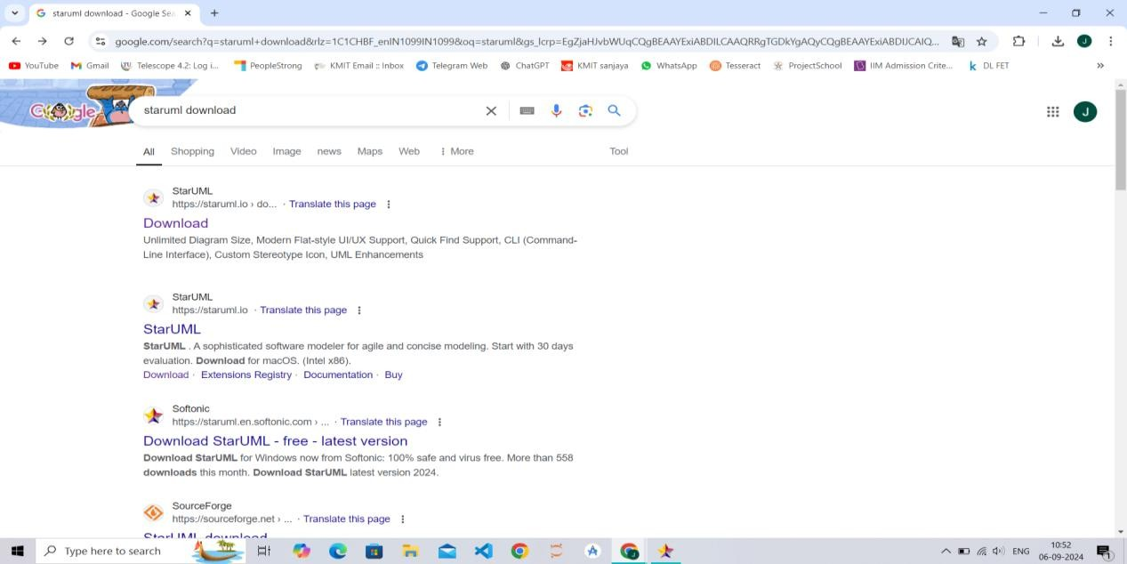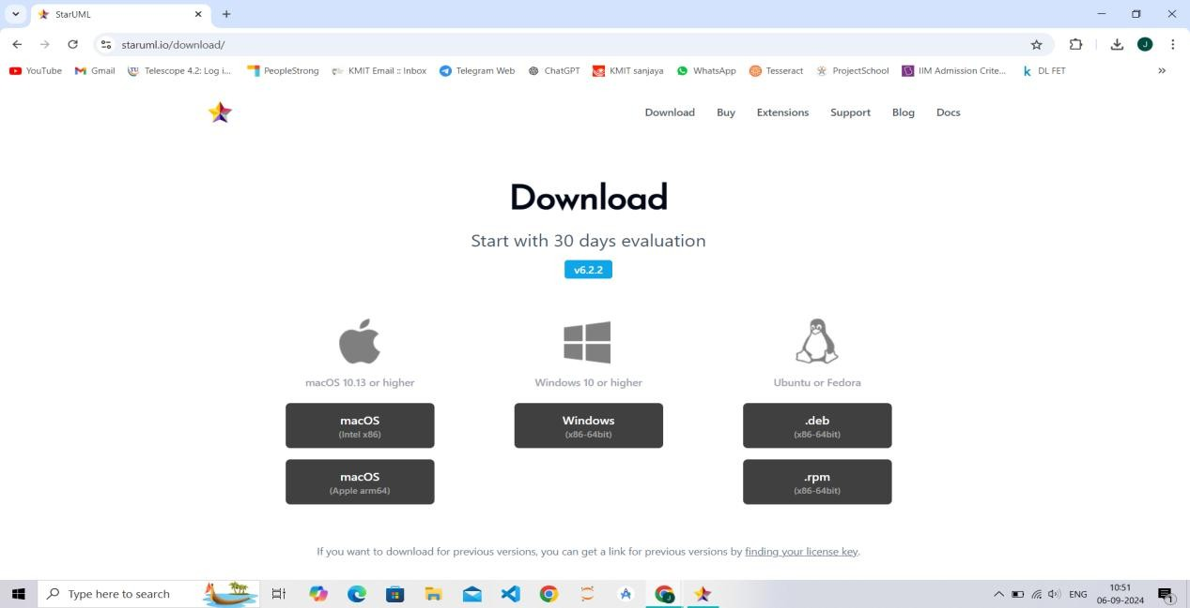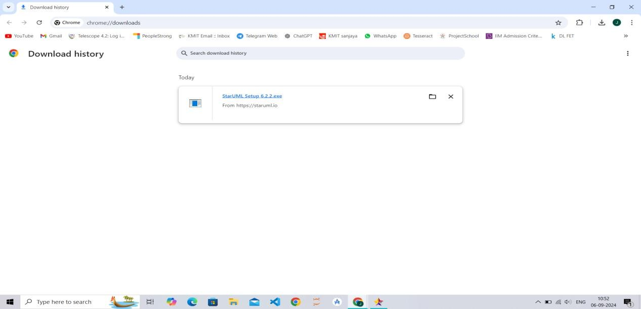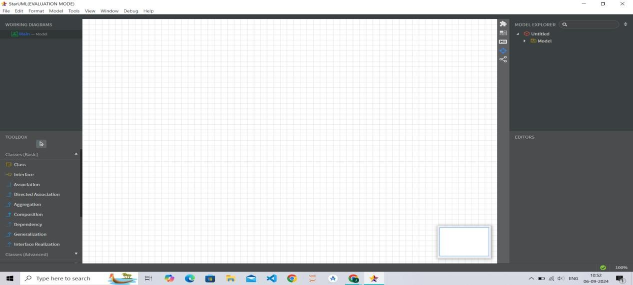

GITHUB INSTALLATION

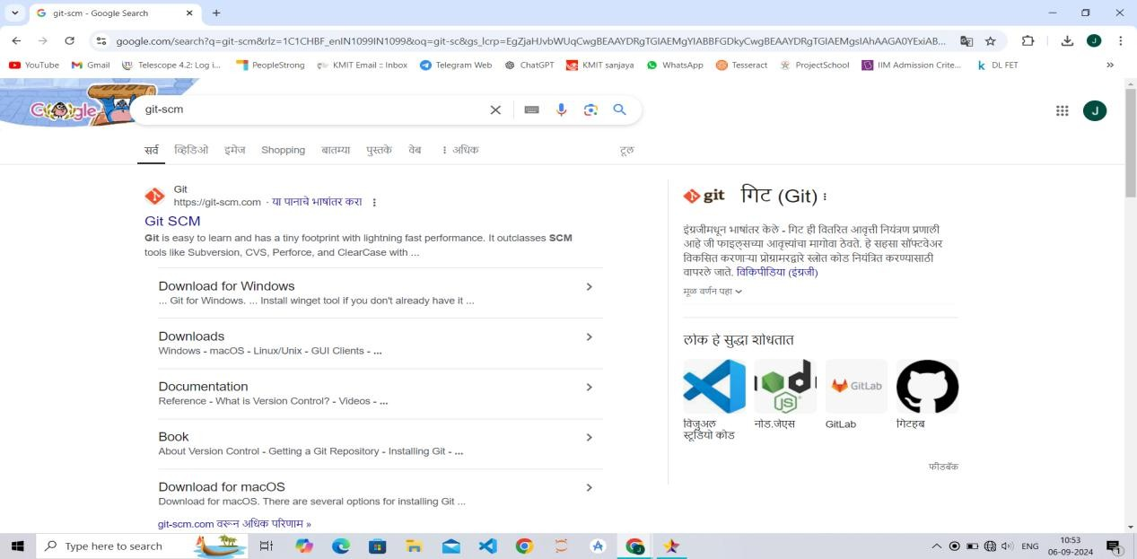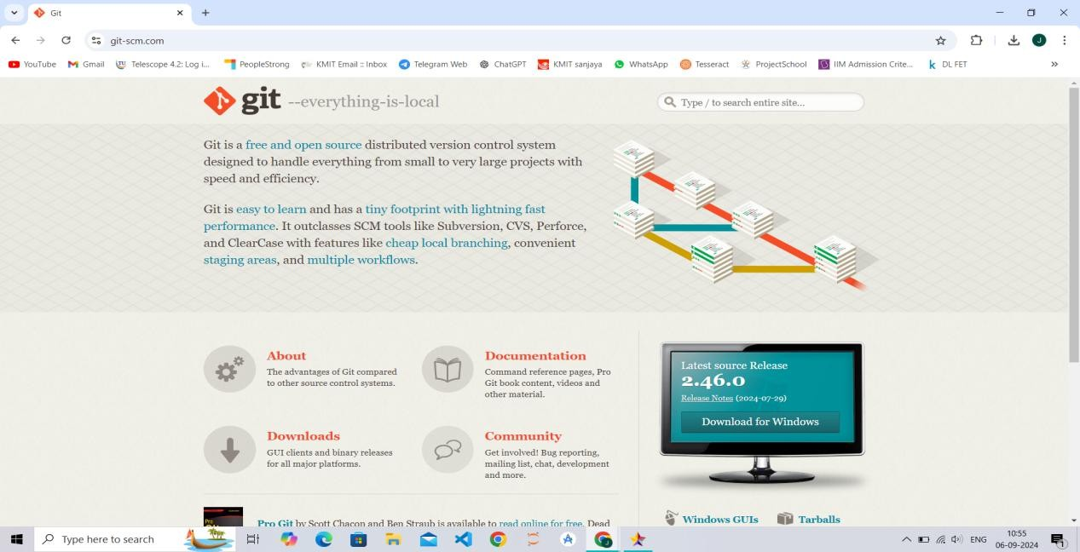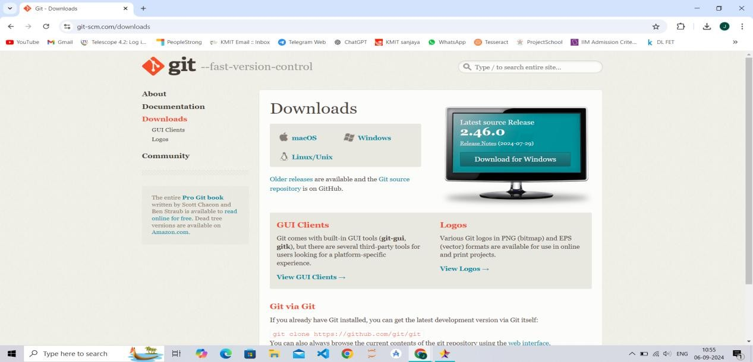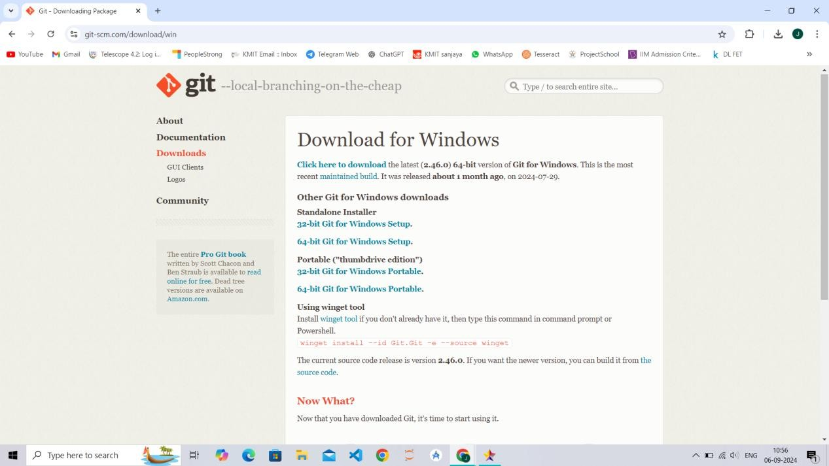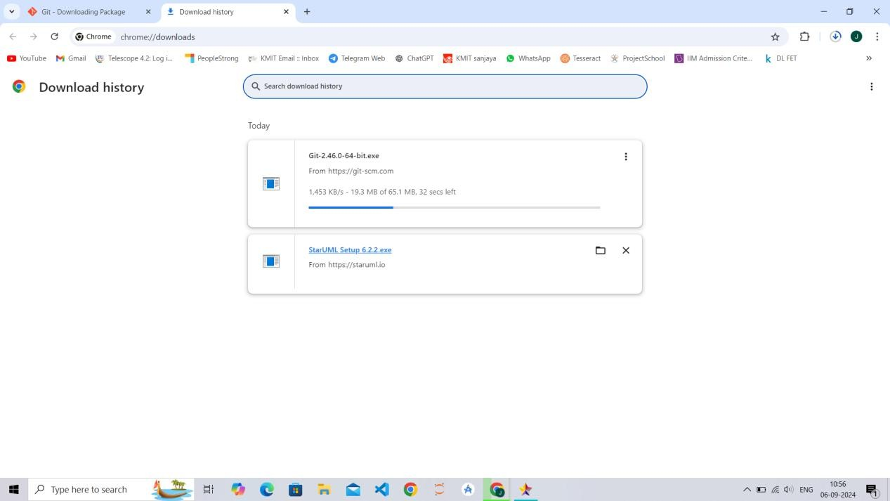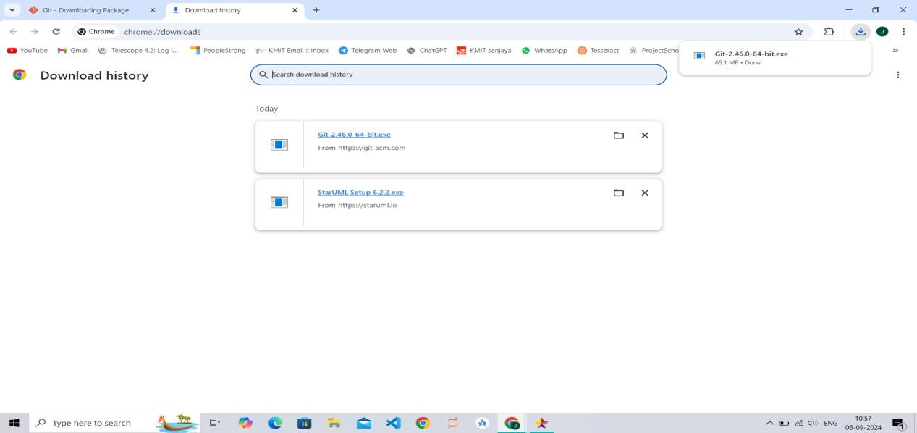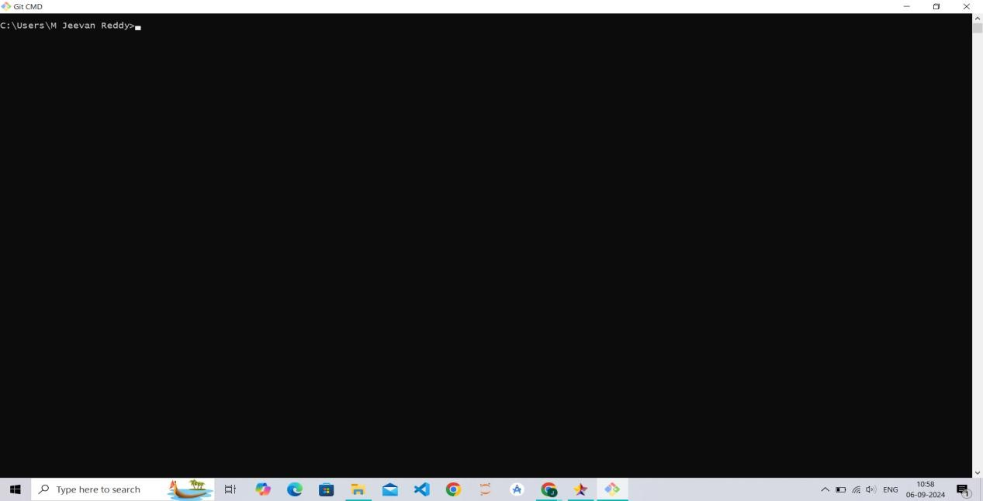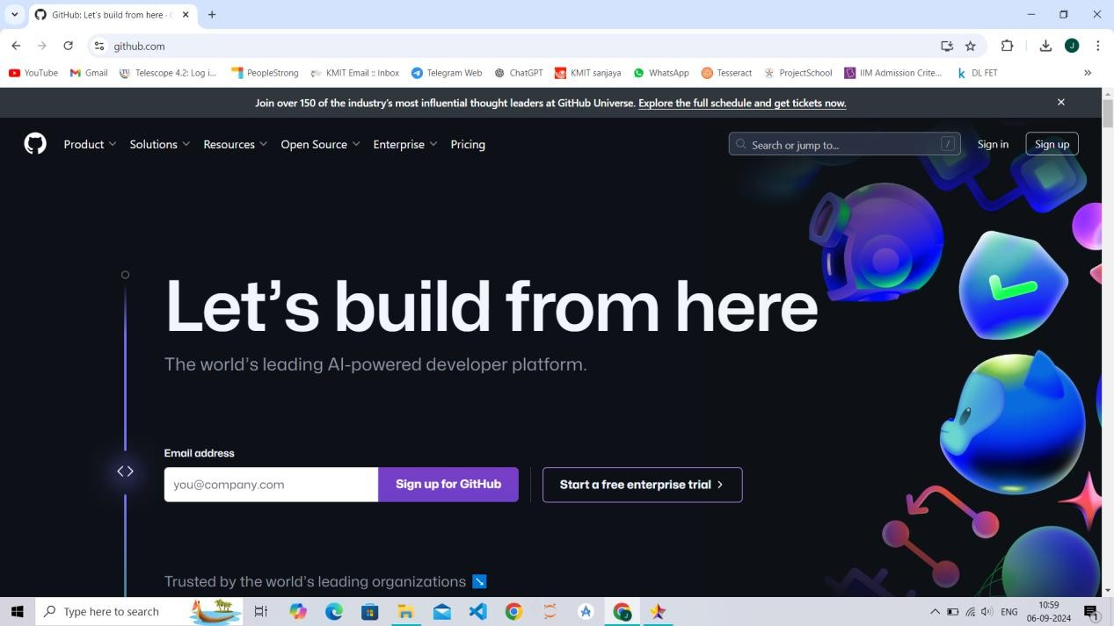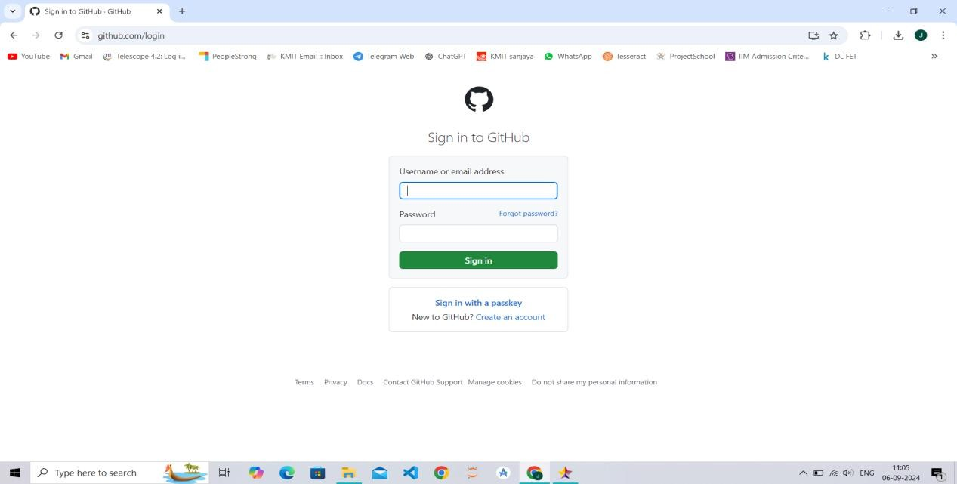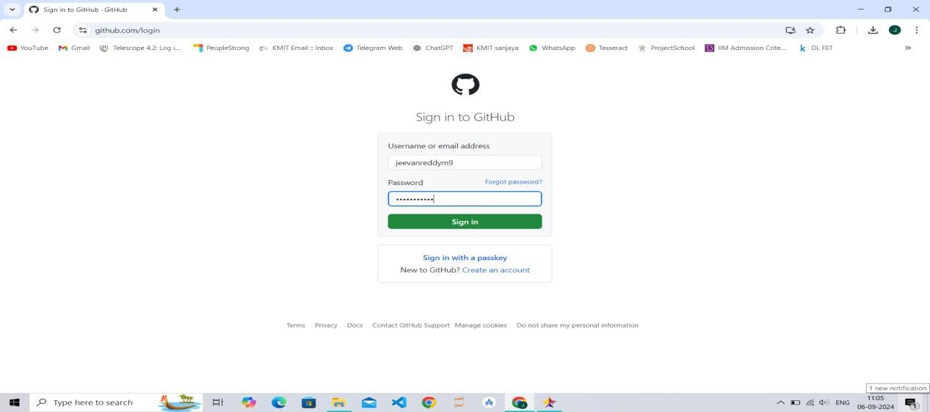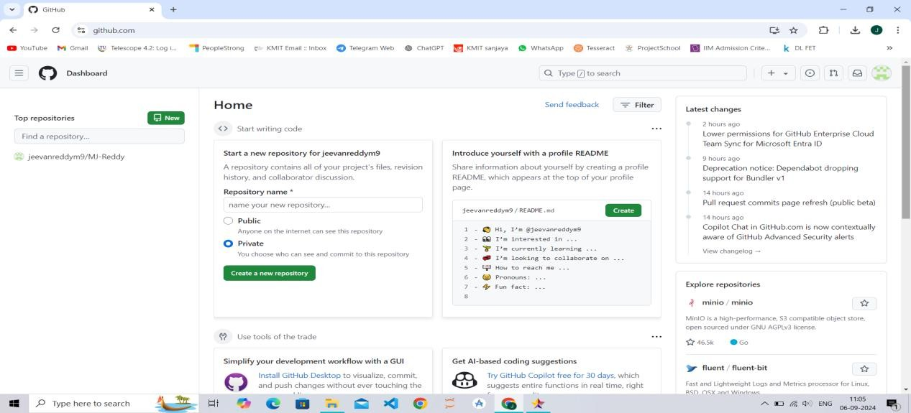

**EXPERIMENT 2**

**Software Requirements Specification**

**For**

**Hospital Management System**

**Version 1.0 approved**

**Prepared by:**

M Jeevan Reddy

M Vibhas Reddy

N Abhishek Ritesh P

M Sai Charan

G Rohan

**Keshav Memorial Institute of Technology**

**Table of Contents**

#### Introduction 4

##### Purpose

##### Document Conventions

##### Intended Audience and Reading Suggestions

##### Product Scope

##### References

#### Overall Description 5

##### Product Perspective

##### Product Functions

##### User Classes and Characteristics

##### Operating Environment

##### Design and Implementation Constraints

##### User Documentation

##### Assumptions and Dependencies

#### External Interface Requirements 7

##### User Interfaces

##### Hardware Interfaces

##### Software Interfaces

##### Communications Interfaces

#### System Features 8

##### Patient Registration

##### Doctor Management

##### Appointment Scheduling

##### Billing and Payment

##### Reporting

#### Other Nonfunctional Requirements 10

##### Performance Requirements

##### Safety Requirements

##### Security Requirements

##### Software Quality Attributes

##### Business Rules

#### Other Requirements 11

**Appendix A**: Glossary **----------------------------------**i**-**x **12**

Use Case Diagram 13

Class Diagram 14

Sequence Diagram 15

Component Diagram 16

1. **Introduction**

###### Purpose

##### The purpose of this SRS is to describe the software requirements for the **Hospital Management System (HMS)**. The HMS will automate patient management, doctor management, appointment scheduling, billing, and reporting. This document outlines the system's functionality and intended use.

###### Document Conventions

##### Priority of requirements will be indicated using "High," "Medium," or "Low" labels.

##### Functional requirements are listed as REQ-<number>.

##### Nonfunctional requirements are specified under respective categories.

###### Intended Audience and Reading Suggestions

##### This document is intended for software developers, project managers, testers, and hospital administration staff. The document begins with a high-level overview of the system, followed by detailed system features and requirements. Developers should focus on Sections 2 and 4, while testers may concentrate on Sections 3 and 5.

###### Product Scope

##### The **Hospital Management System (HMS)** is a comprehensive system that automates operations within a hospital, including patient registration, doctor management, appointment scheduling, billing, and report generation. It aims to streamline administrative tasks, improve patient care, and ensure accuracy in billing and reporting.

###### References

##### HMS User Interface Guidelines, Version 1.2

##### Hospital Data Privacy Act, 2019

##### Web link: [Include URL if any]

1. **Overall Description**

###### Product Perspective

##### The HMS will replace current manual or semi-automated systems in hospitals. It will interact with other systems such as inventory management and laboratory systems and must be easily integrable with electronic health record (EHR) systems for data transfer.

###### Product Functions

##### Patient registration and management

##### Doctor information management

##### Appointment scheduling

##### Billing and payment processing

##### Reporting and analytics

##### User role management (Admin, Doctor, Nurse, etc.)

###### User Classes and Characteristics

##### **Admin**: Manages system settings and user roles.

##### **Doctors**: Access patient records and manage appointments.

##### **Nurses**: Assist in patient management and access patient information.

* **Patients**: Can book appointments online.
* **Billing Staff**: Manage billing, payments, and reports.

###### Operating Environment

##### Windows/Linux server environment

##### Web browser: Chrome, Firefox, Safari

##### Database: MySQL/PostgreSQL

##### Frontend: HTML5, CSS3, JavaScript (React/Angular)

###### Design and Implementation Constraints

##### System must comply with local hospital regulations and data privacy laws.

##### The system should be built using secure coding practices, especially for handling sensitive patient data.

##### The system will use HTTPS protocol for secure data transmission.

###### User Documentation

##### User manual for Admin, Doctors, and Billing Staff

##### Online help for patients (for appointmentixscheduling)

##### Training tutorials

###### Assumptions and Dependencies

##### The system assumes users will have access to modern web browsers and reliable internet connections.

##### Third-party integration for payment gateways may be necessary.

1. **External Interface Requirements**

###### User Interfaces

##### Intuitive dashboard for Admins, Doctors, and Billing Staff.

##### Patient-friendly interface for online appointment scheduling.

##### Reports section with printable and exportable formats (PDF/Excel).

###### Hardware Interfaces

##### The system will interface with barcode scanners for patient registration.

##### Integration with laboratory equipment to fetch diagnostic reports.

###### Software Interfaces

##### Integration with hospital inventory management system for medication tracking.

##### Connection to government health portals for reporting.

###### Communications Interfaces

##### Email notifications for appointment confirmations and reminders.

##### SMS gateway for alerts to patients and doctors.

1. **System Features**

###### Patient Registration

#### Description and Priority

##### Allows patients to register their details into the system for appointment scheduling and hospital visits. **Priority: High**

#### Stimulus/Response Sequences

##### Patient enters details.

##### System generates a unique patient ID.

##### Confirmation message sent to patient via email/SMS.

#### Functional Requirements

##### REQ-1: The system must allow patients to register via an online form or at the hospital.

##### REQ-2: The system must store patient records securely in the database.

###### Doctor Management

#### Description and Priority

##### Manages doctor profiles, specializations, schedules, and availability. **Priority: High**

#### Functional Requirements

##### REQ-1: The system must allow the admin to add, update, or remove doctor profiles.

##### REQ-2: Doctors' availability should be updated in real-time for appointment scheduling.

###### Appointment Scheduling

#### Description and Priority

##### Allows patients to schedule, reschedule, or cancel appointments with doctors. **Priority: High**

#### Functional Requirements

##### REQ-1: Patients must be able to book appointments through the website.

##### REQ-2: The system must prevent double booking by checking doctor's availability.

###### Billing and Payment

#### Description and Priority

Manages patient billing, invoicing, and payment processing. **Priority: Medium**

#### Functional Requirements

##### REQ-1: The system should calculate bills based on services availed by the patient.

##### REQ-2: It must integrate with payment gateways for online payments.

###### Reporting

#### Description and Priority

##### Generates various reports, including patient records, billing, and doctor performance. **Priority: Medium**

#### Functional Requirements

##### REQ-1: Admin must be able to generate custom reports in PDF or Excel format.

1. **Other Nonfunctional Requirements**

###### Performance Requirements

##### The system should support up to 1000 concurrent users with no significant performance degradation.

##### Page load times must not exceed 3 seconds.

###### Safety Requirements

##### Sensitive patient data must be encrypted both in transit and at rest.

##### The system should have a backup mechanism in case of failure.

###### Security Requirements

##### Role-based access control must be enforced.

##### User authentication should include multi-factor authentication (MFA) for Admins and Doctors.

###### Software Quality Attributes

* **Availability**: 99.9% uptime

##### **Maintainability**: The system should be easy to update with minimal downtime.

##### **Usability**: User interfaces should be intuitive and accessible with minimal training.

###### Business Rules

##### Only authorized personnel can access patient medical records.

##### Billing data should be locked after final payment.

1. **Other Requirements**

##### The system must support multiple languages.

##### Must comply with GDPR and HIPAA regulations for data privacy.

#### Appendix A: Glossary

##### **HMS**: Hospital Management System

##### **EHR**: Electronic Health Record

##### **HIPAA**: Health Insurance Portability and Accountability Act

## Use Case Diagram:

A Use Case Diagram is a visual representation in UML (Unified Modeling Language) that illustrates how a system interacts with external entities (actors) to perform specific tasks or functions (use cases). It captures system requirements by focusing on "who" does "what" with the system, providing a user-centered perspective.

Key Components:

* **Actors**: Represent external users or systems that interact with the system.
* **Use Cases**: Specify tasks the system performs in response to an actor’s action
  + **Association**: Connects actors to use cases.
  + **Include/Extend**: Show mandatory or optional behaviors within use cases.
  + **Generalization**: Represents inheritance relationships among actors or use cases.

Purpose:

Use case diagrams help gather requirements by clearly showing the system’s functionalities and who will use them, aiding developers and stakeholders in understanding user needs. They also serve as a foundation for system design, testing, and validating requirements.

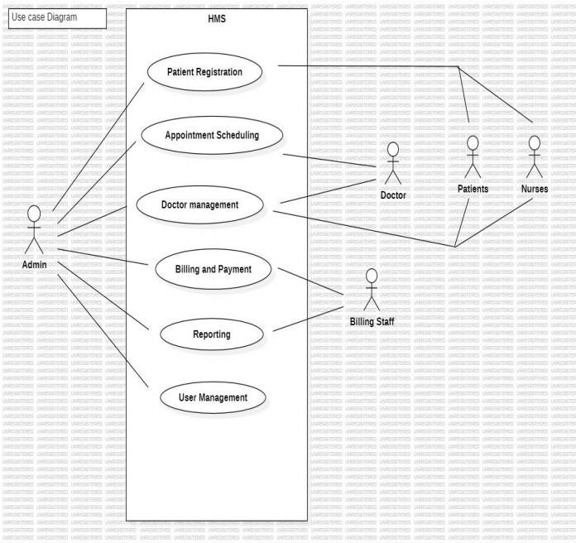

## Class Diagram:

A Class Diagram is a structural diagram in UML (Unified Modeling Language) that depicts the static structure of a system by showing its classes, attributes, methods, and the relationships among objects. It represents the fundamental building blocks of a system and is essential in object-oriented design.

Key Components:

1. **Classes**: Represents real-world entities or concepts within the system. Each class has **Attributes** and

Methods.

1. Relationships:

**Association**: Shows a connection between classes **Aggregation/Composition**: Represents "whole-part" relationships **Inheritance (Generalization)**: Depicts a parent-child relationship **Purpose:**

Class diagrams help model the structure of a system at a conceptual and detailed level, guiding the implementation process. They provide a blueprint for developers, clarify system architecture, support code generation, and serve as a reference for future maintenance and enhancements.

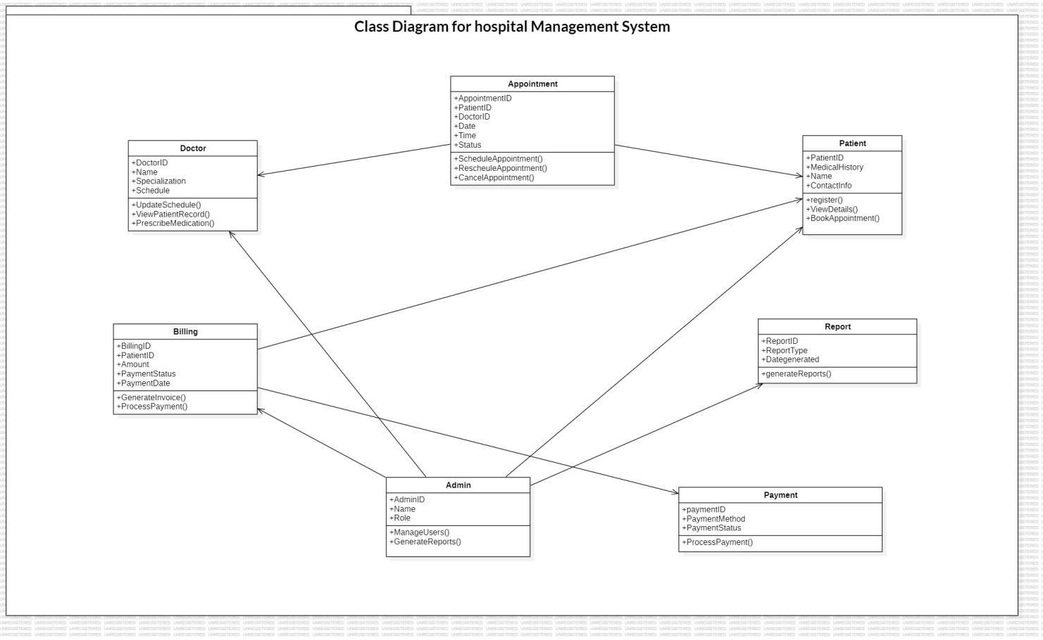

# Sequence Diagram:

A Sequence Diagram is a type of interaction diagram in UML (Unified Modeling Language) that shows how objects interact with each other over time to complete a specific process or use case. It visualizes the sequence of messages exchanged between objects, capturing the dynamic behavior of a system.

Key Components:

1. **Objects/Actors**: Represent the entities that interact in the process
2. **Lifelines**: Vertical dashed lines that show the life of an object during the sequence.
3. **Messages**: Horizontal arrows between lifelines that indicate the communication between objects.
4. **Activation Bars**: Narrow rectangles on a lifeline that show when an object is active or engaged in a specific action.

Purpose:

Sequence diagrams are crucial for understanding the flow of logic and order of interactions in a system. They help developers visualize complex processes, identify potential issues, and establish clear communication between components. This is especially valuable during the design phase, as it helps ensure that the system behavior aligns with requirements and aids in debugging and testing.

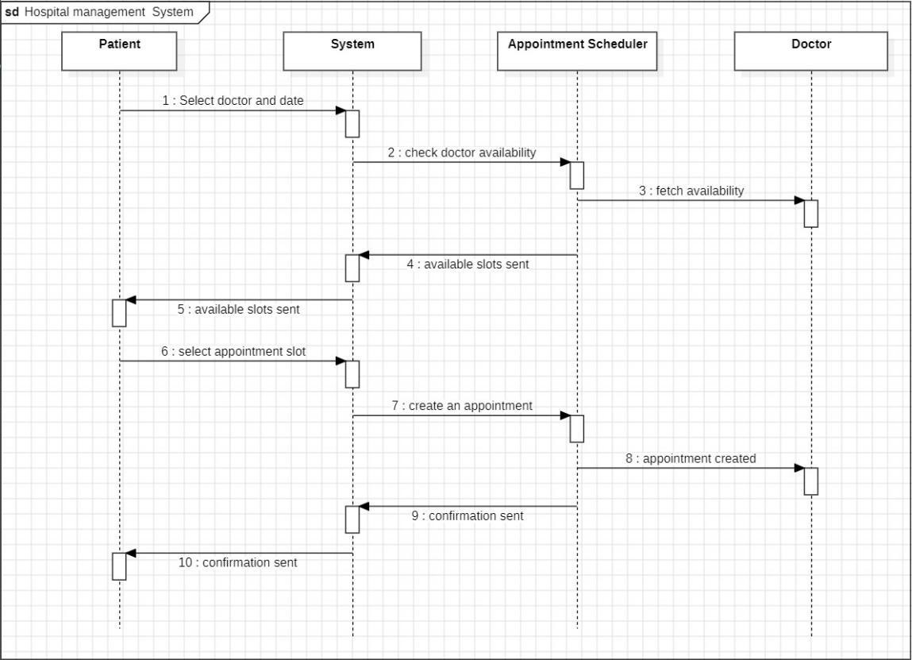

# Component Diagram:

A Component Diagram in UML (Unified Modeling Language) is a structural diagram that shows how a system is divided into components and how these components interact through interfaces. It provides a high-level view of the system’s architecture, focusing on the organization and dependencies of software components rather than the internal details.

Key Components:

1. **Components**: Represent the modular parts of the system, such as classes, libraries, or sub-systems.
2. **Interfaces**: Specify the functions provided or required by a component.
3. **Dependencies**: Show the relationships between components, usually through dashed arrows

Purpose:

Component diagrams are essential for illustrating the system's physical structure, helping developers and architects understand how different parts of the system fit together. They are widely used in the design phase to validate system architecture, manage dependencies, plan integration, and maintain scalability. This visual representation assists in organizing development, debugging, and future system updates.

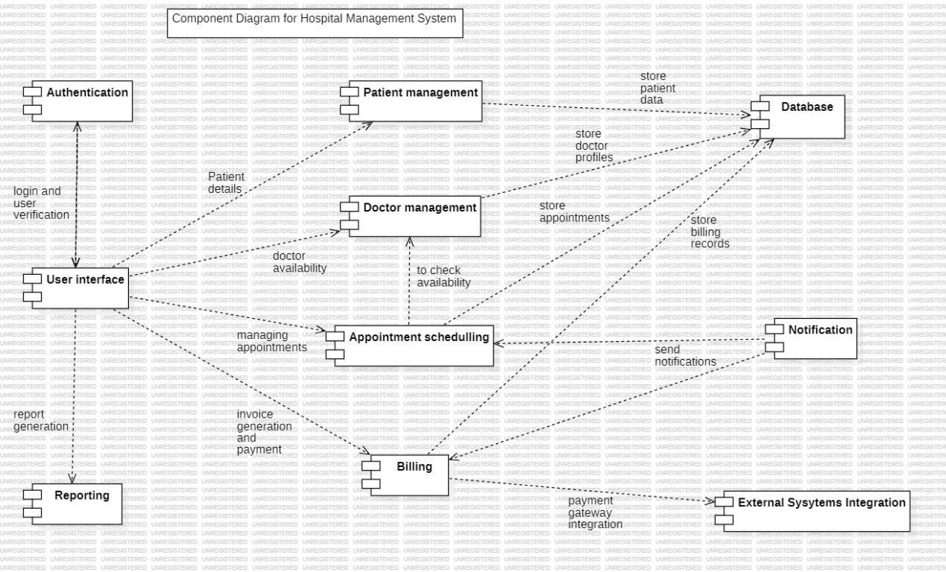

**EXPERIMENT 3**

**Maven Installation**

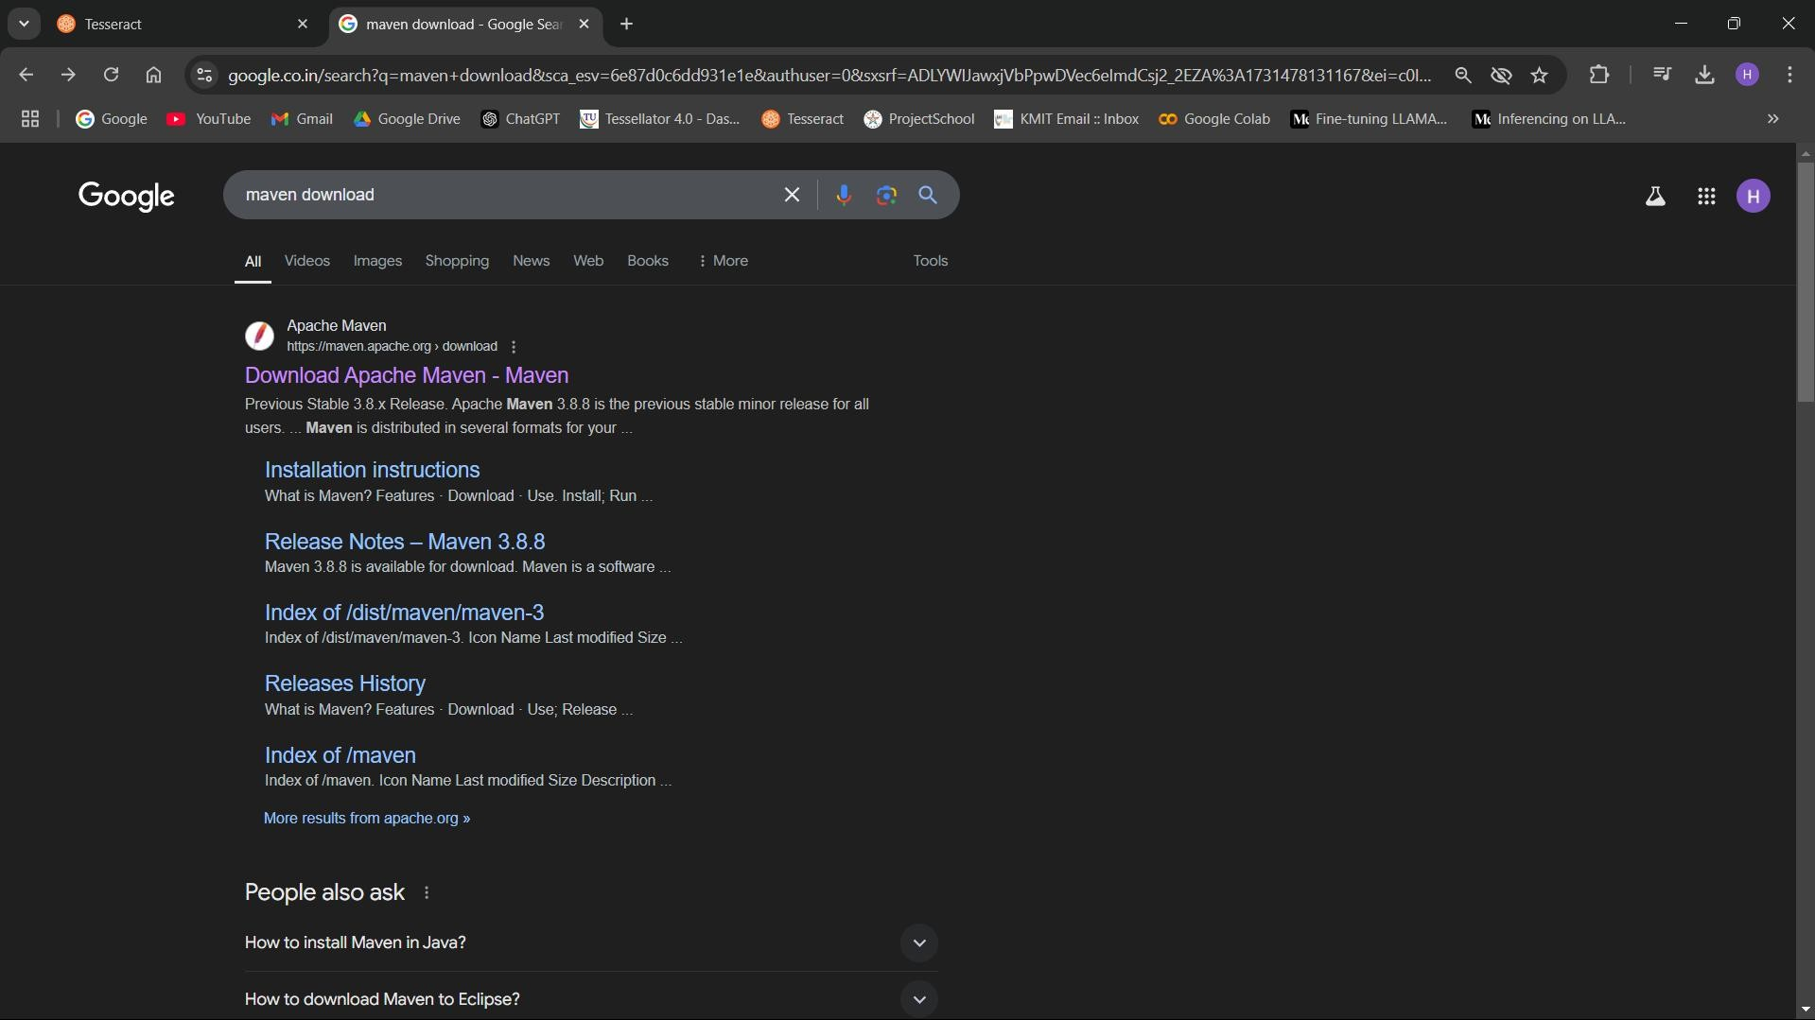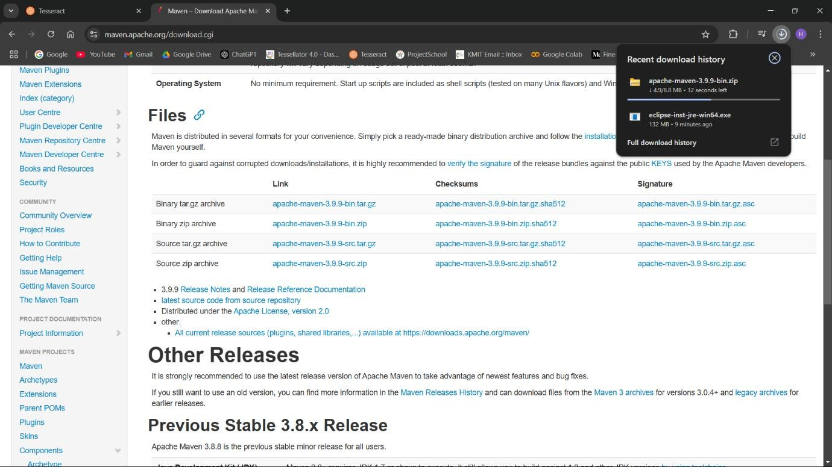

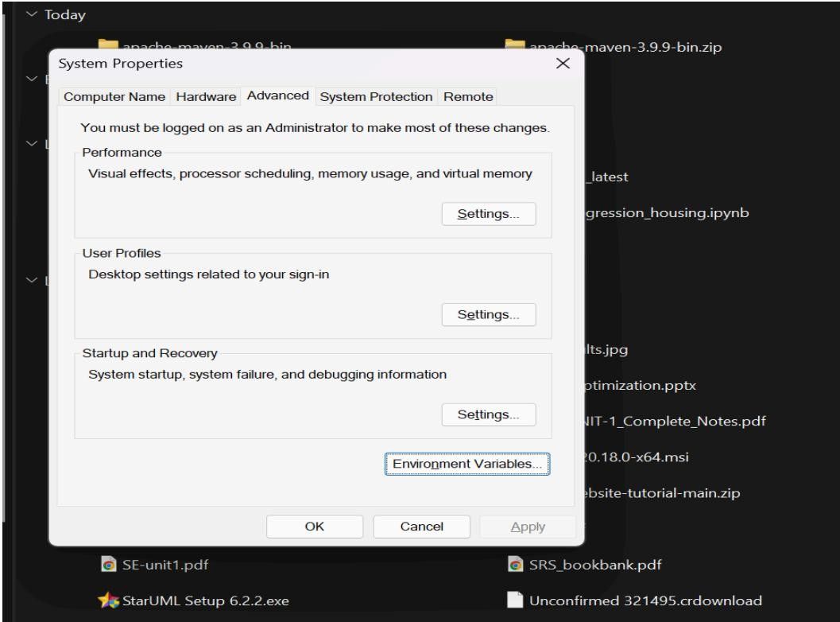

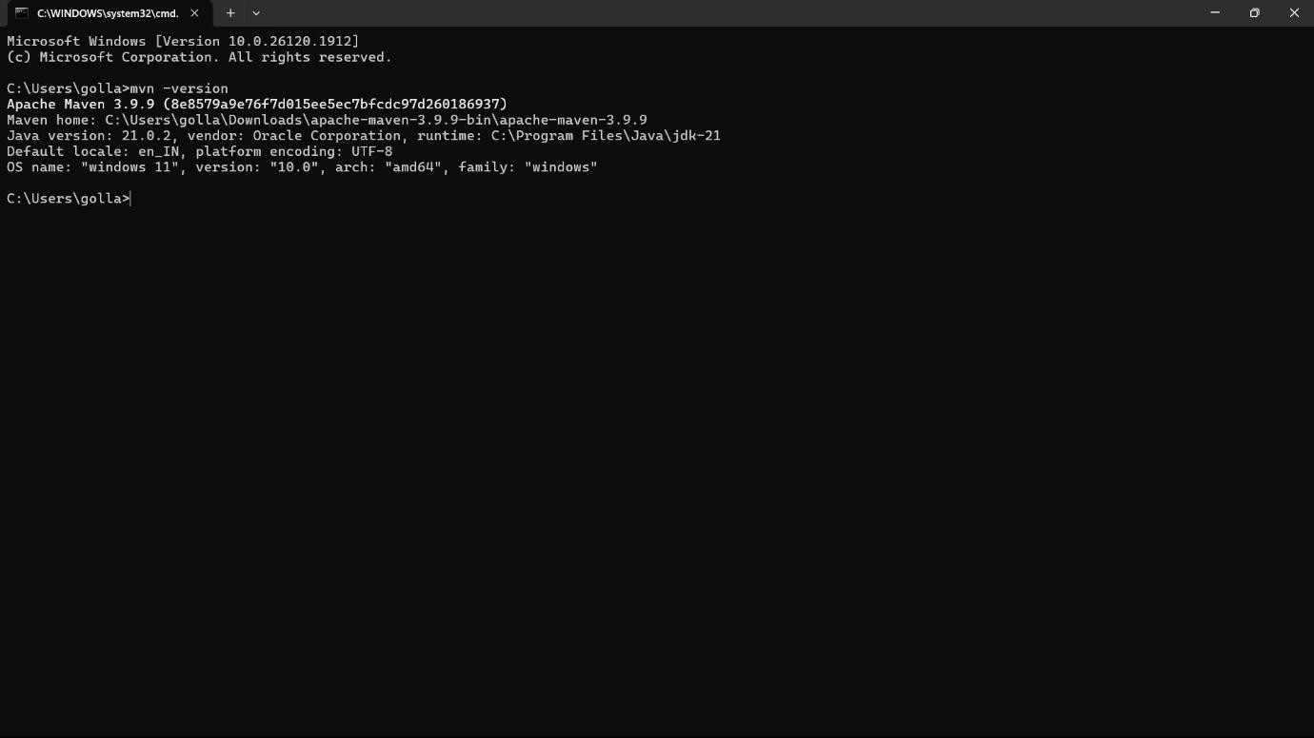

**Eclipse Installation**

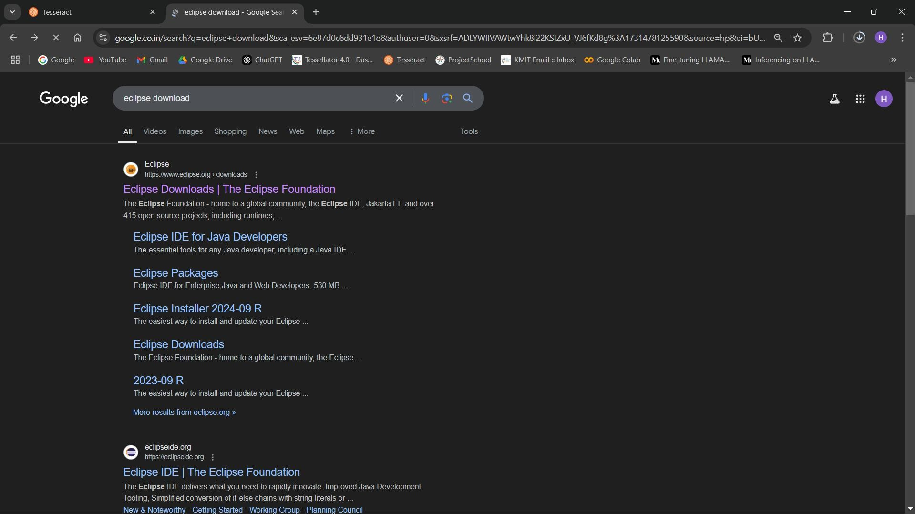

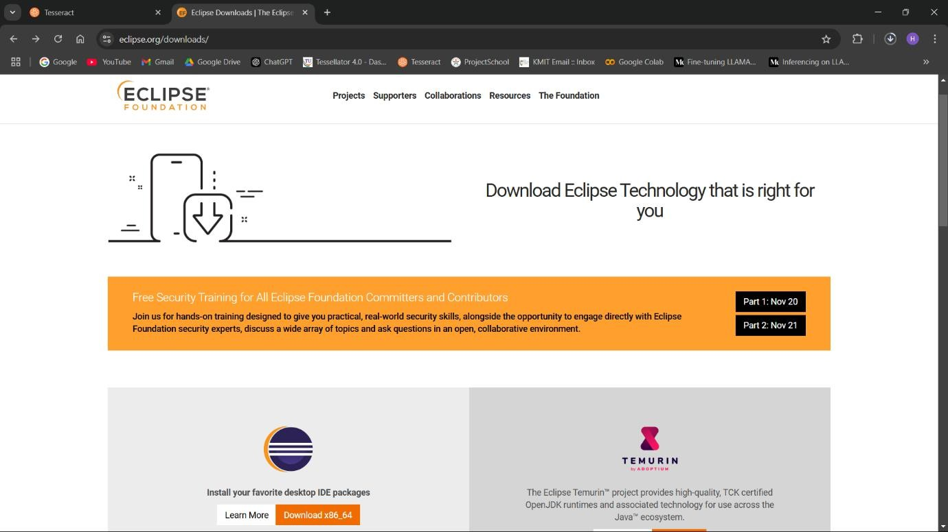

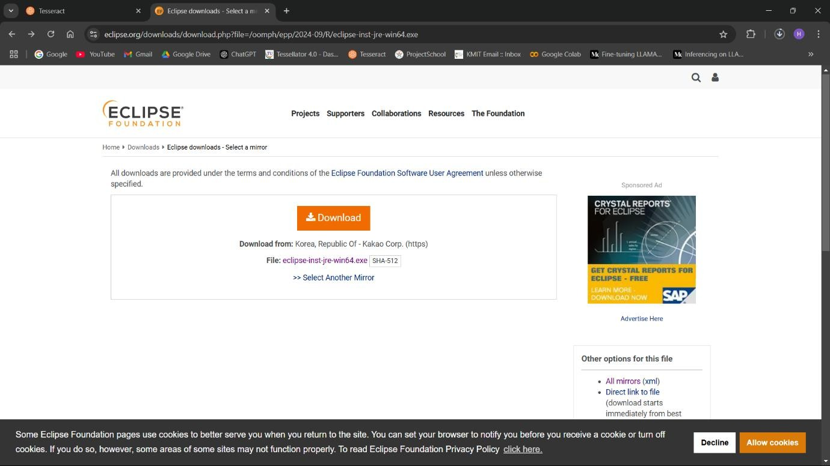

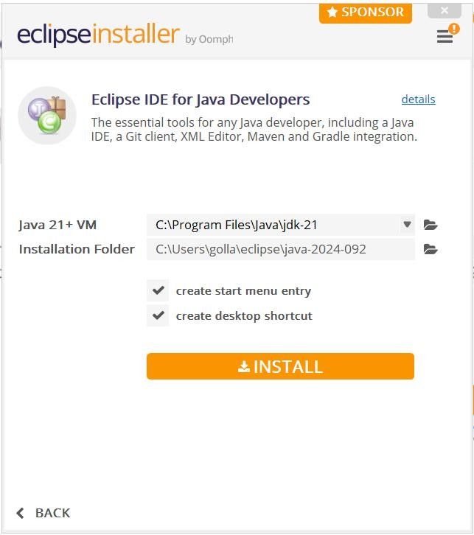

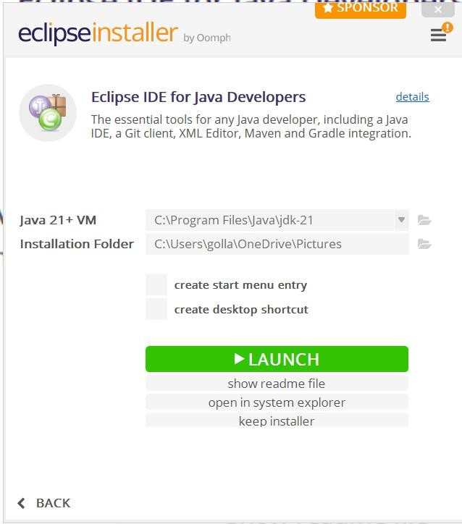

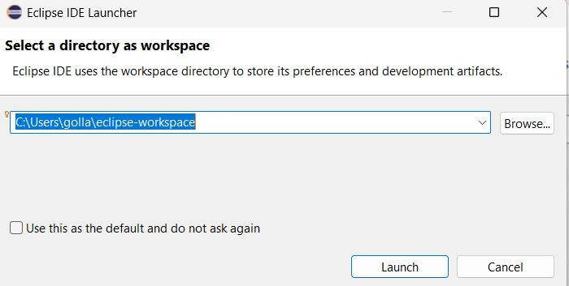

**Tomcat Installation**

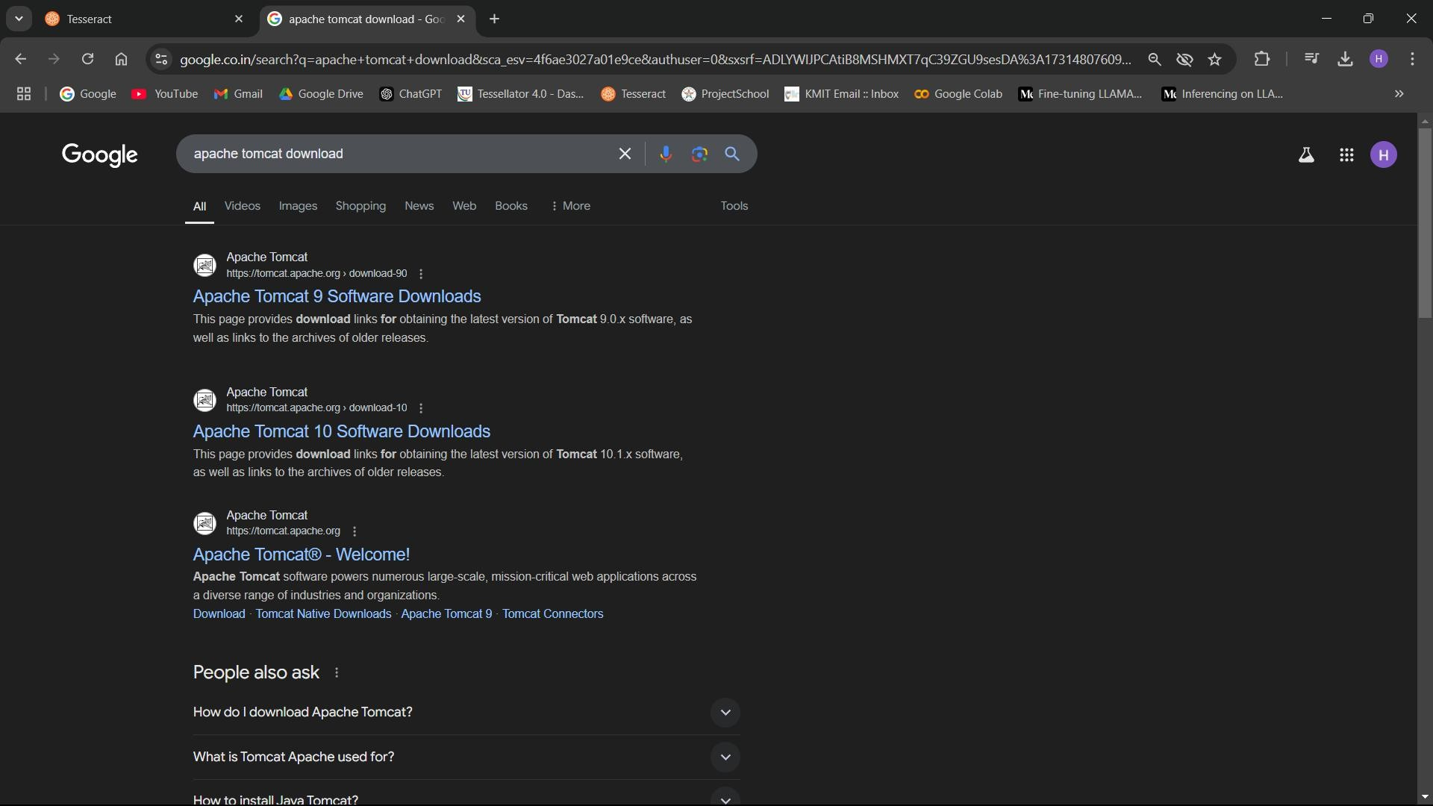

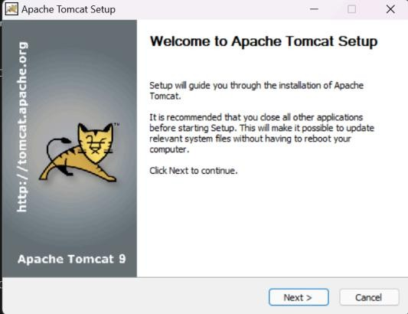

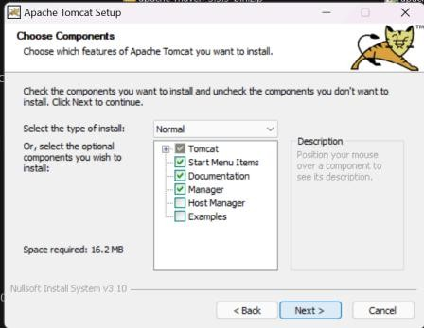

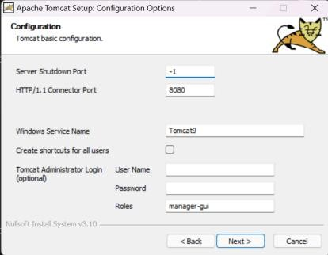

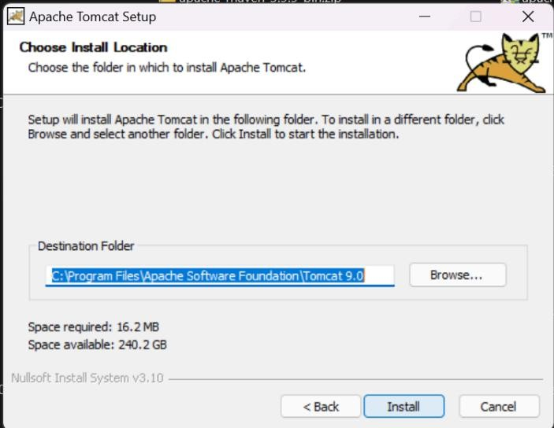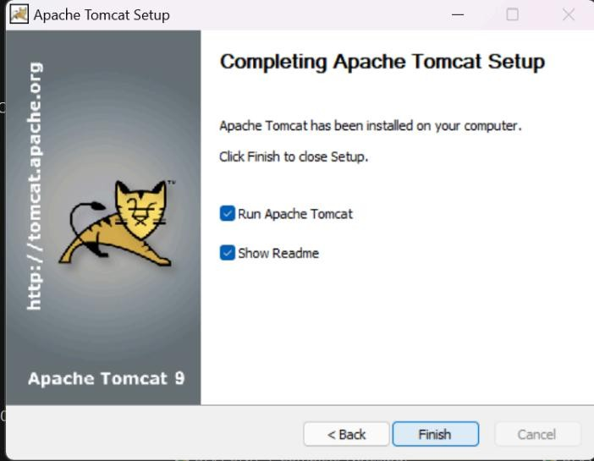

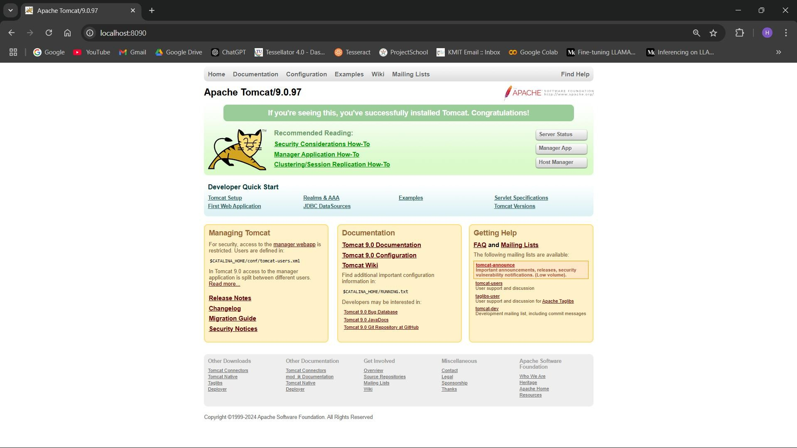

**Tomcat Configuration in Eclipse**

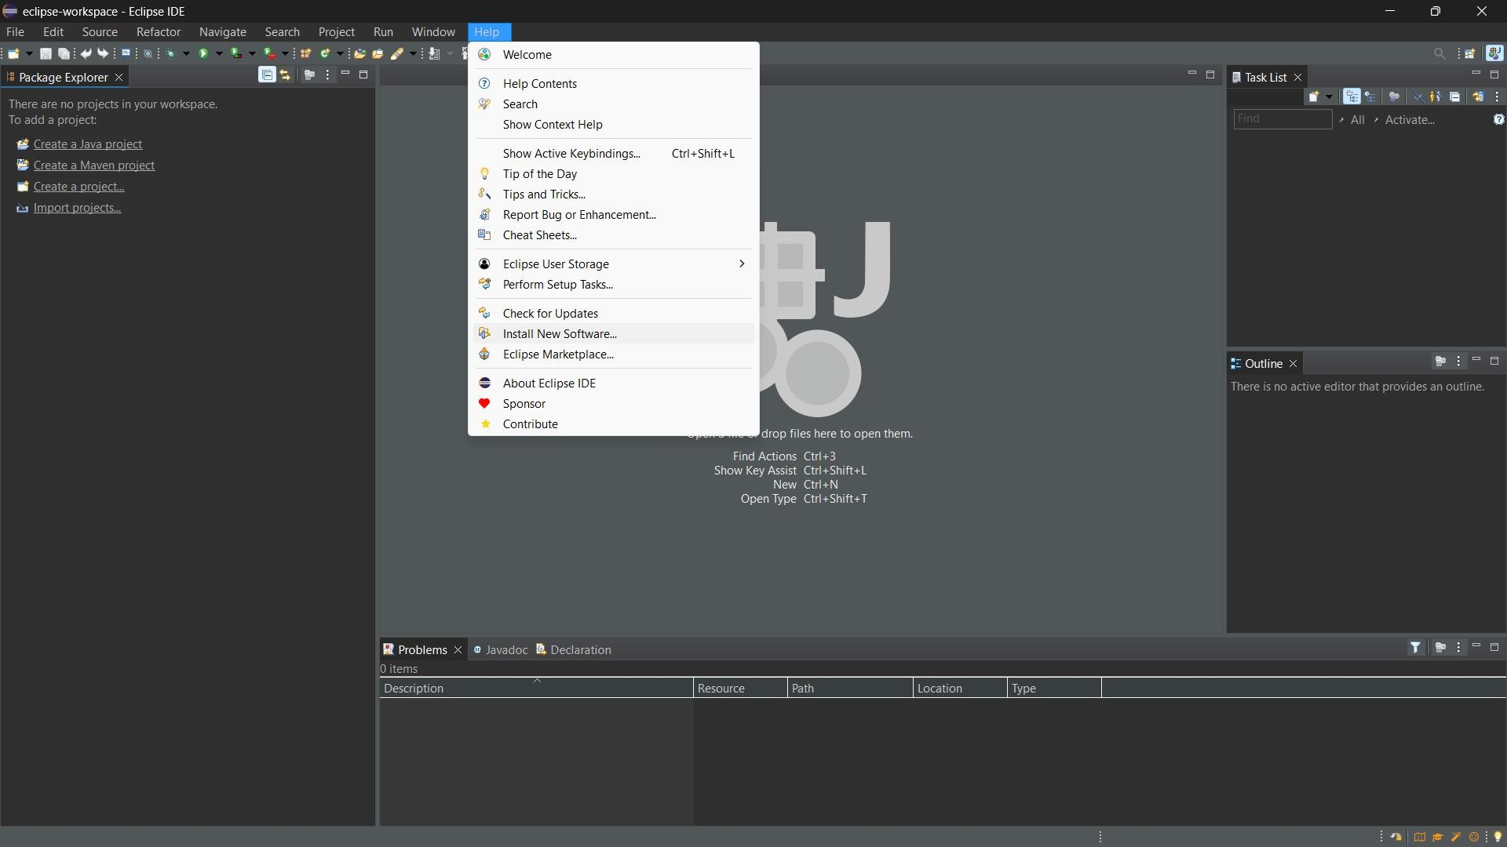

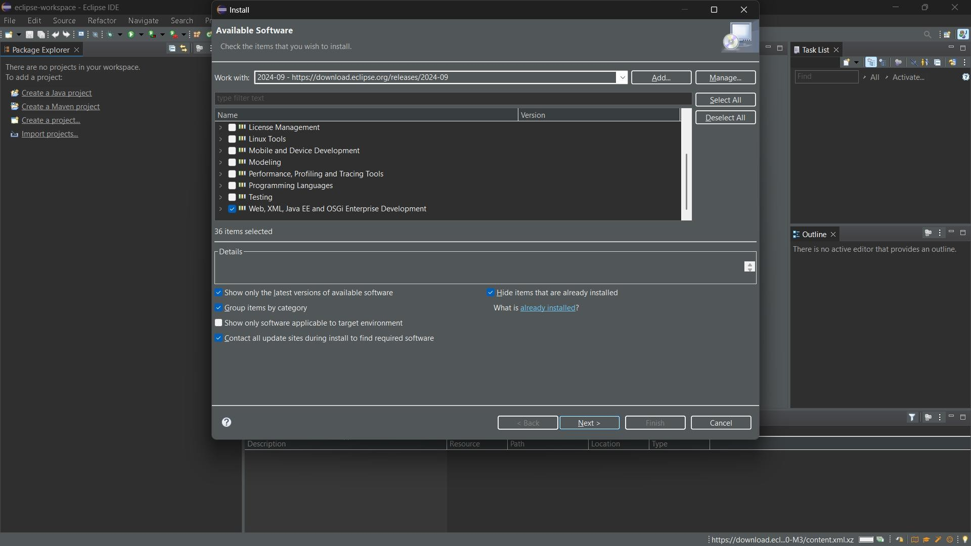

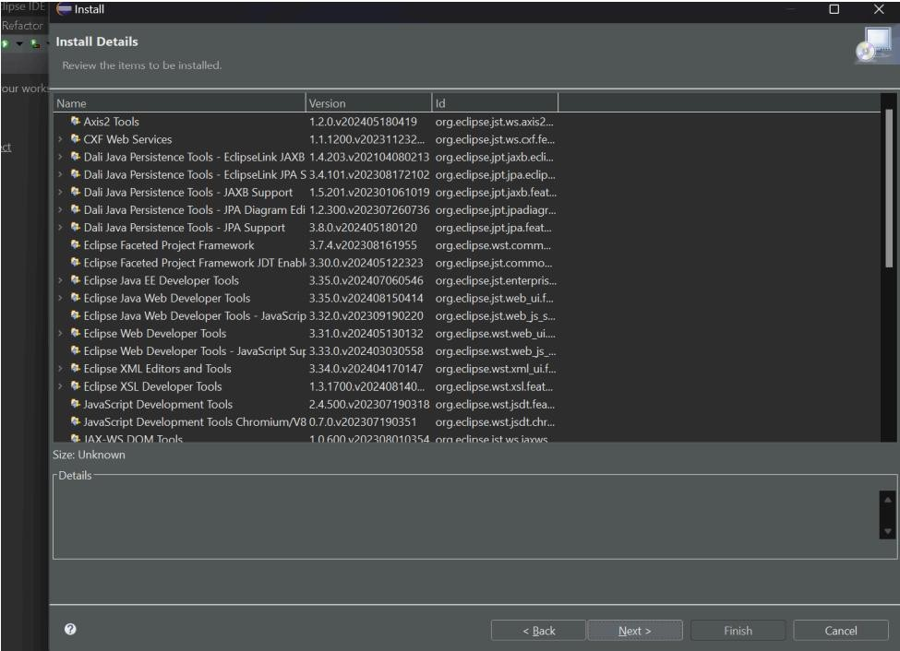

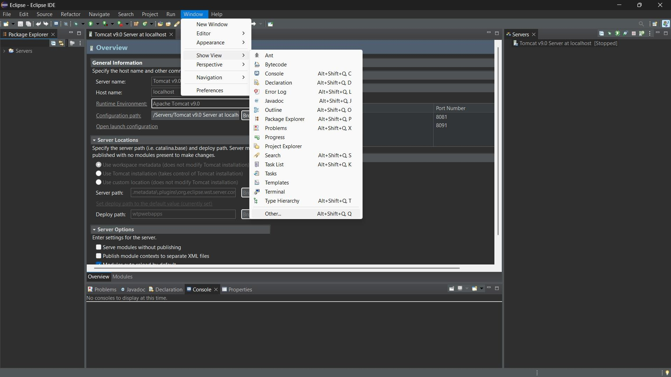

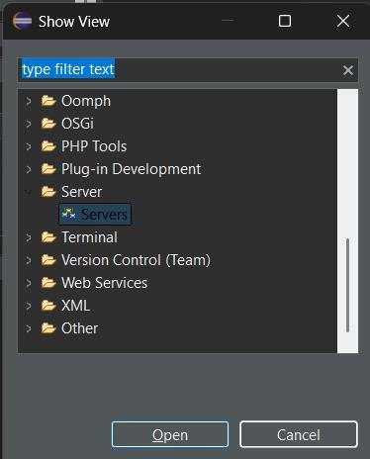

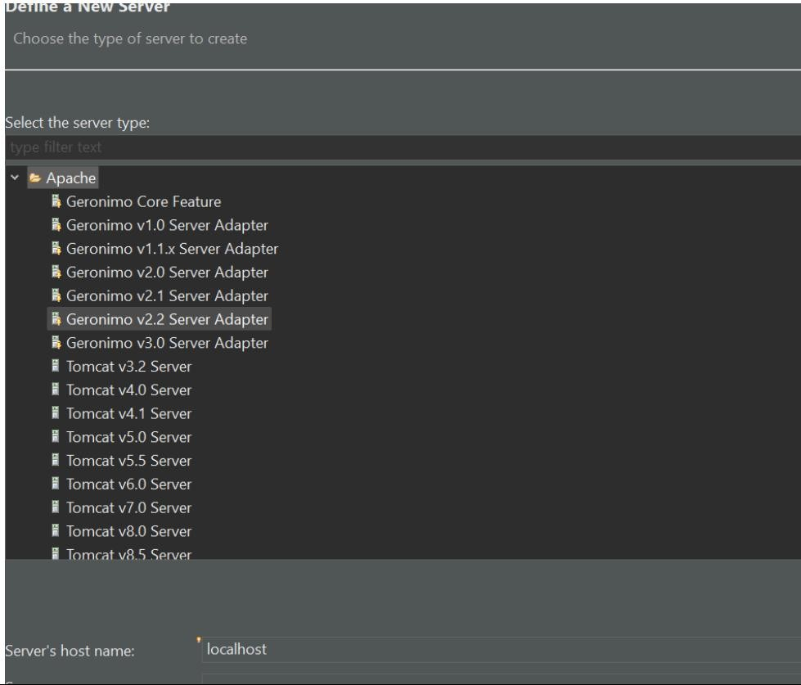

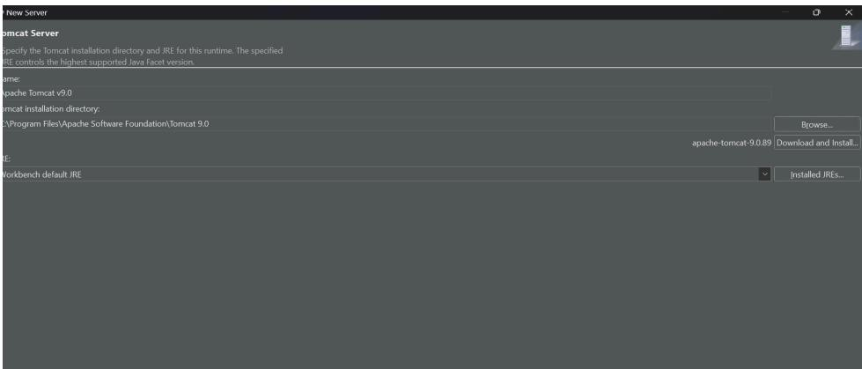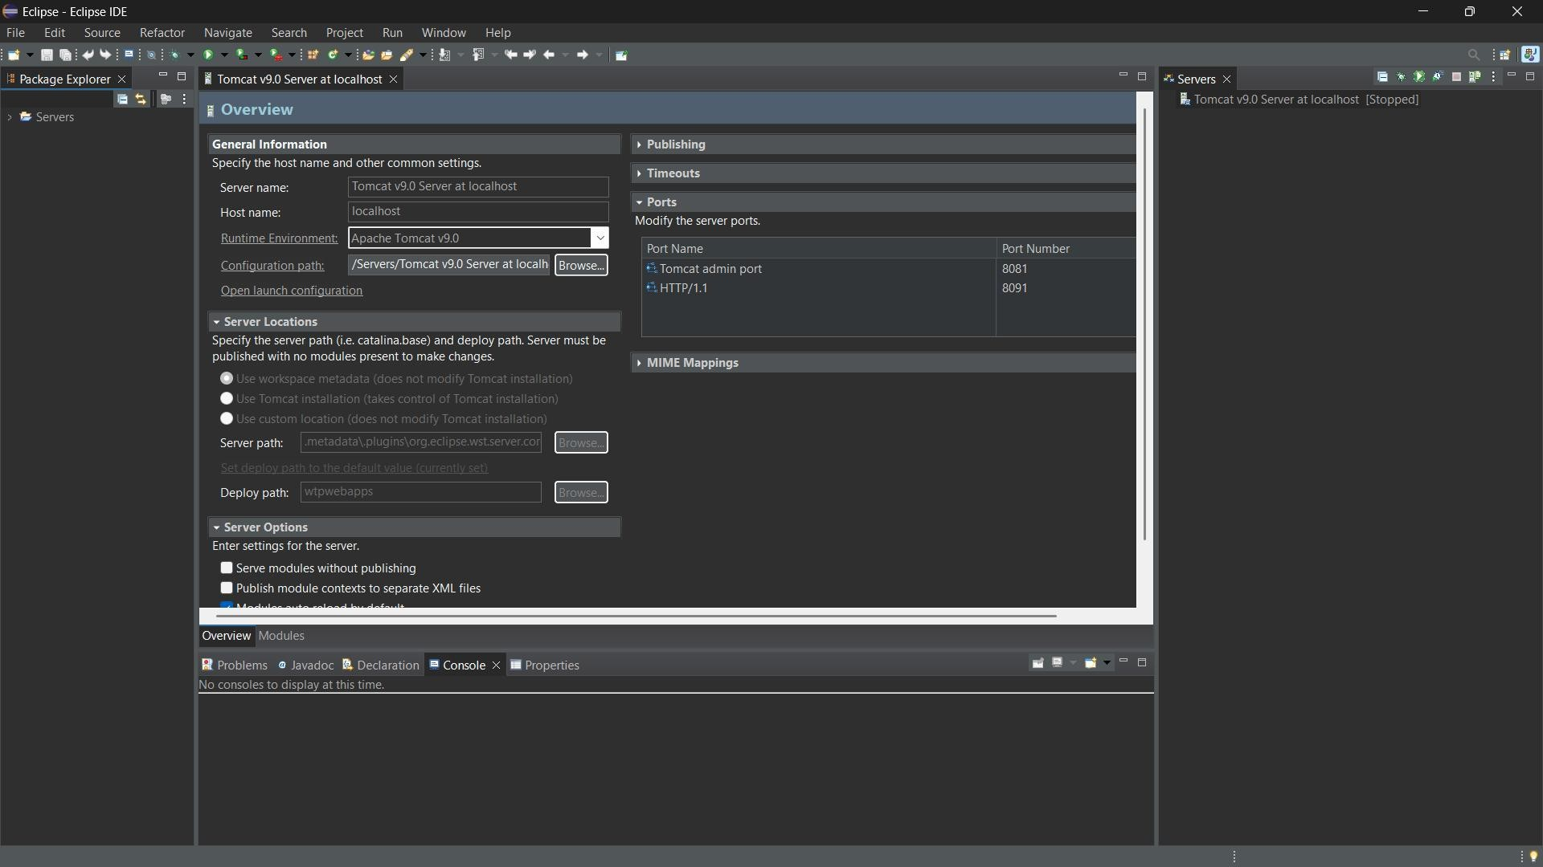

**EXPERIMENT 4**

**Git Commands**

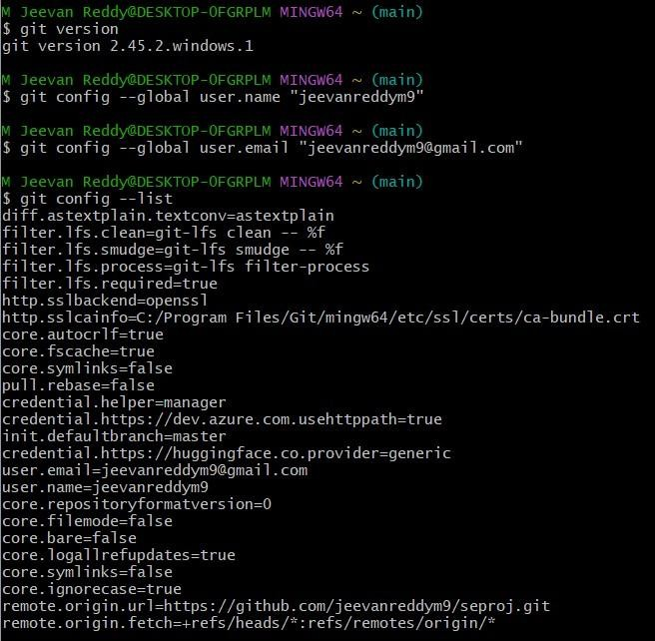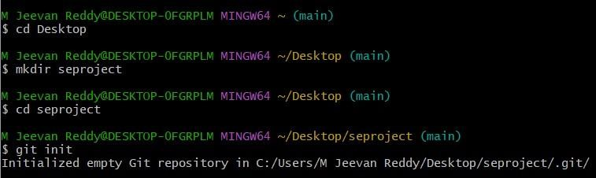

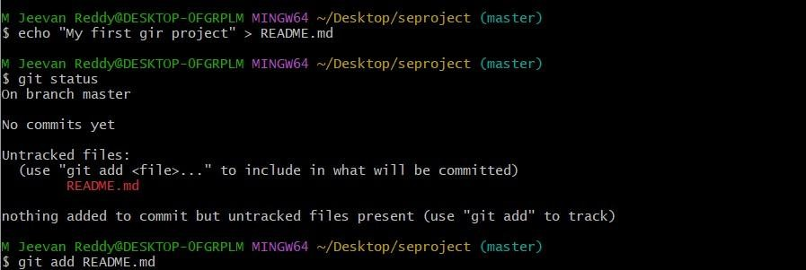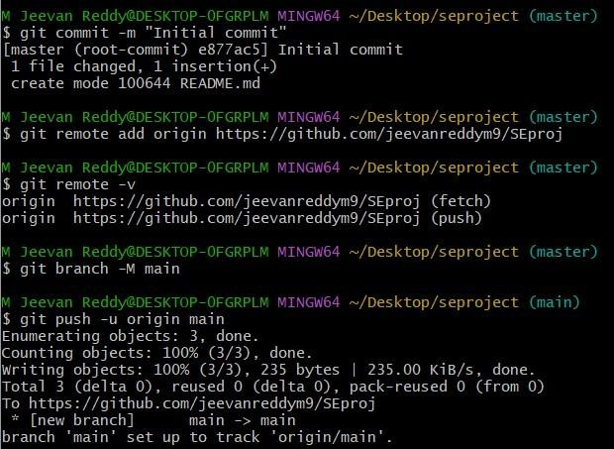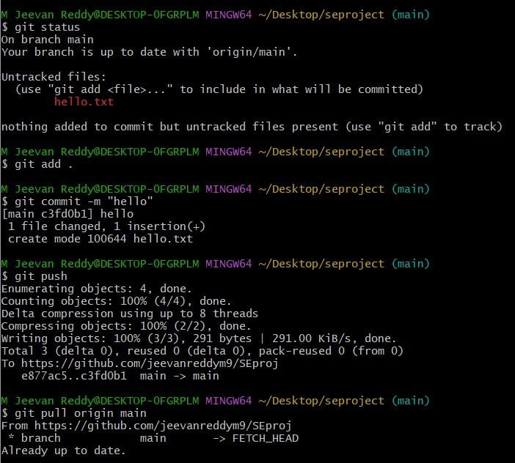

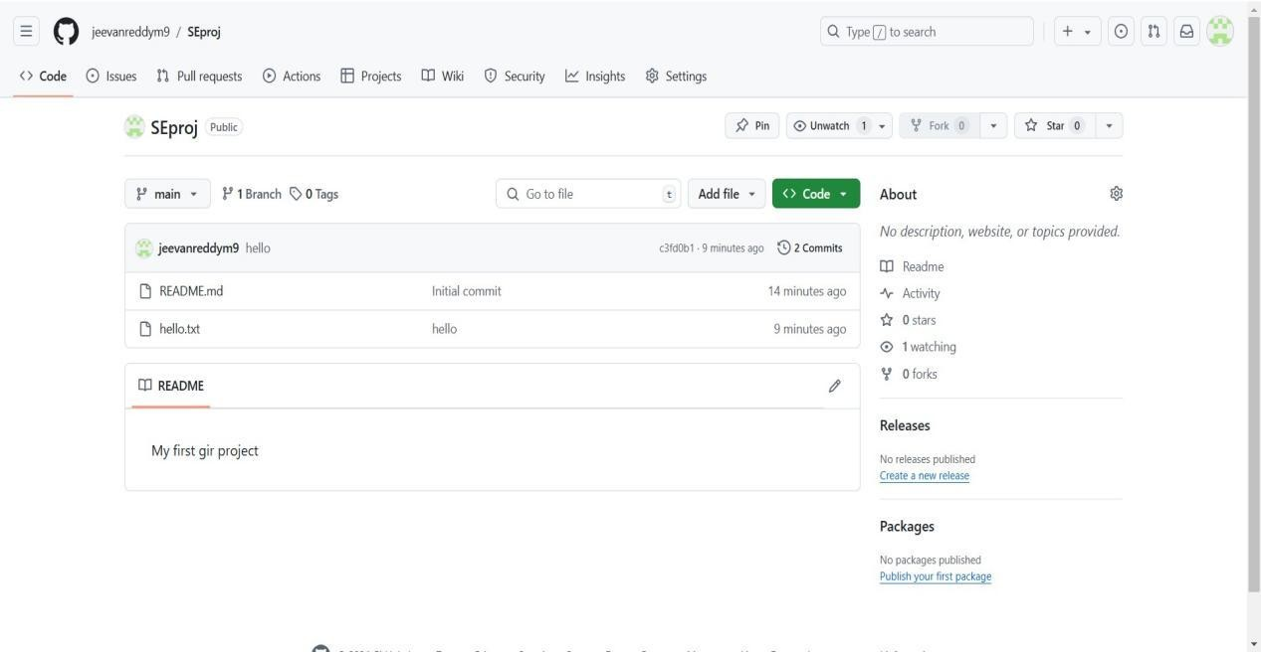

**SSH key**

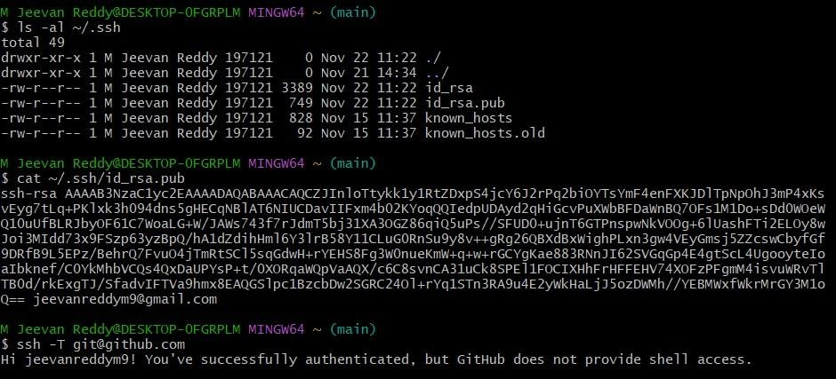

**EXPERIMENT - 5**

**Creating a New Maven Java Project**

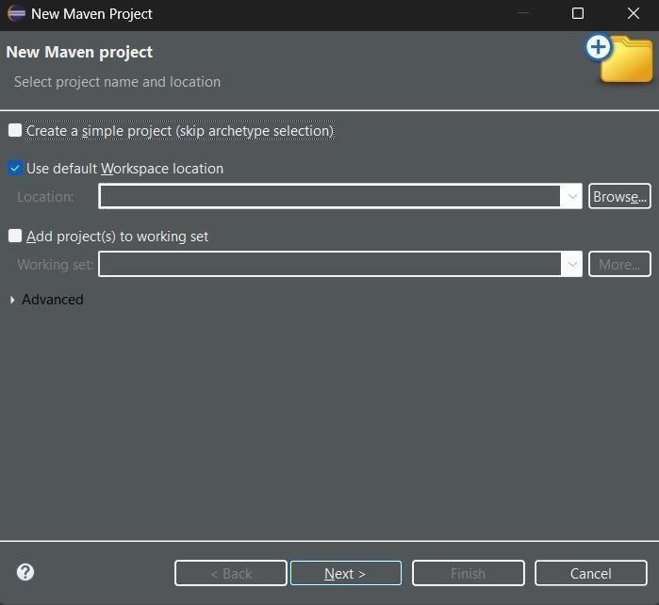

Choosing the archetype :

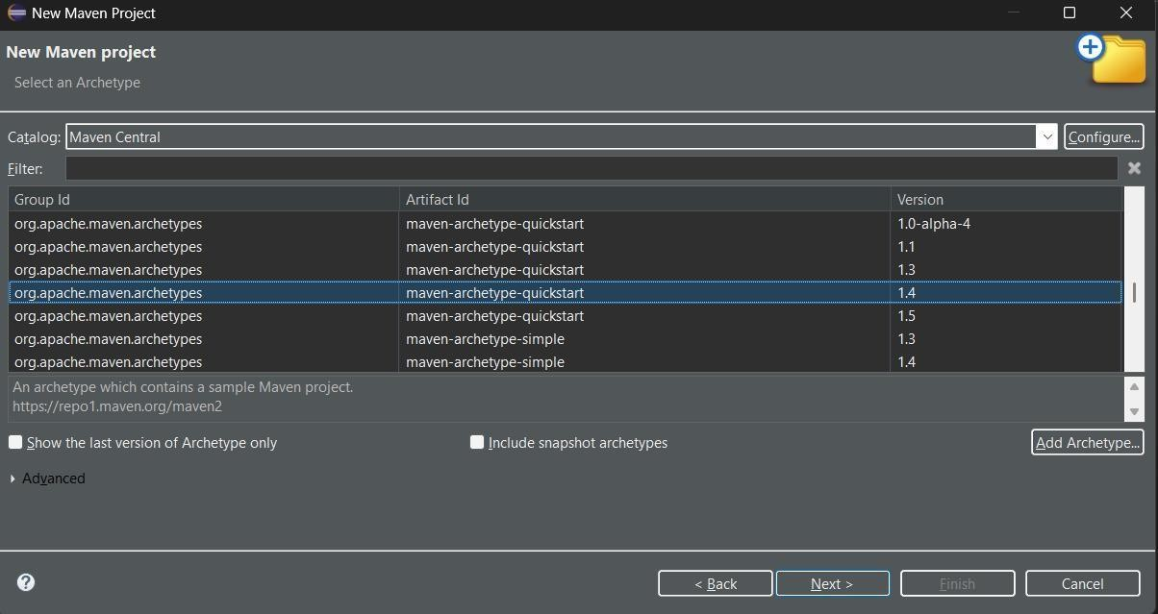

Saving the Group Id and Artifact Id :

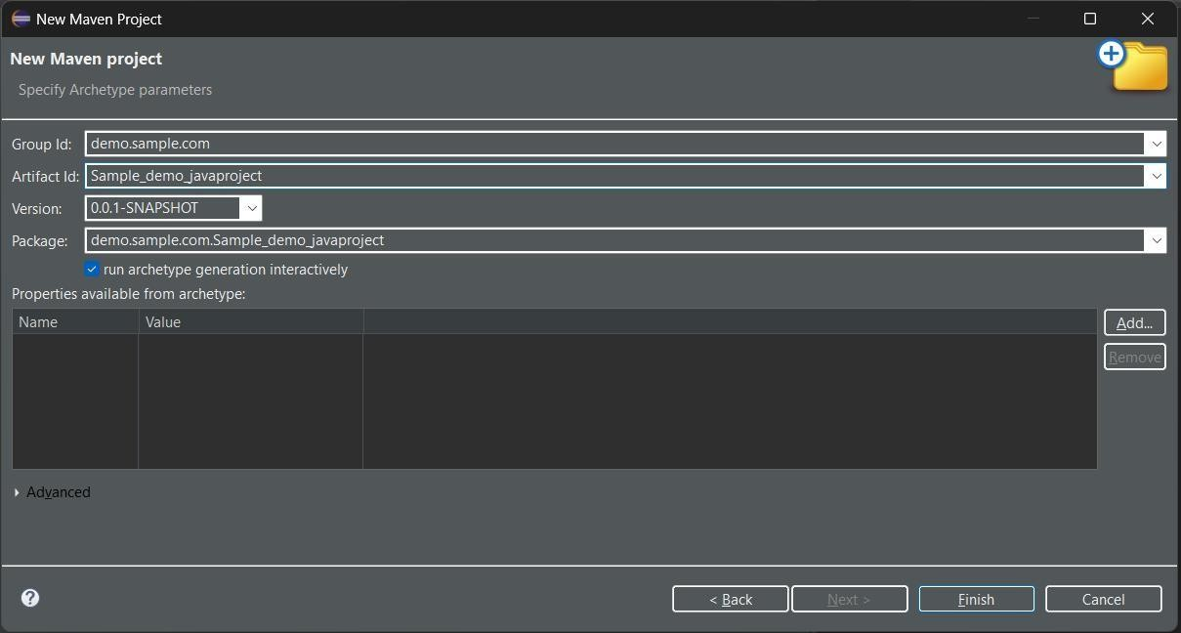

New project successful

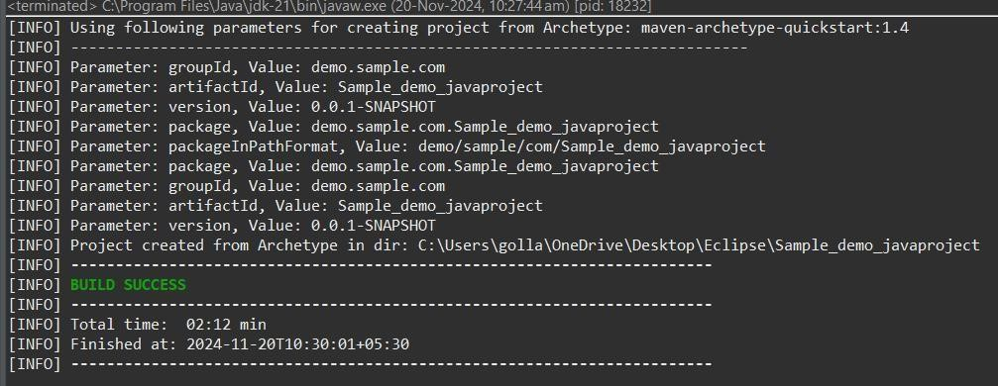

Maven clean

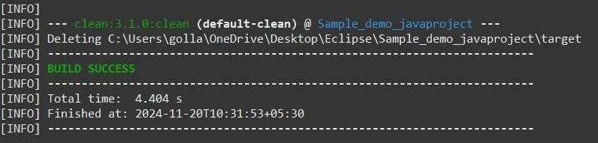

Maven install

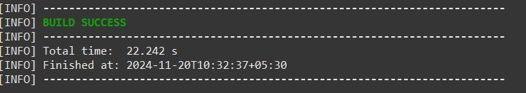

Maven test

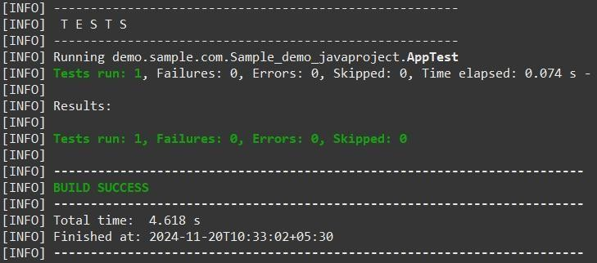

Maven build

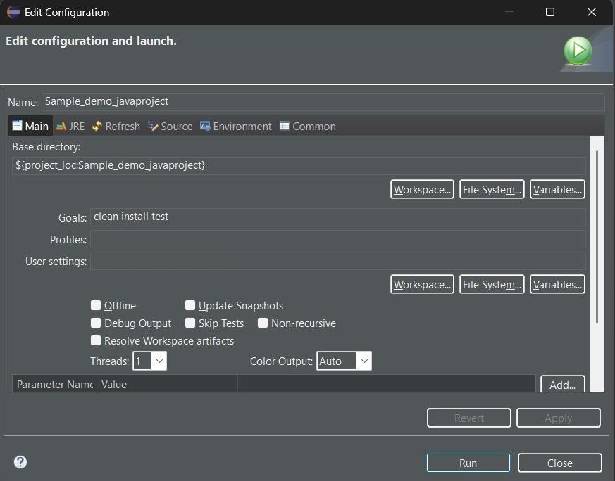

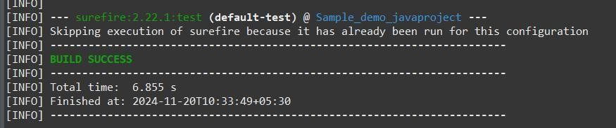

Final output:

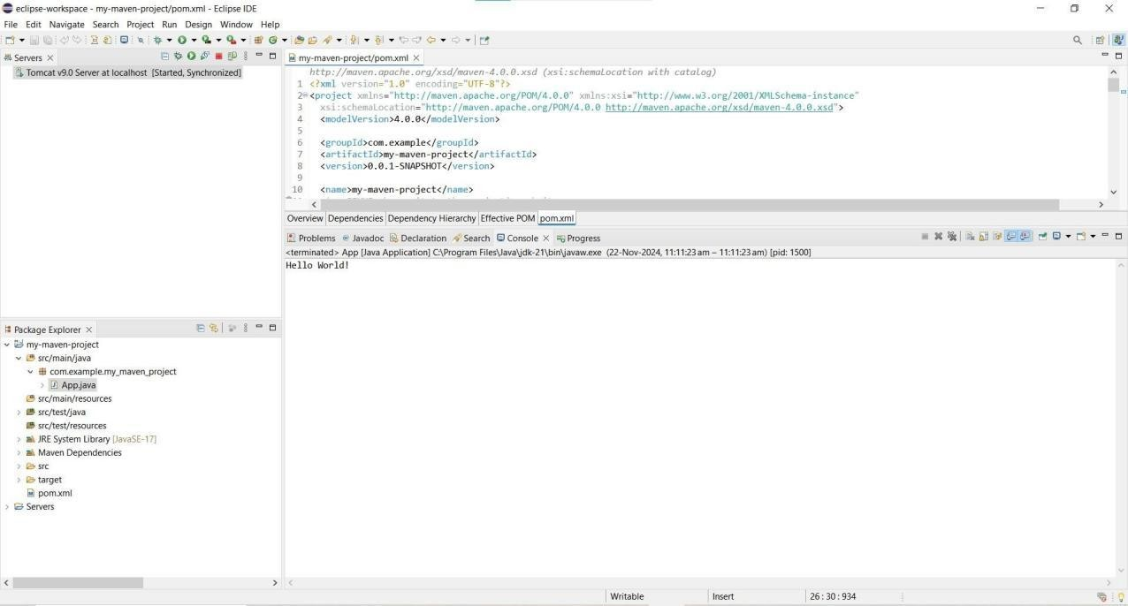

Pushing into git:

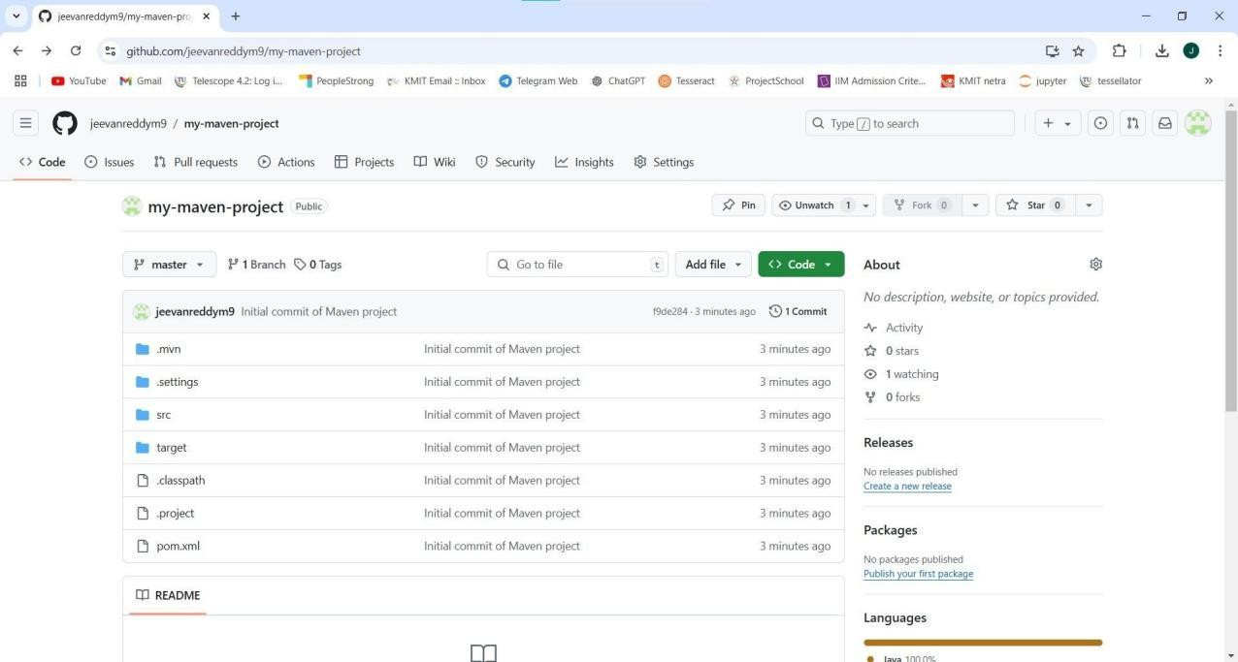

**Creation of Maven Web Java Project**

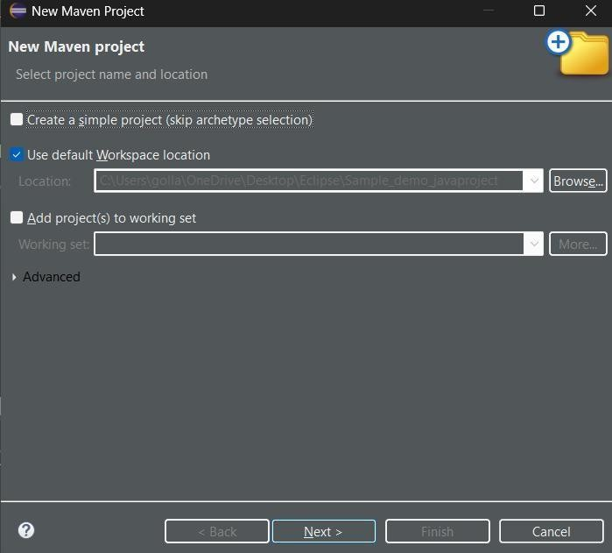

Choosing the archetype :

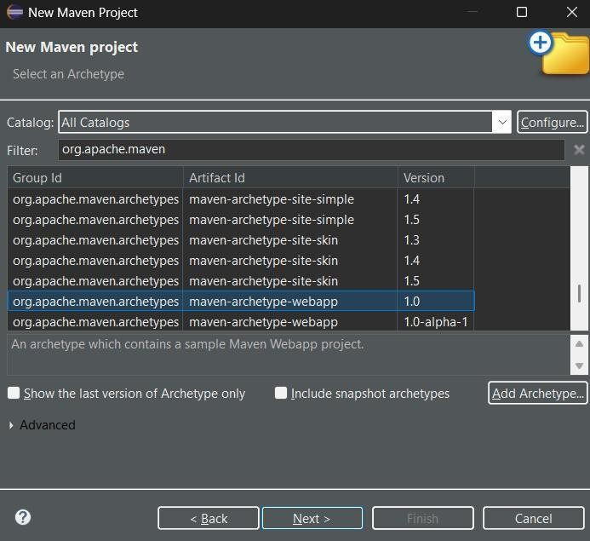

ix

Saving the group Id and artifact Id :

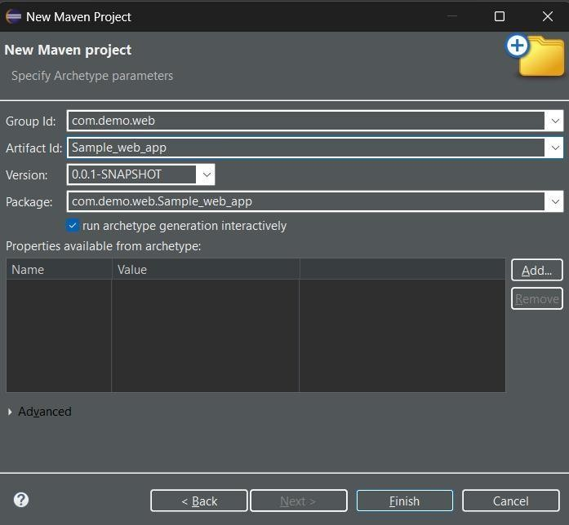

Build successful :

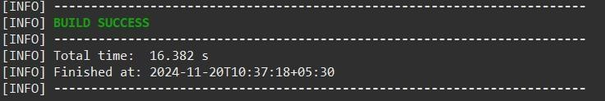

Maven clean :

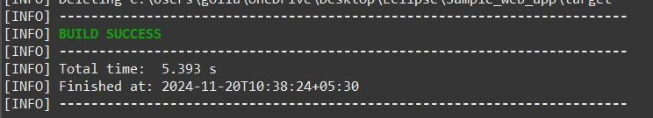

Maven install :

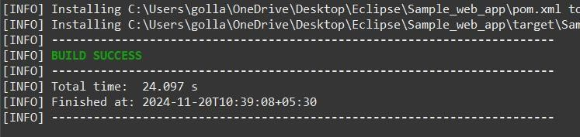

Maven test: ix

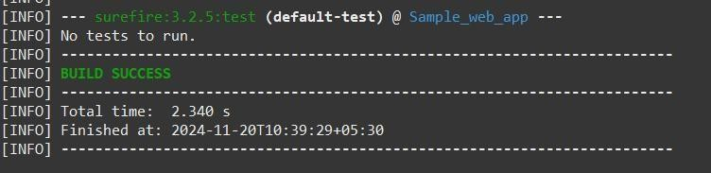

Maven build :

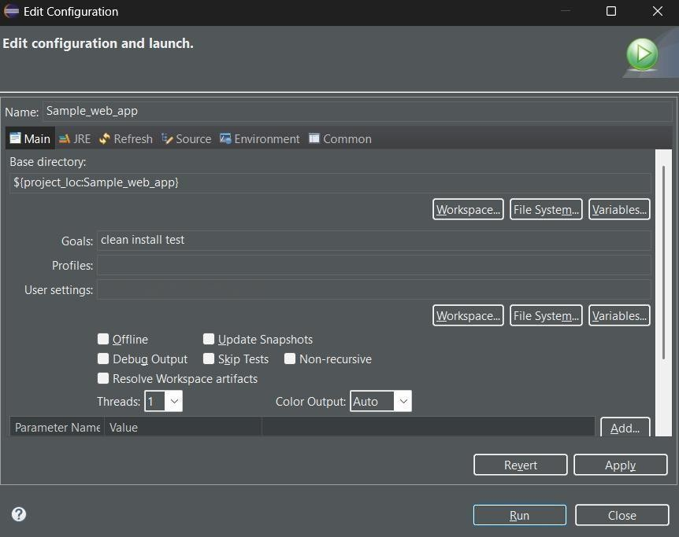

Build Successful :

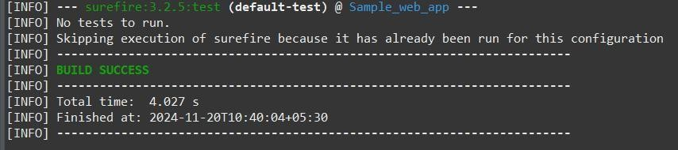

ix

Run on tomcat server :

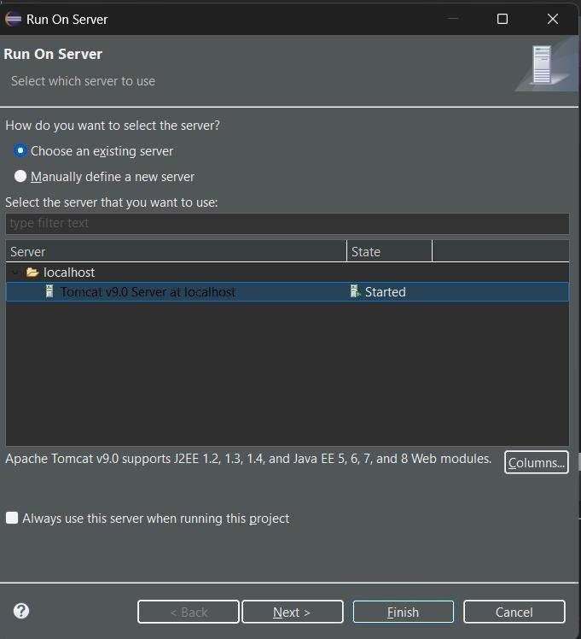

Final output:

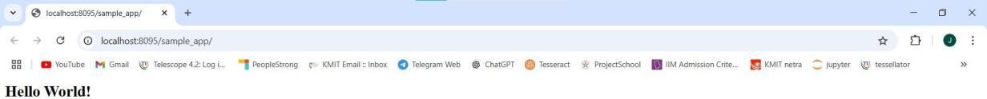

ix

Pushing into git:

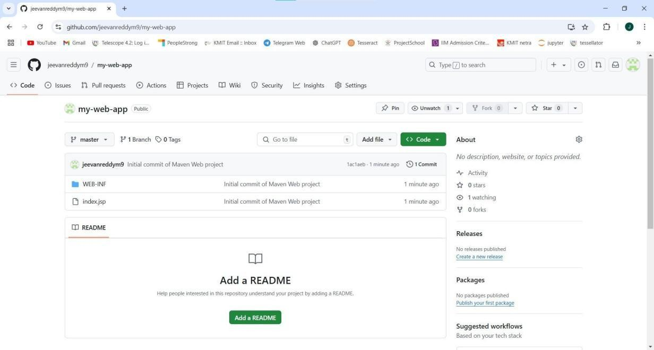

**EXPERIMENT - 6**

**Week7: Jenkins Automation**

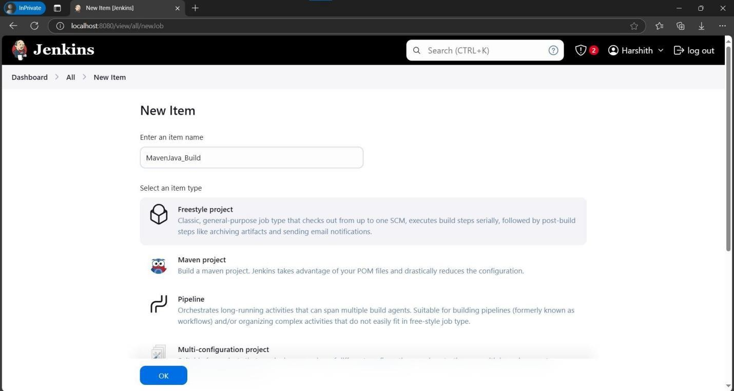

Step 3: In description type e.g., Java Build demo, Scroll sown and in Source code management give the Git MavenJava repository URL of the project to be built.

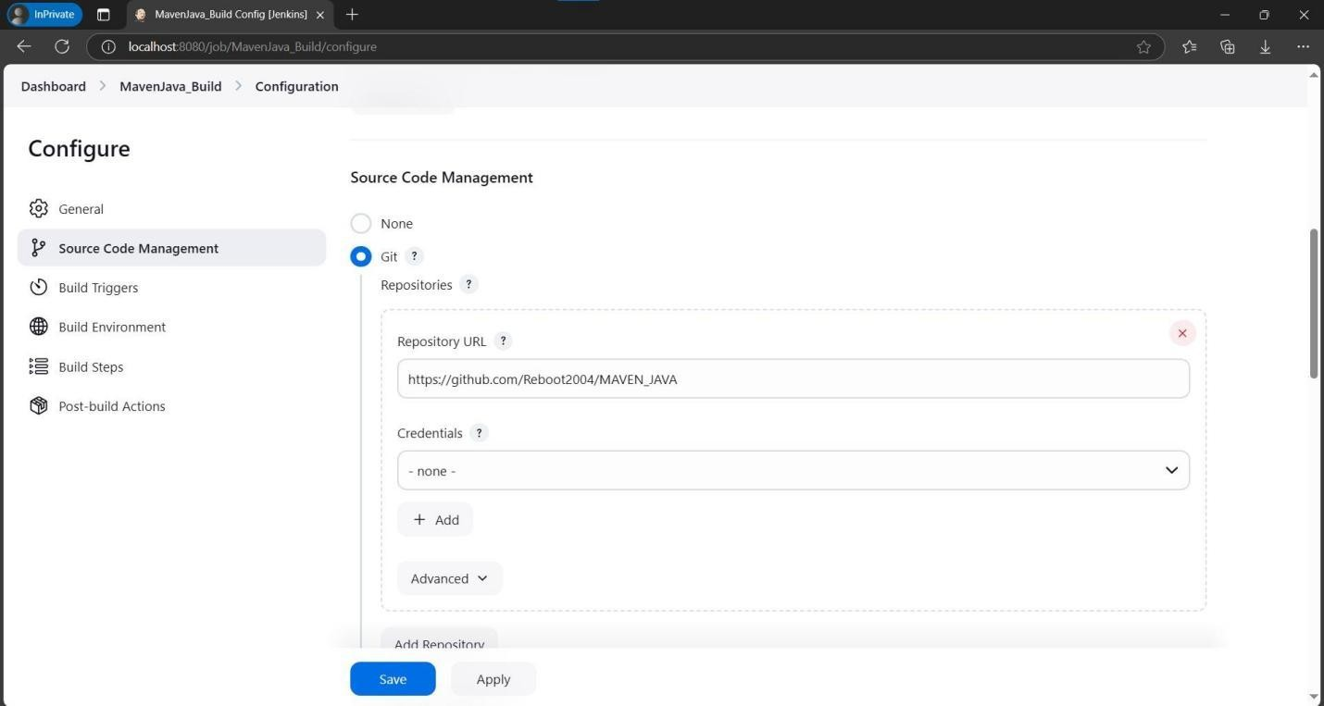

Step 4: Scroll down in Branches to build, Specify the Branch as */Main as it is in the GitHub

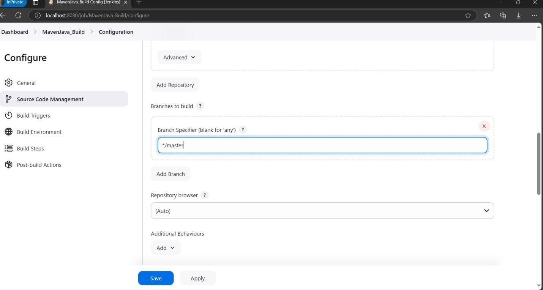

Step 5: Goto Build Steps -> Add Build Step-> Invoke top-level Maven targets, Type MAVEN_HOME in Maven version, Goals: Clean.

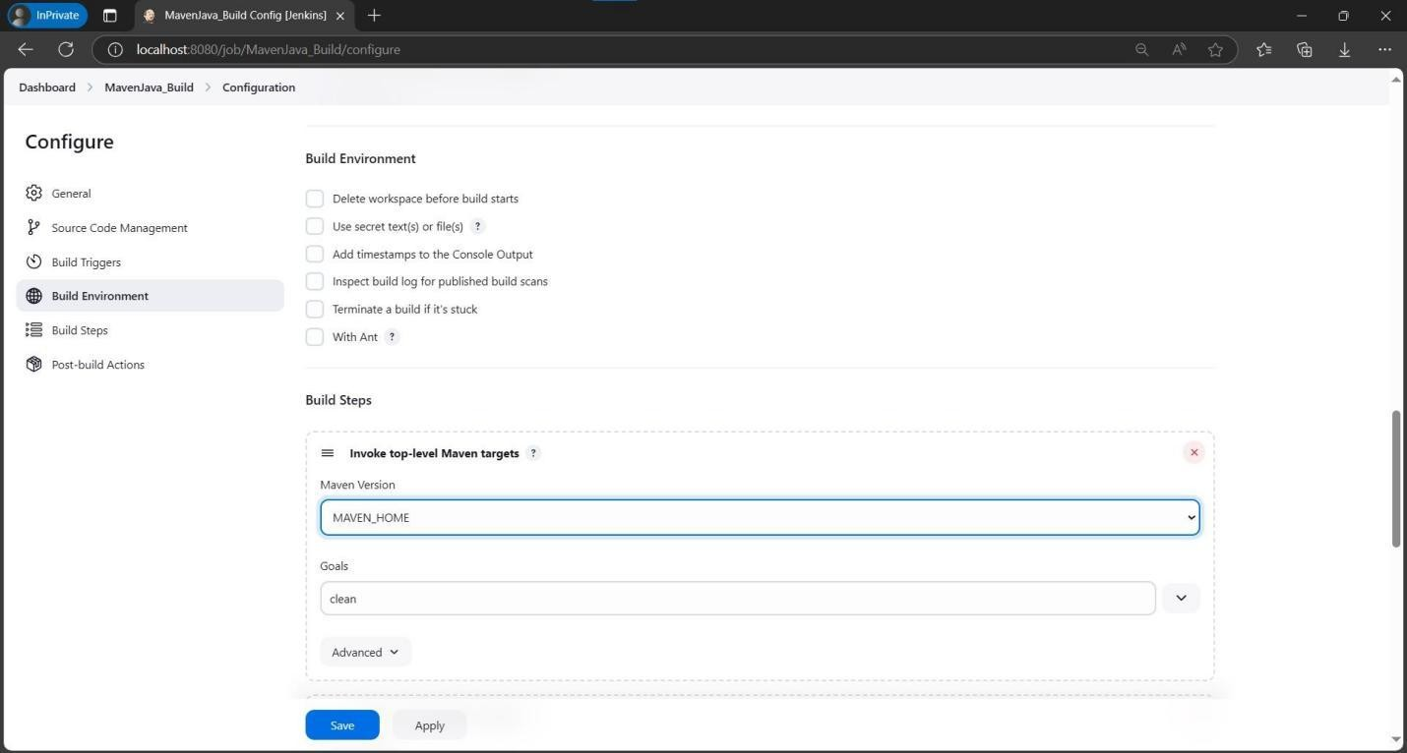

Step 6: Again, click Add Build Step-> Invoke top-level Maven targets-> Type MAVEN_HOME in Maven version, Goals: install.

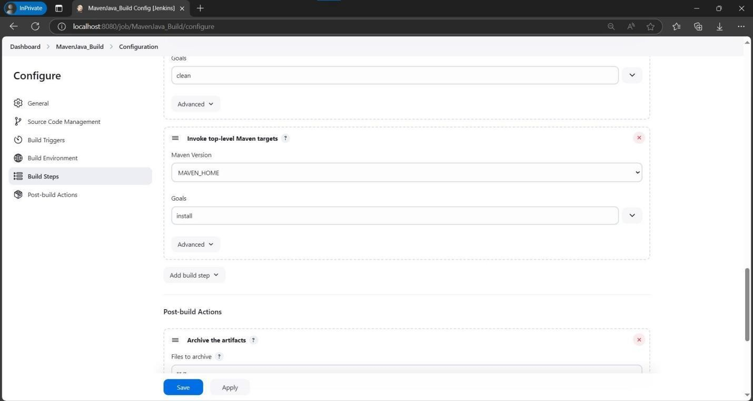

Step 7: Click add post build actions-> select Archive the artifacts, Type **/* in Files to Archive.

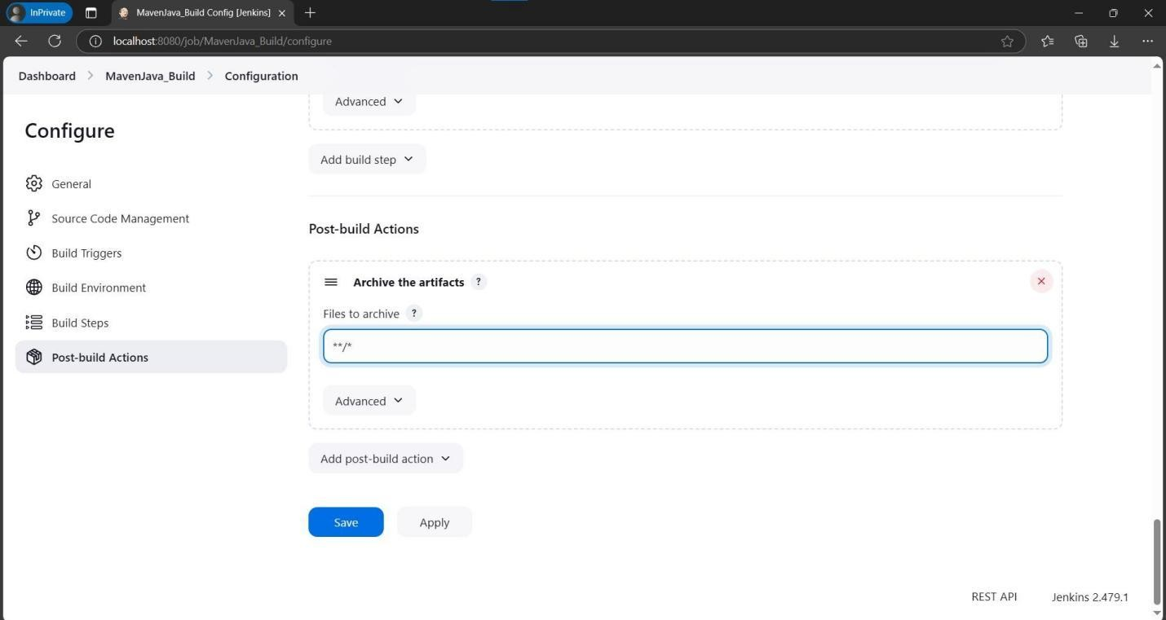

Step 8: Now click Add Post Build Action-> Build other projects**.** In Projects to build, write MavenJava_Test and select Trigger only if build is stable.

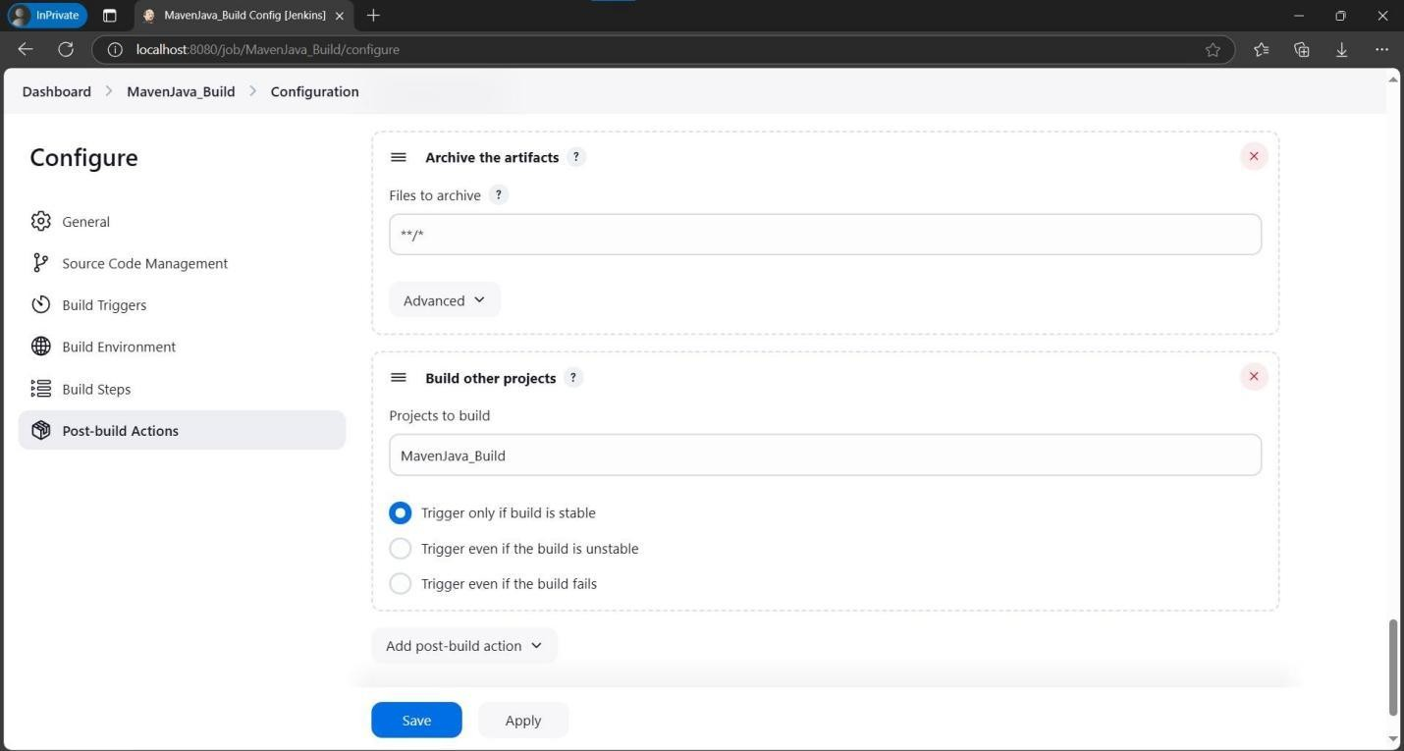

Step 9: Click on Apply and save.

Step 10: Go to dashboard -> New item-> Freestyle Project, give project name as

**MavenJava_Test**, then press on OK.

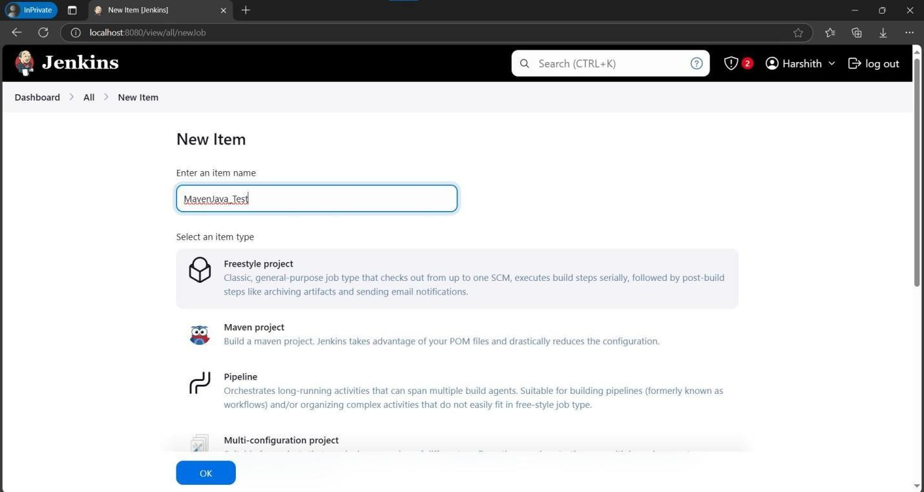

Step 11: In description type Test demo and in Build environment, check the box with name “Delete the workspace before build starts”.

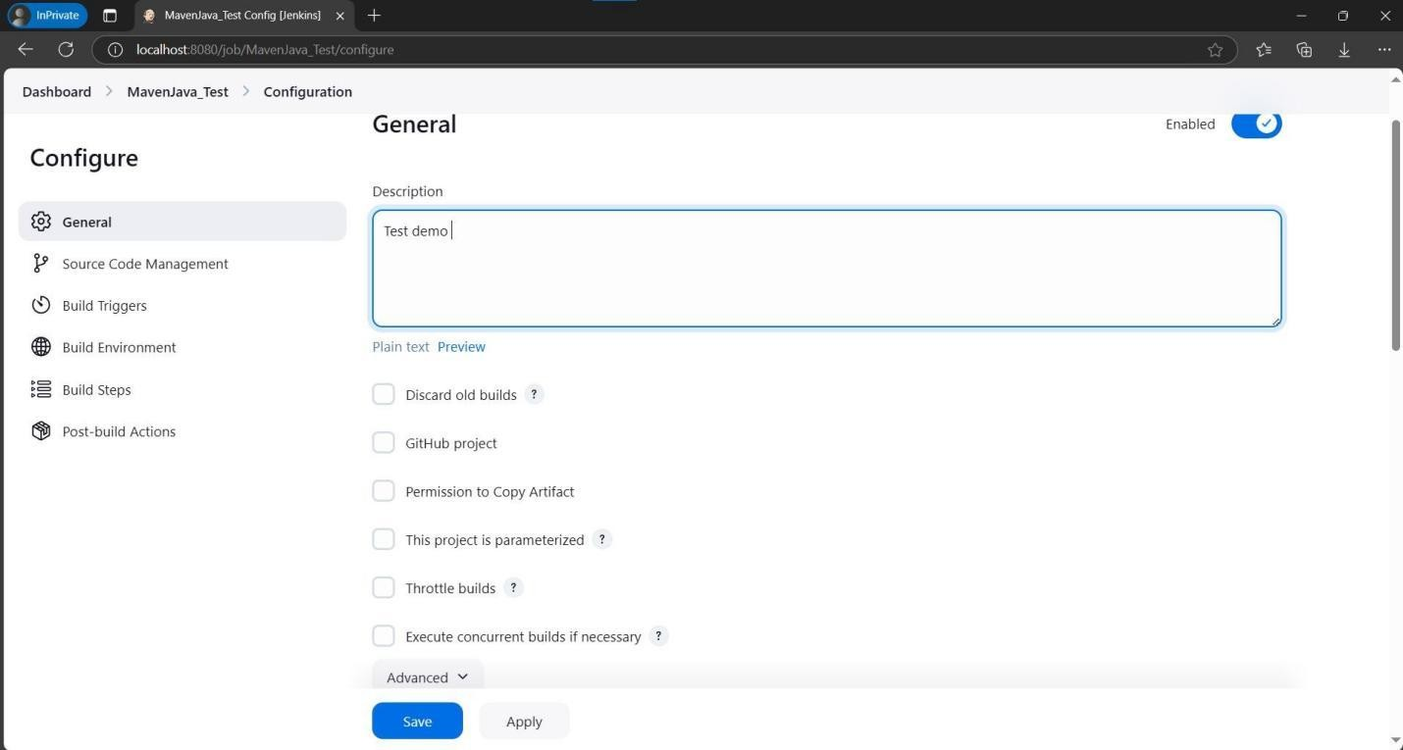

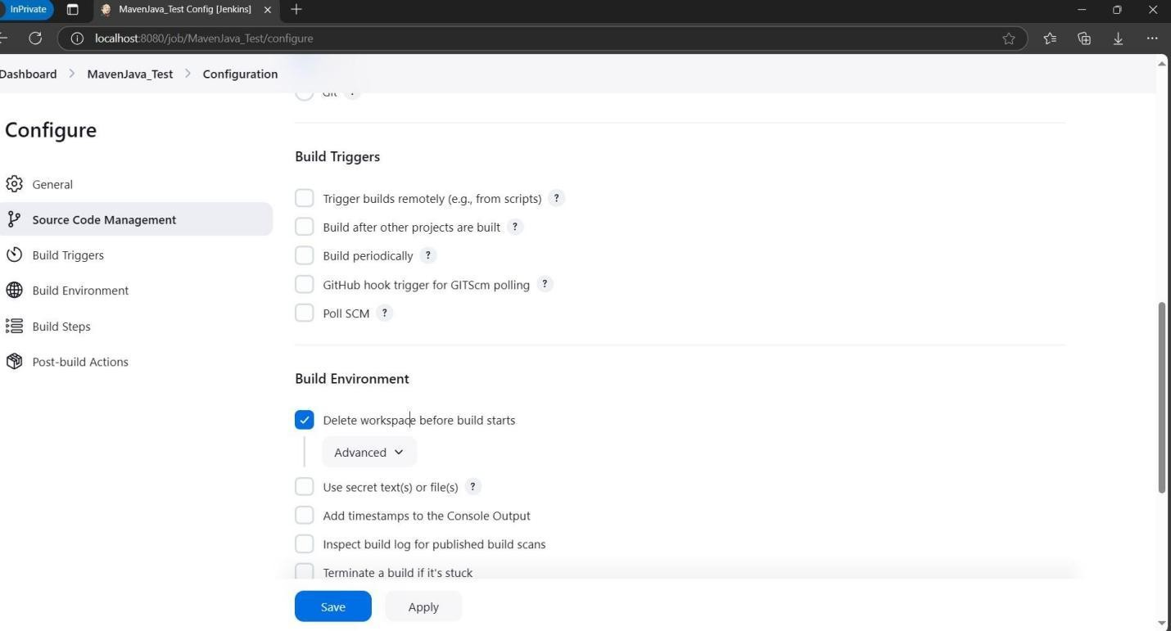

Step 12: Click on Add Build Step-> copy the artifacts from another project.

Step 13: Now Give project name: MavenJava_Build, Which build: Check the boxstable build only, Artifacts to copy: **/*.

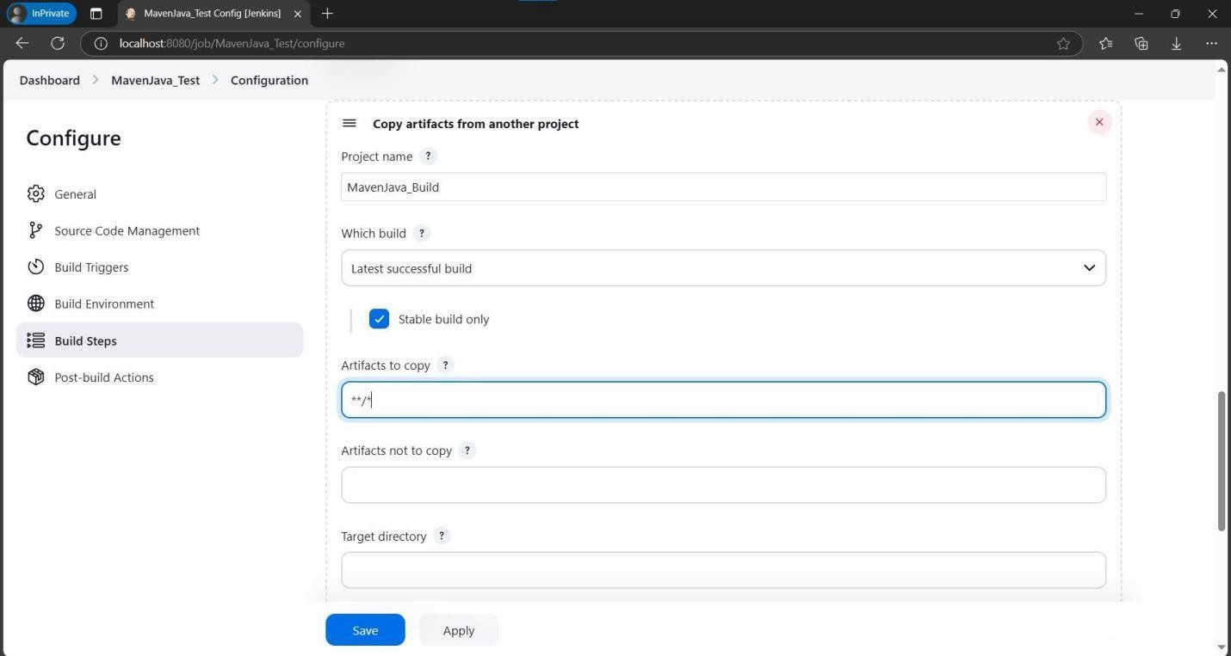

Step 14: Click Add Build Step-> Invoke top-level Maven targets-> Type MAVEN_HOME in Maven version, Goals: test.

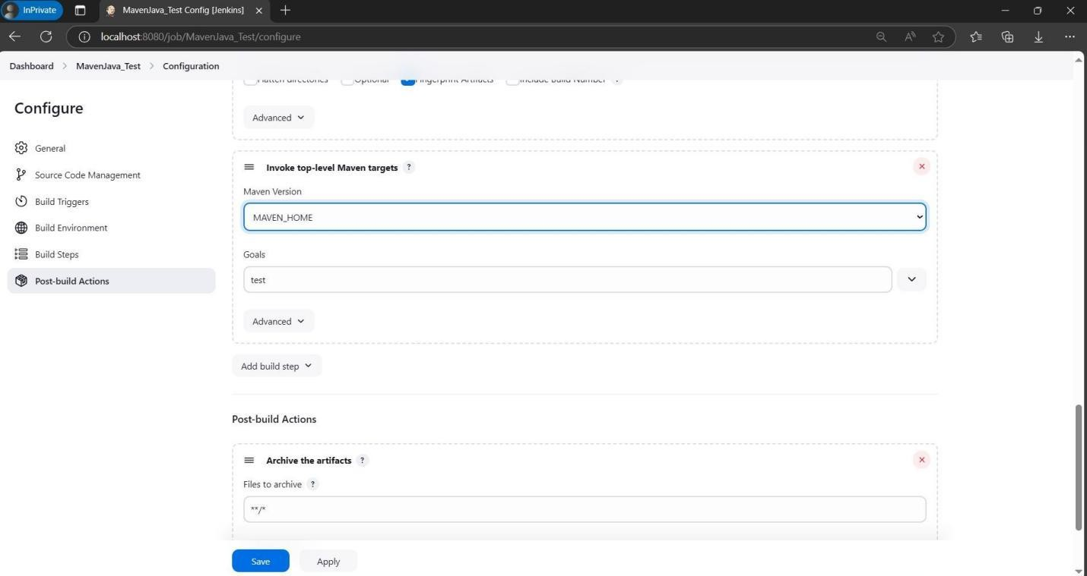

Step 15: Click on Post build actions->Archive the artifacts, in Files to archive type **/*.

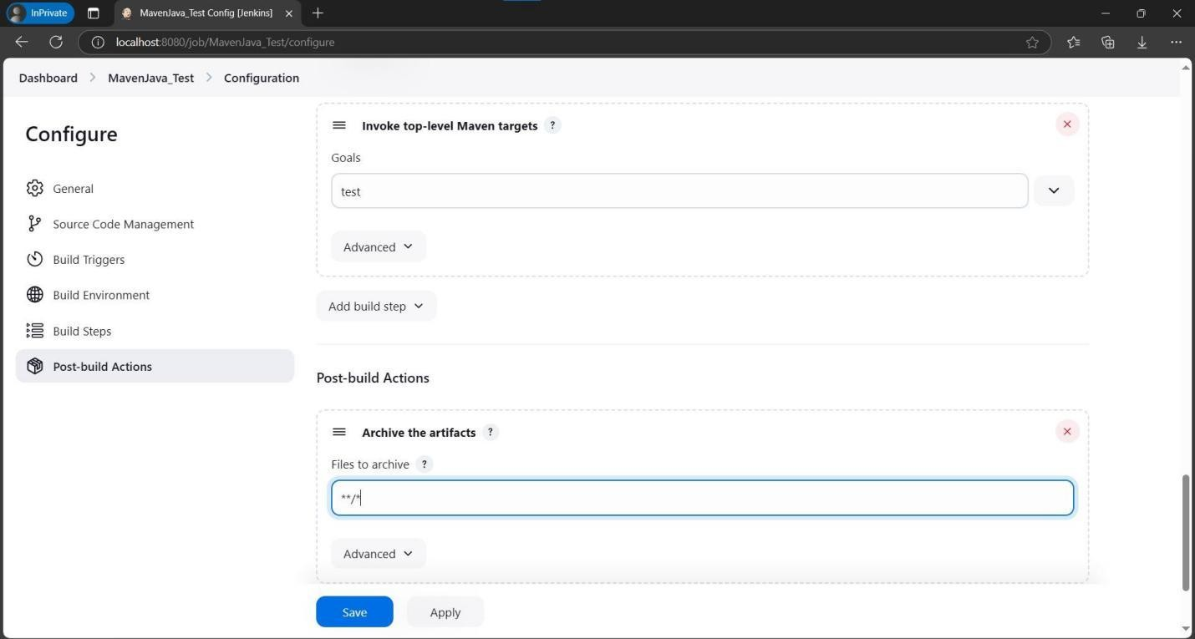

Step 16: Now click apply and save. Now run the project.

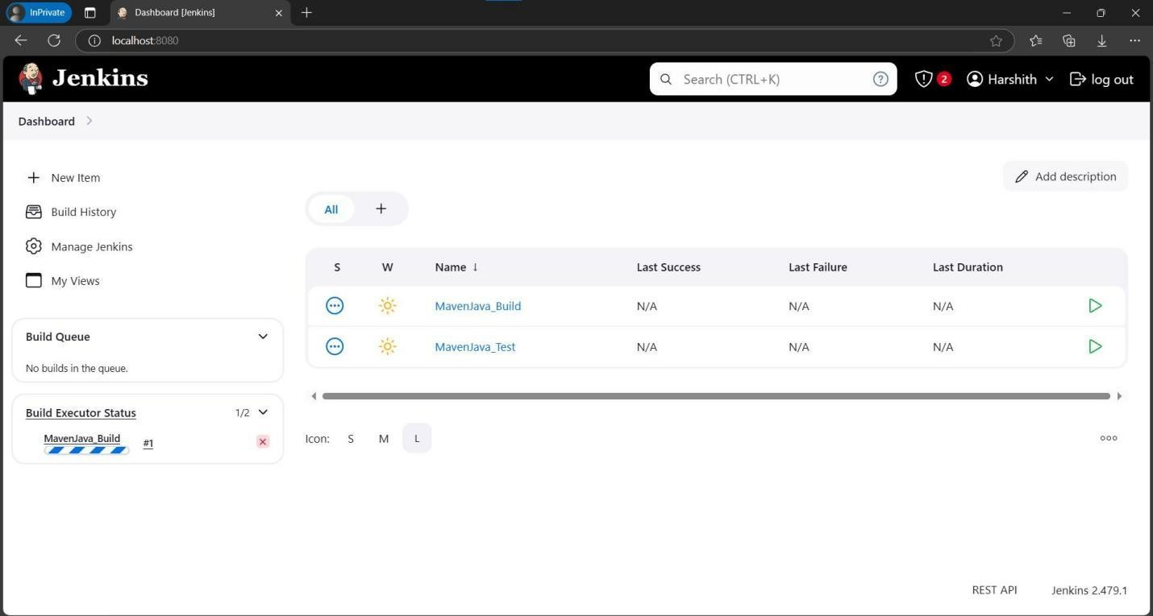

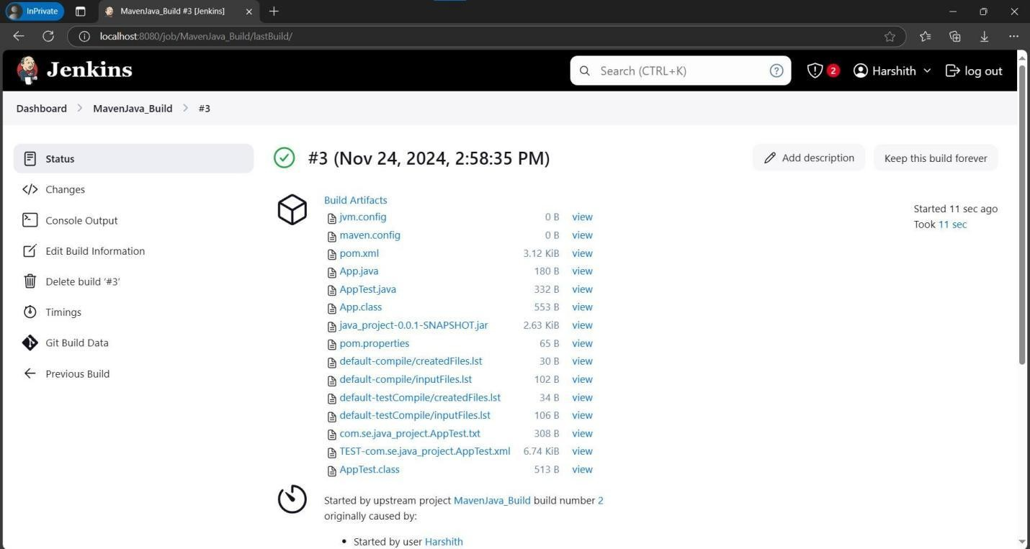

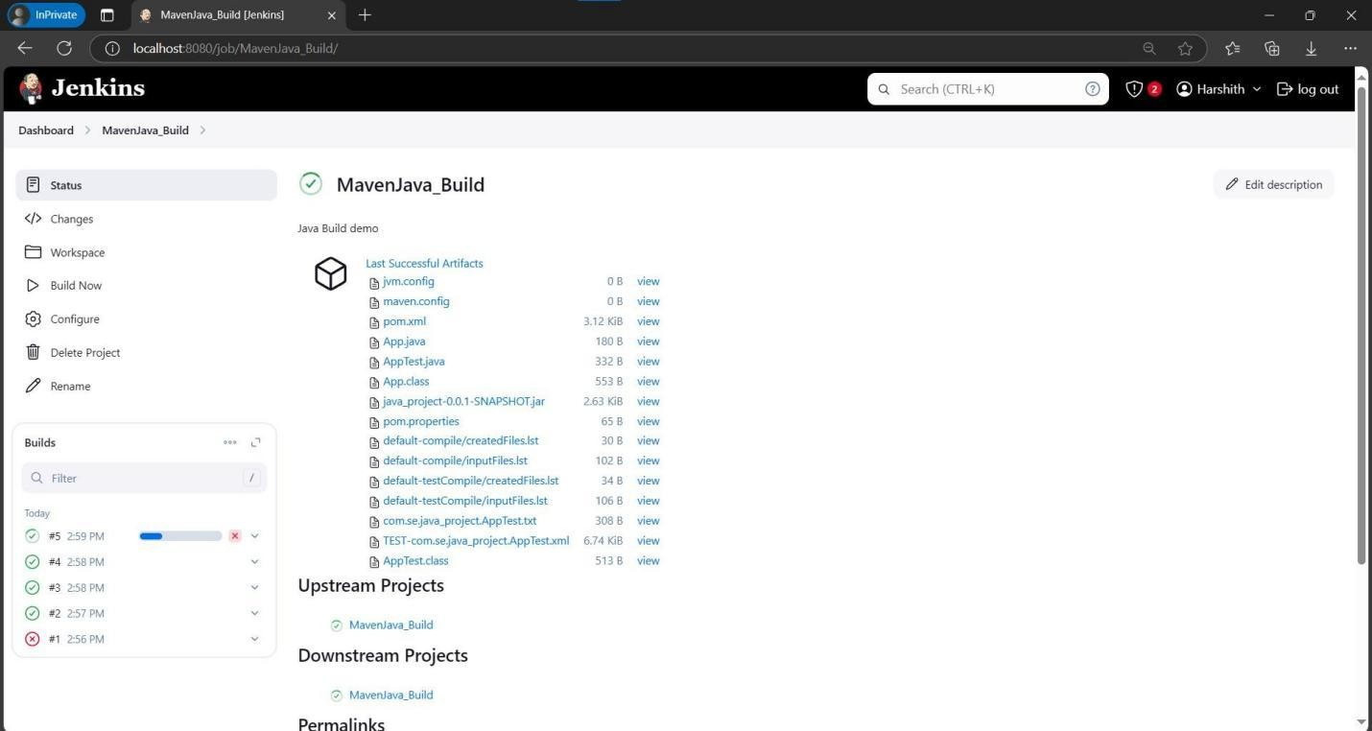

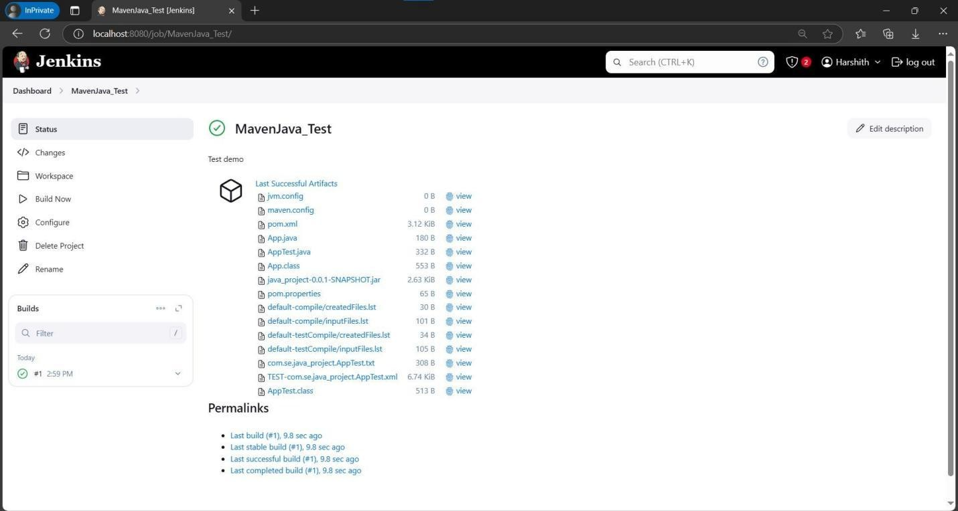

**Steps for Maven Web Automation:**

Step 1: Open Jenkins in local host: 8080/ and click on a new item present in the left side.

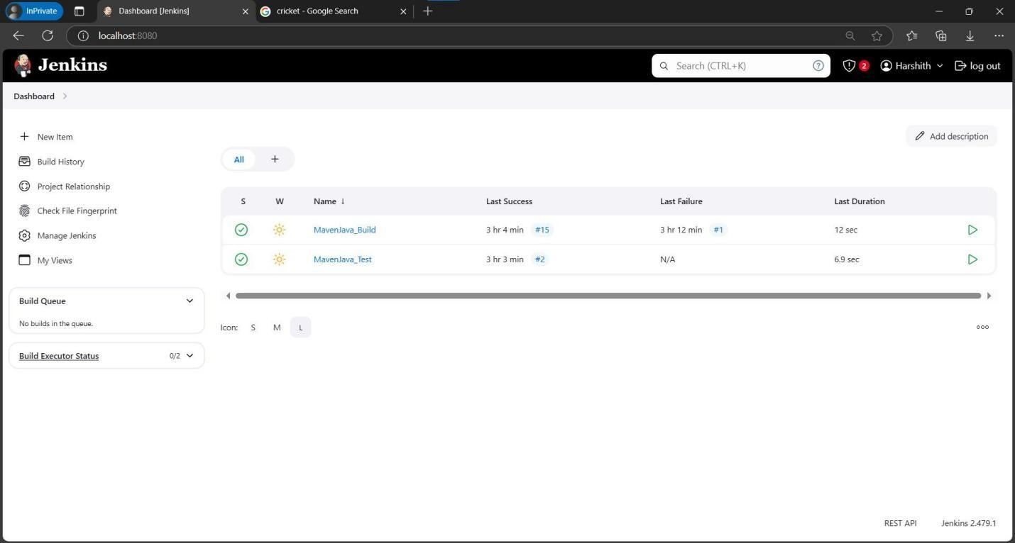

Step 2: Select a new Freestyle Project give name **MavenWeb_Build** and then click ok.

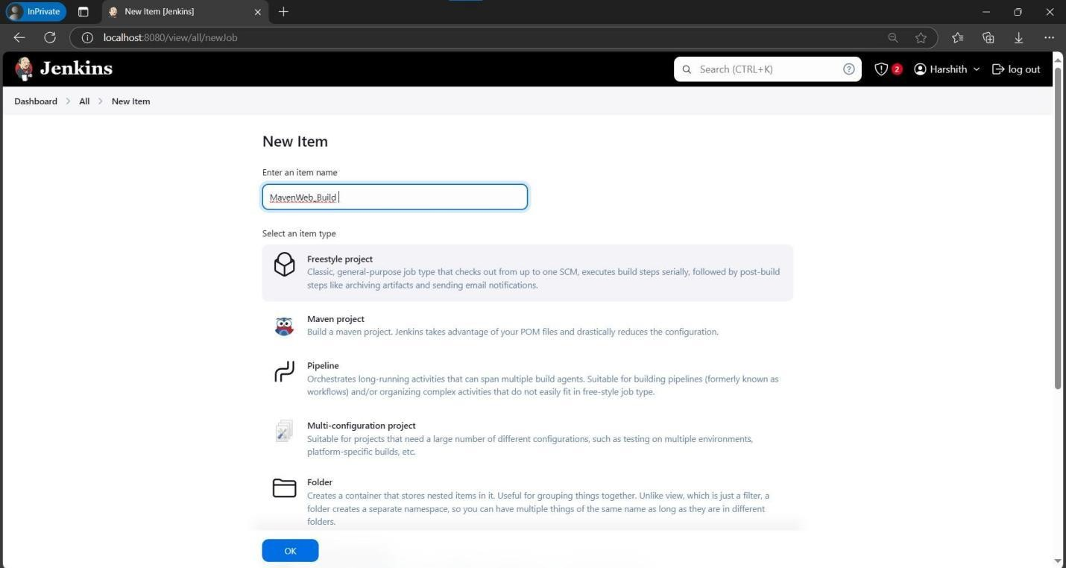

Step 3: In description type e.g., Web Build demo, Scroll sown and in Source code management give the Git MavenWeb repository URL of the project to be built.

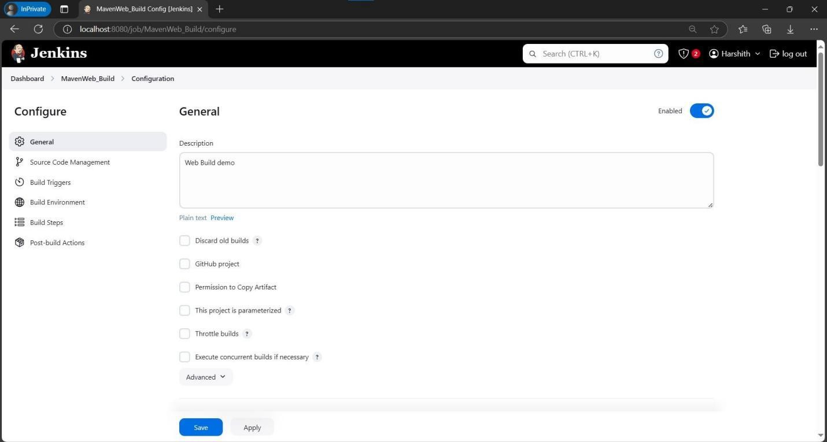

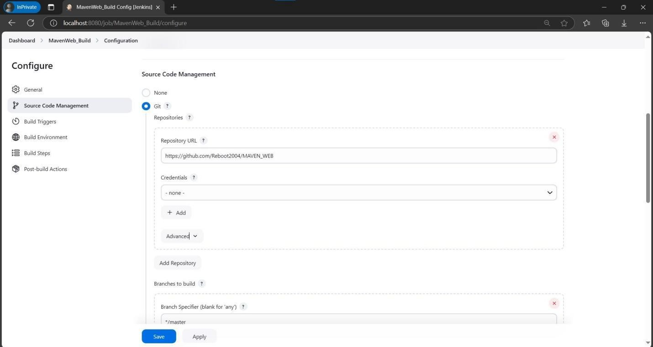

Step 4: Scroll down in Branches to build, Specify the Branch as */Main as it is in the GitHub

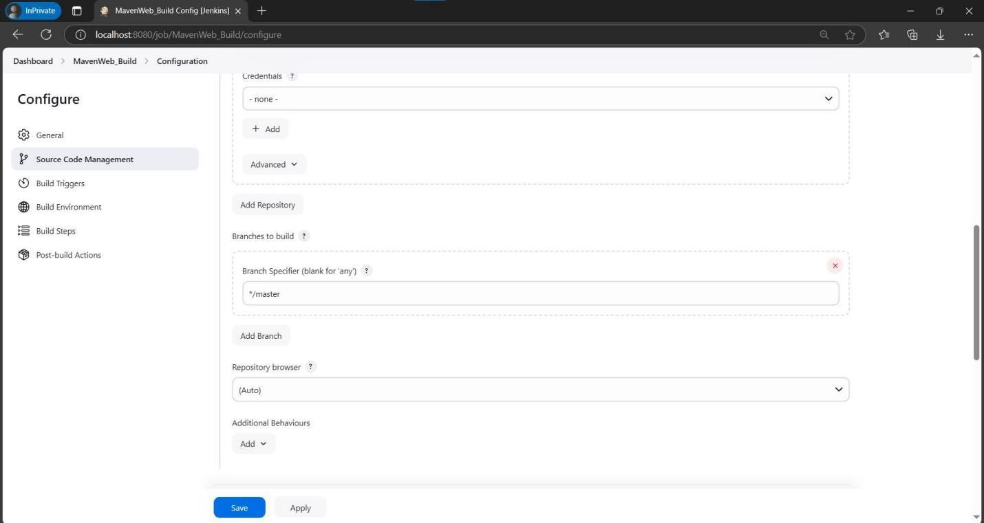

Step 5: Goto Build Steps -> Add Build Step-> Invoke top-level Maven targets, Type MAVEN_HOME in Maven version, Goals: Clean.

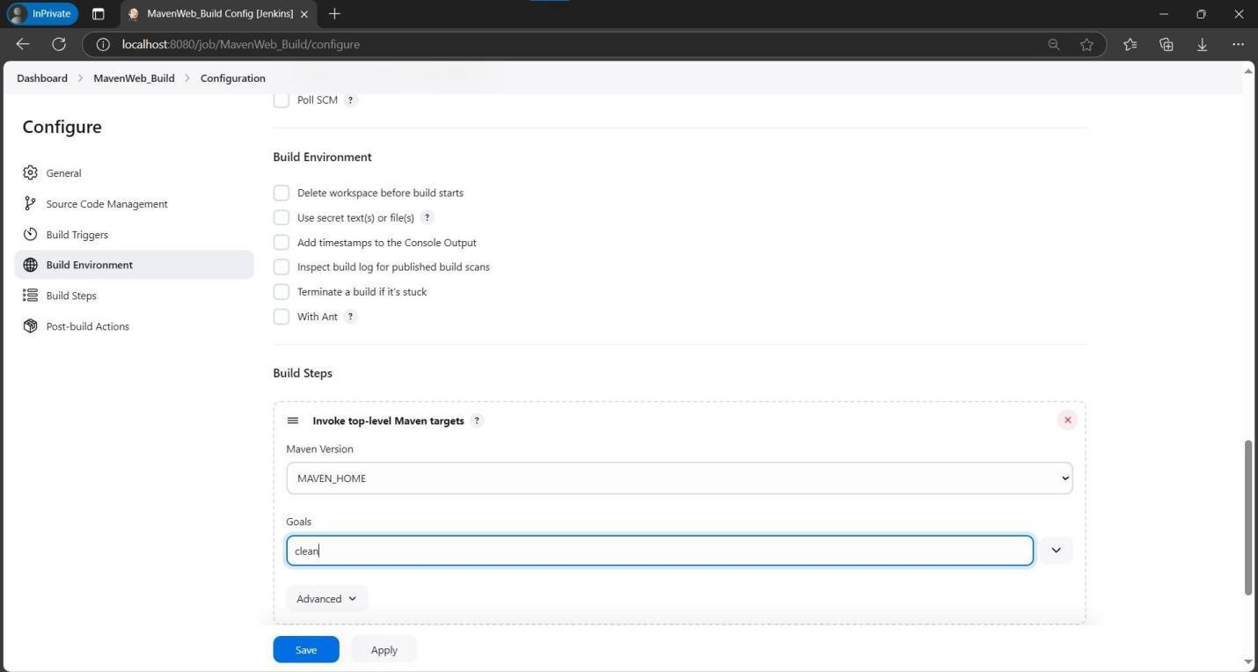

Step 6: Again, click Add Build Step-> Invoke top-level Maven targets-> Type MAVEN_HOME in Maven version, Goals: install.

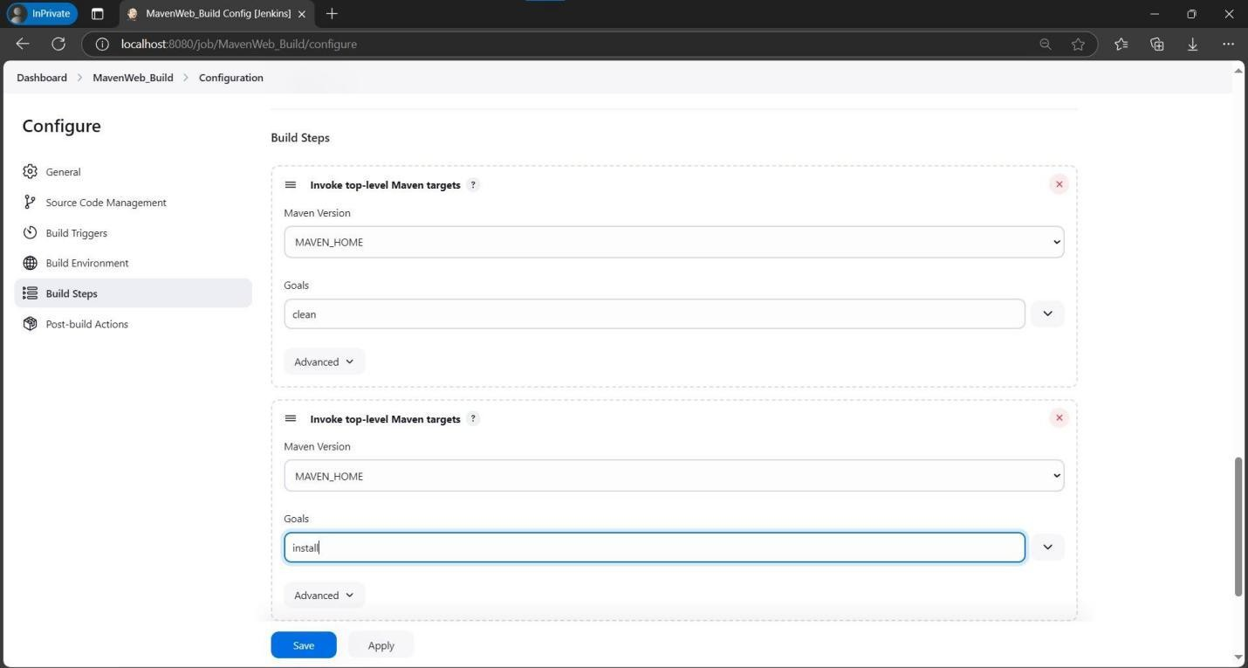

Step 7: Click add post build actions-> select Archive the artifacts, Type **/* in Files to Archive.

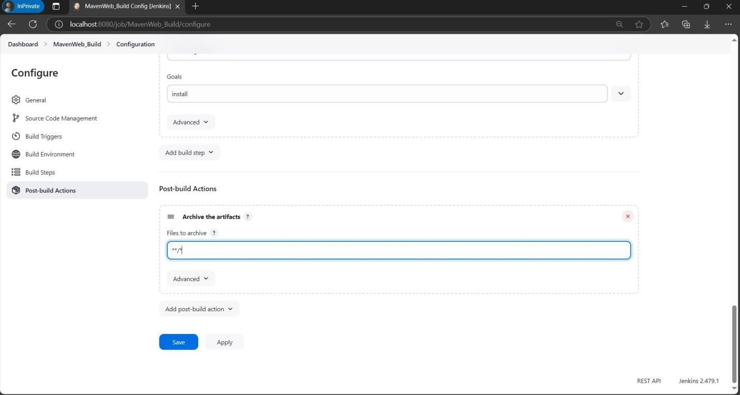

Step 8: Now click Add Post Build Action-> Build other projects**.** In Projects to build, write MavenWeb_Test and select Trigger only if build is stable. Click on apply and save at the bottom.

Step 9: Go to dashboard -> New item-> Freestyle Project, give project name as

**MavenWeb_Test**, then press on OK.

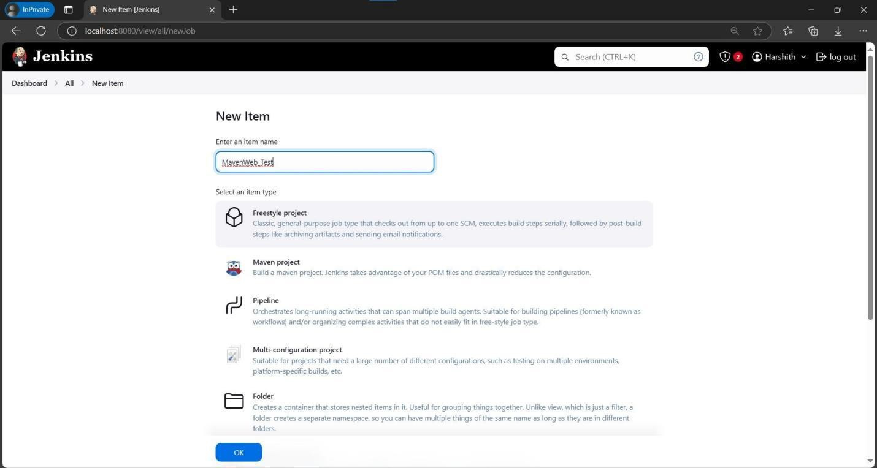

Step 10: In description type Test demo and in Build environment, check the box with name “Delete the workspace before build starts”.

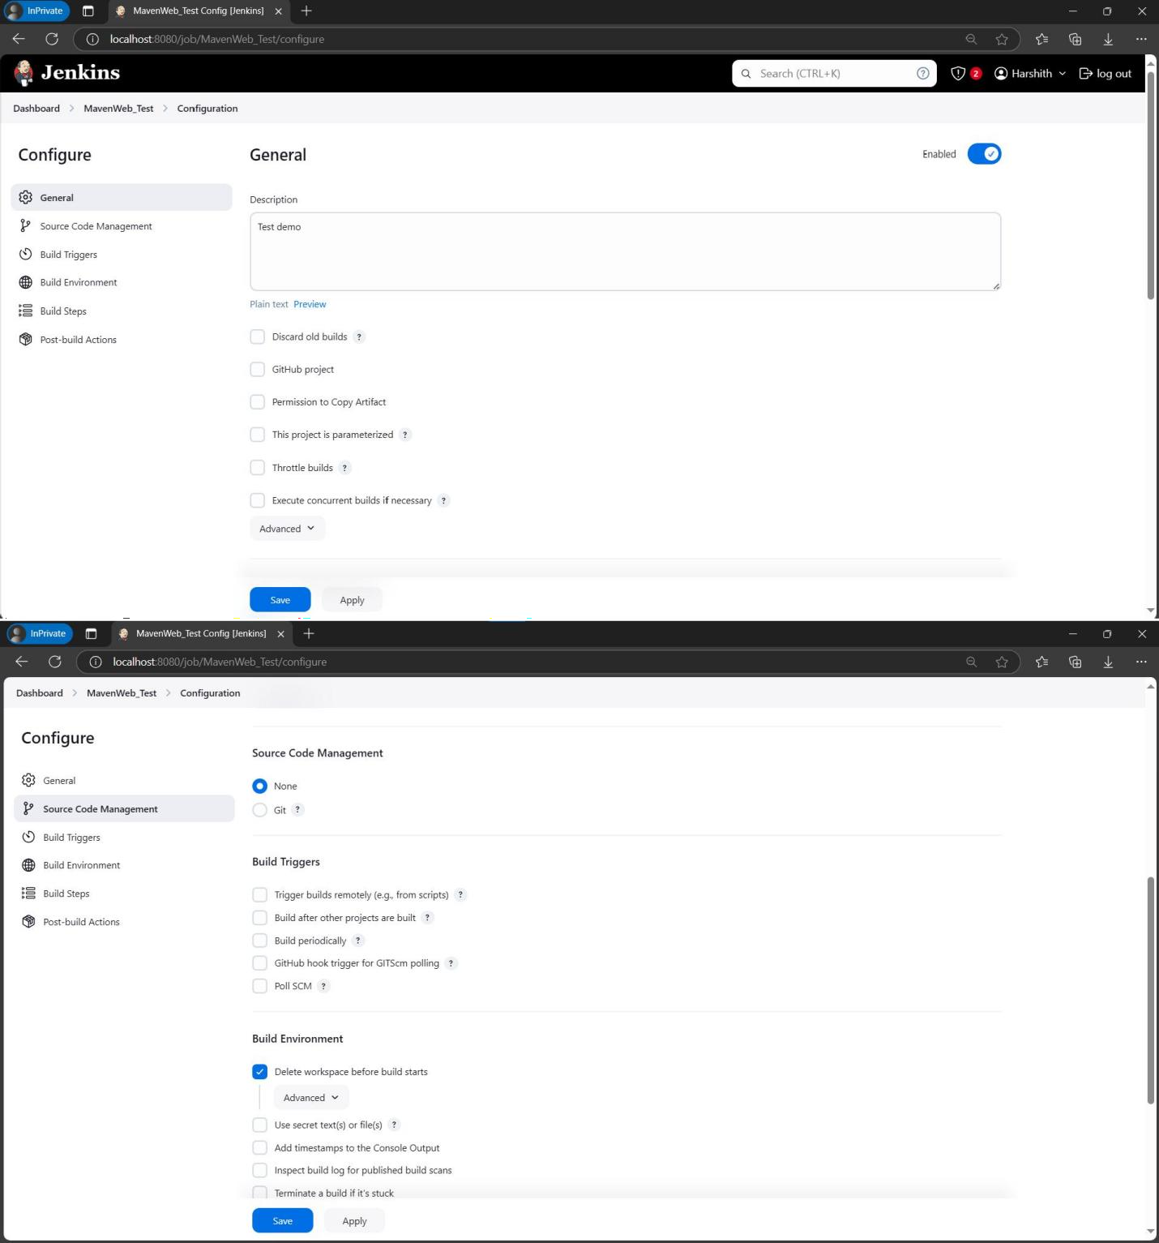

Step 11: Click on Add Build Step-> copy the artifacts from another project.

Step 12: Give project name: MavenWeb_Build, Which build: Check the box stable build only, Artifacts to copy: **/*.

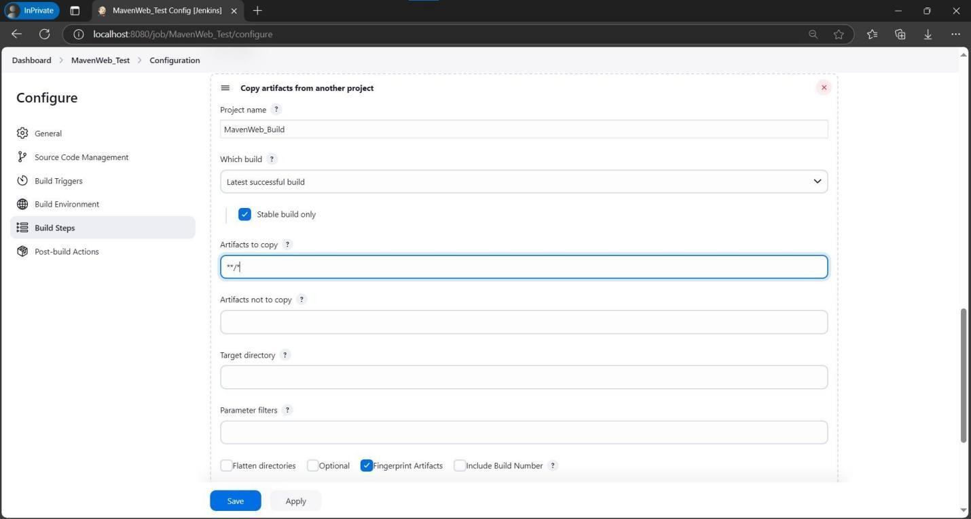

Step 13: Click Add Build Step-> Invoke top-level Maven targets-> Type MAVEN_HOME in Maven version, Goals: test.

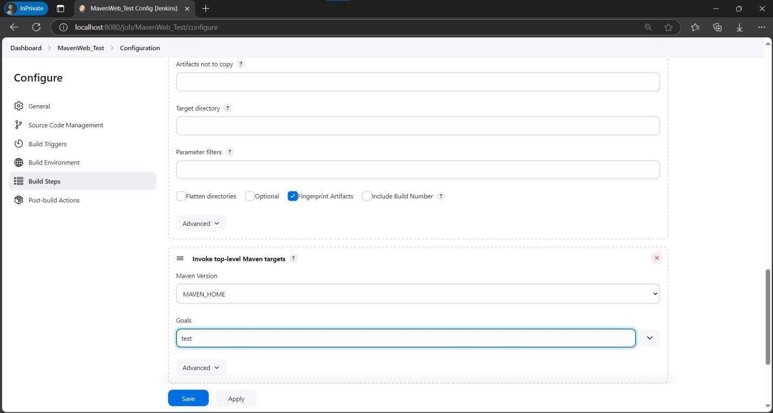

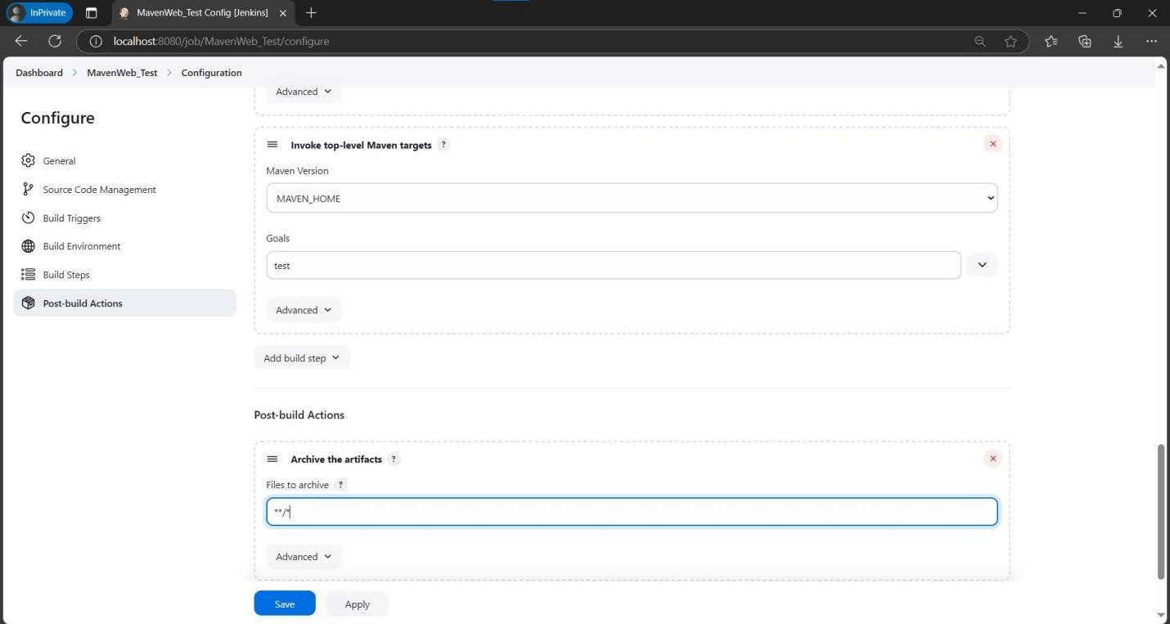

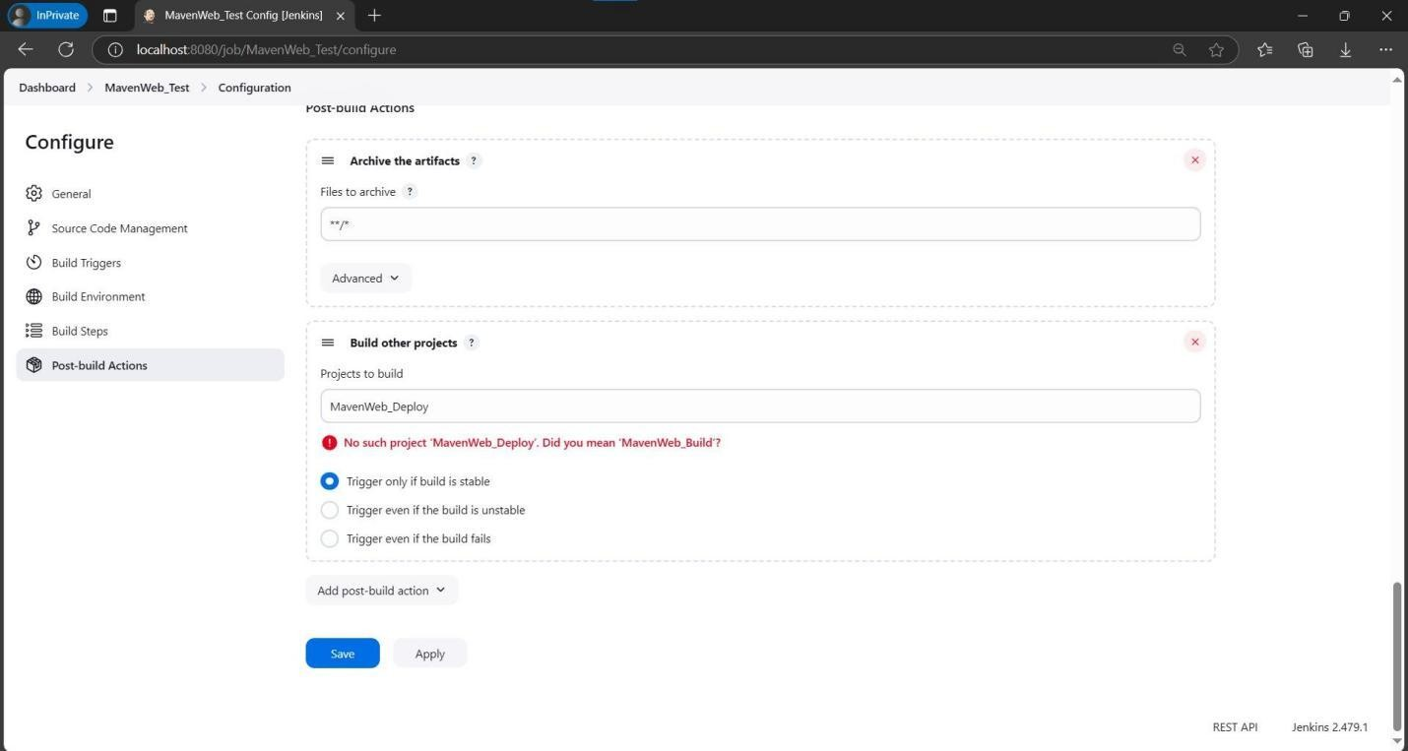

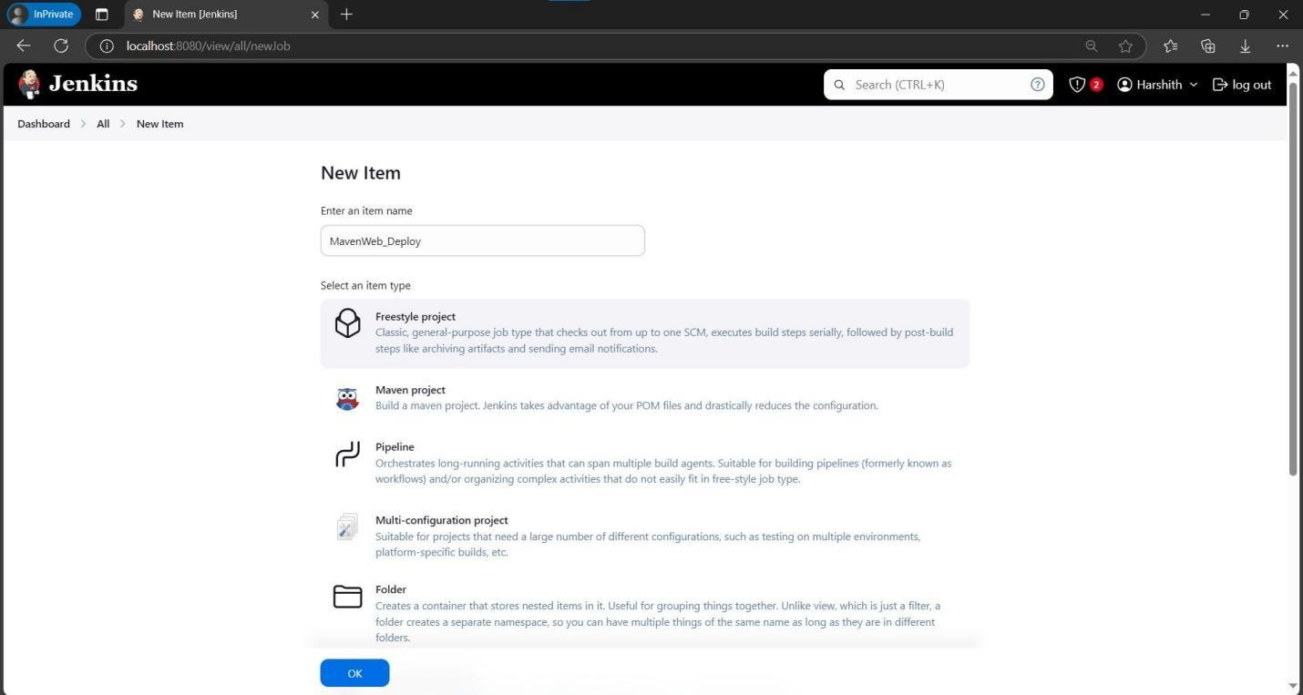

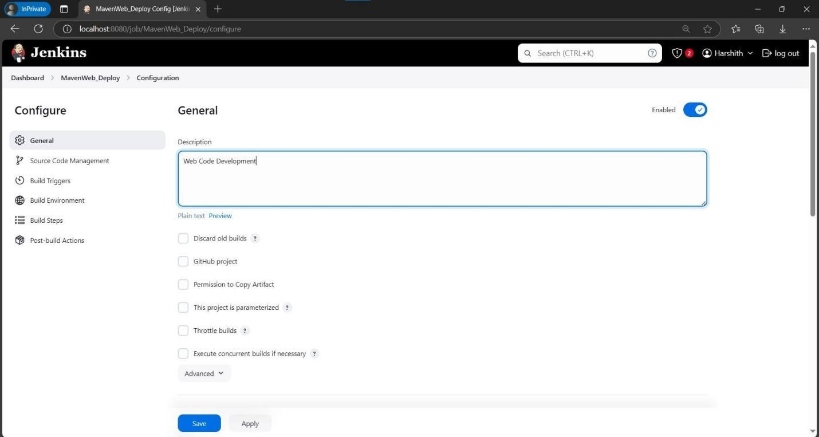

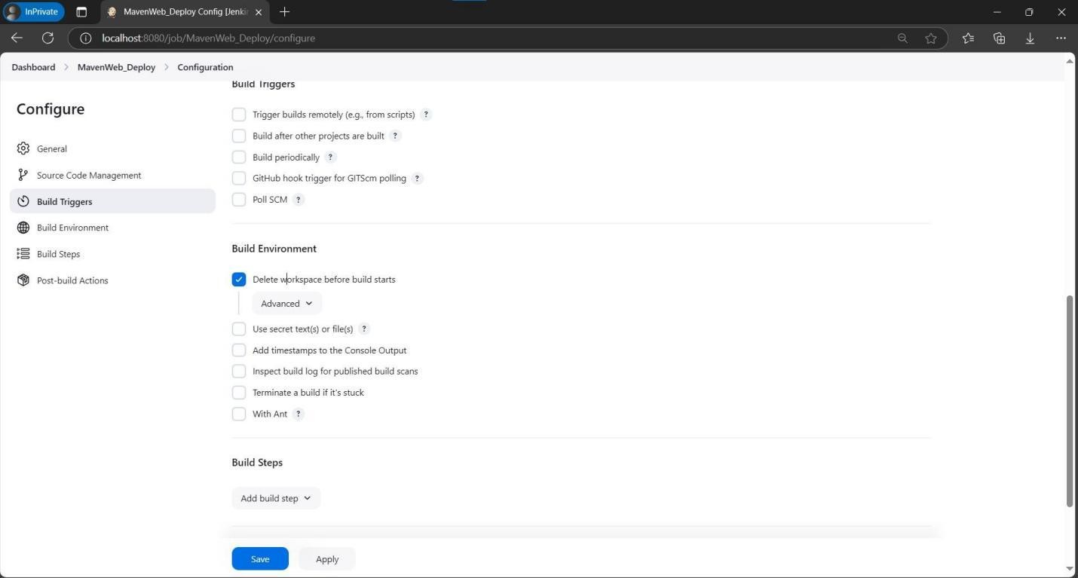

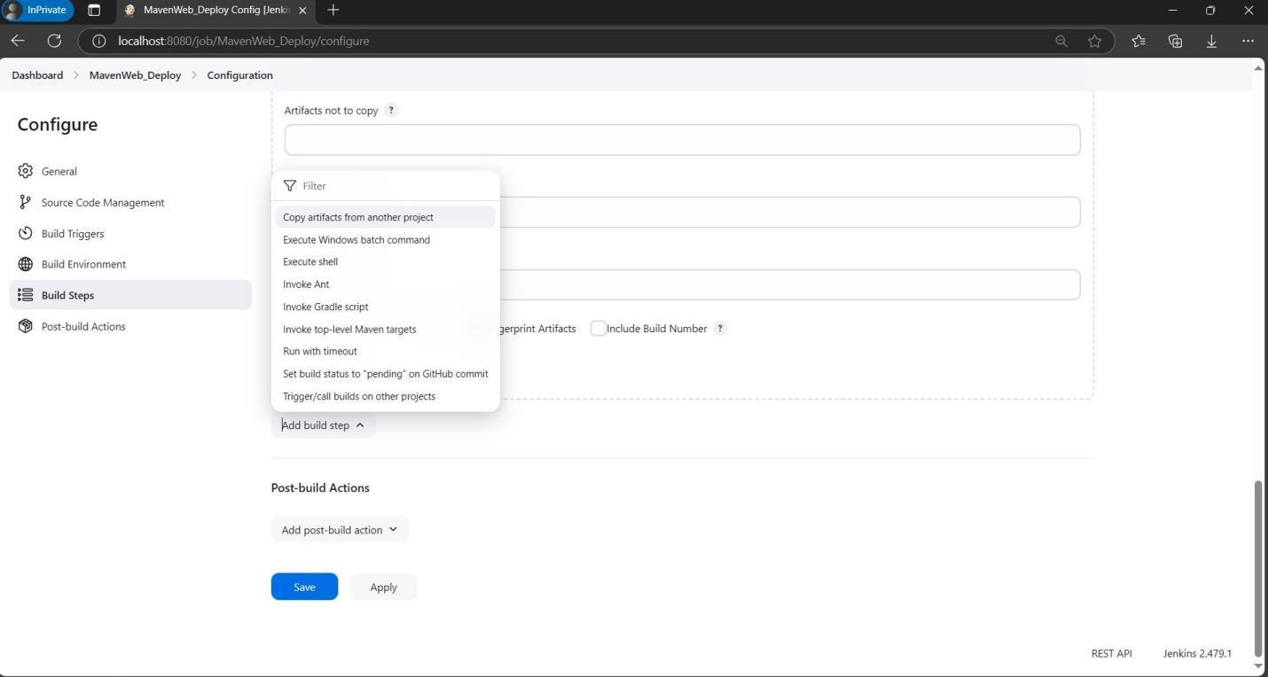

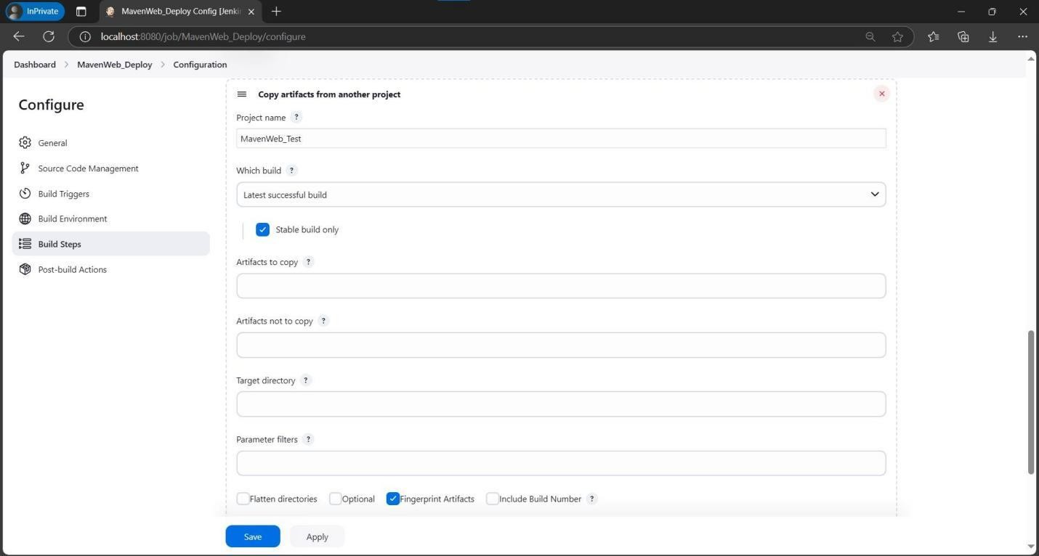

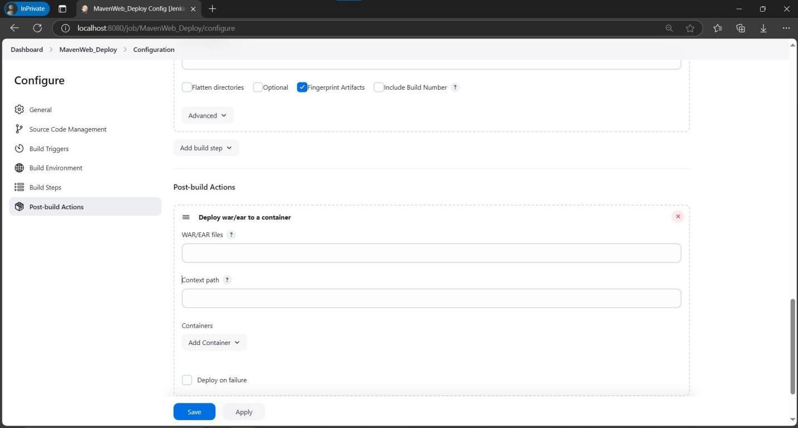

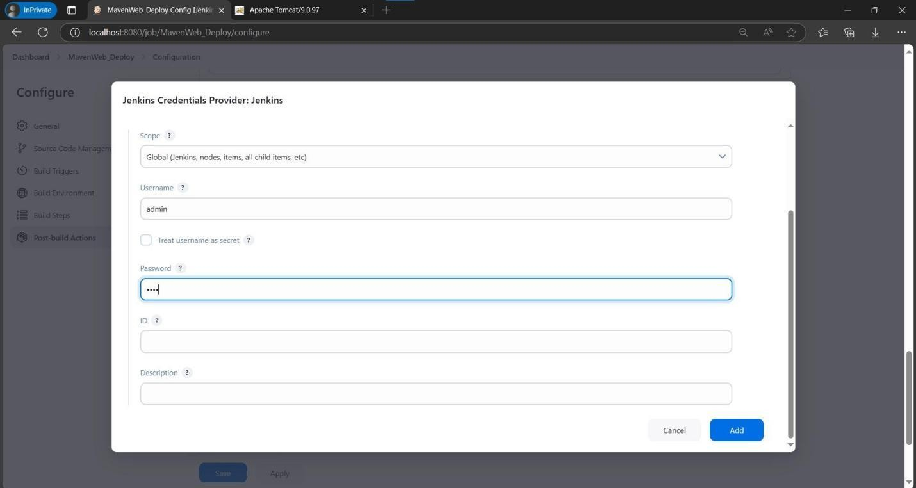

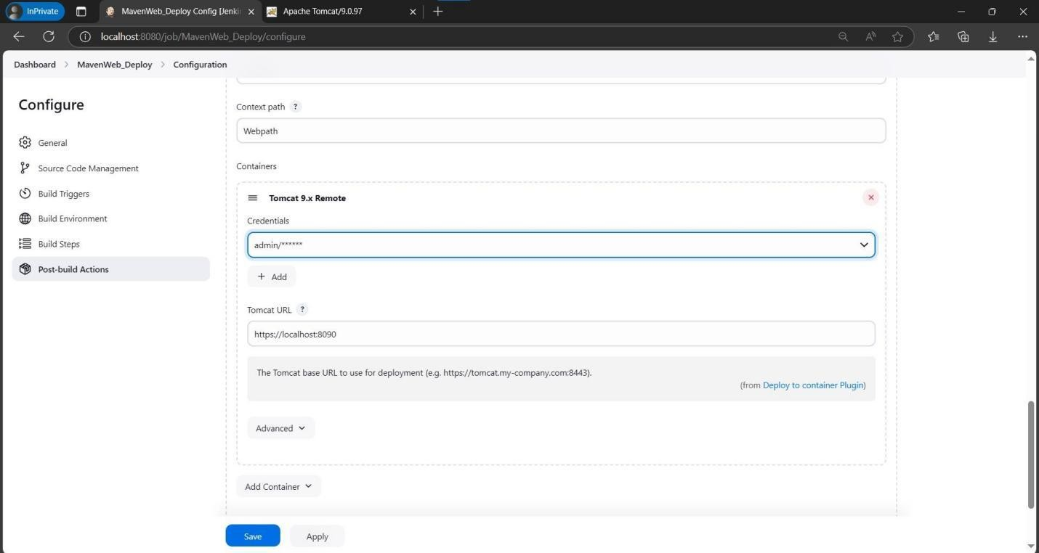

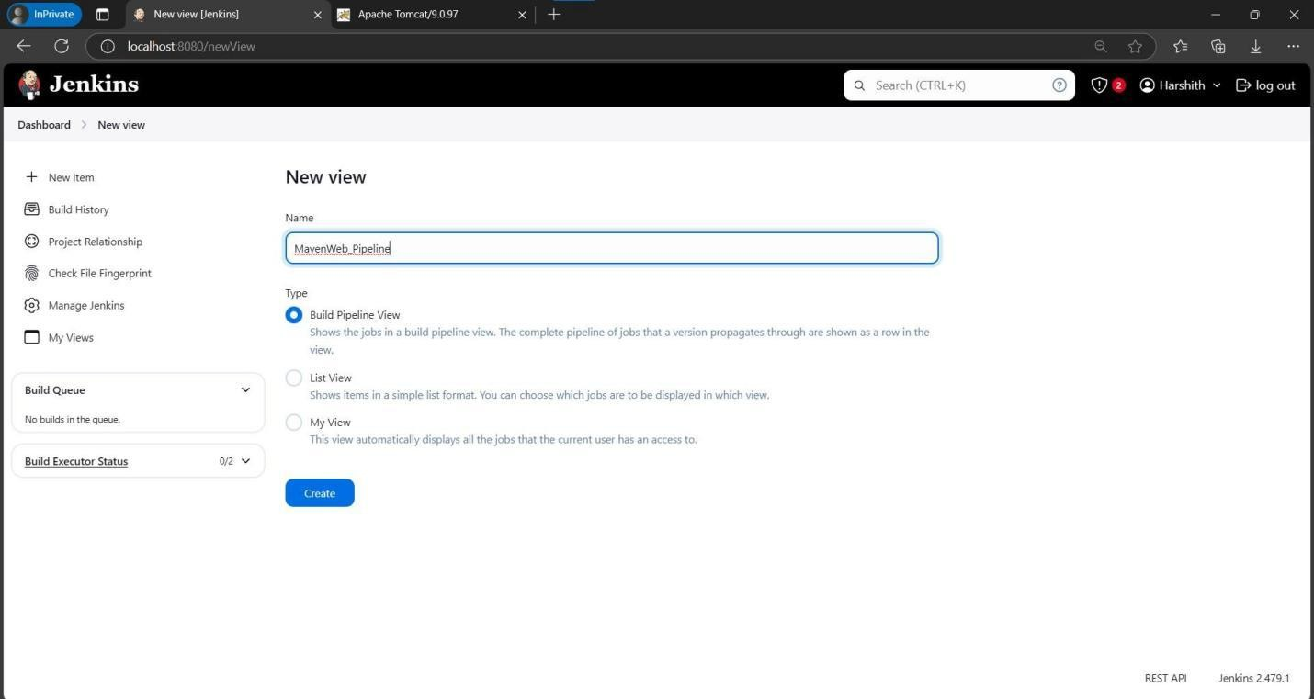

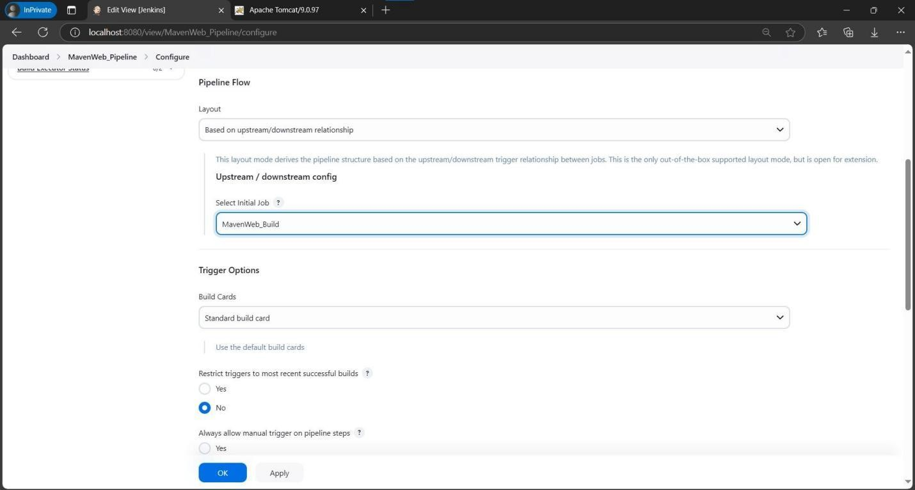

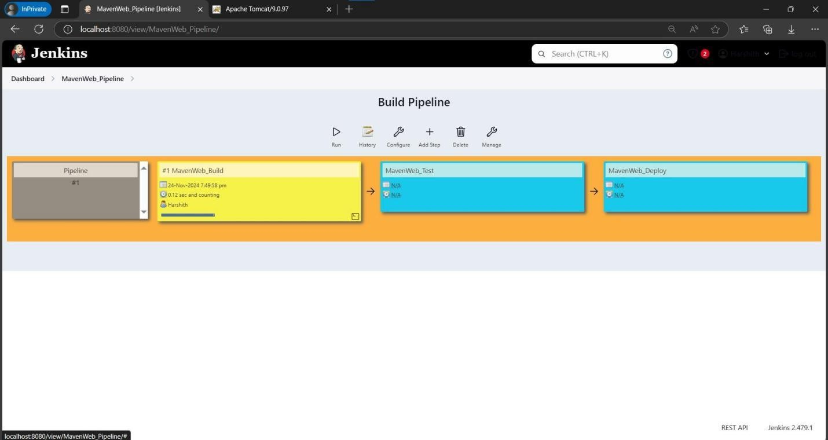

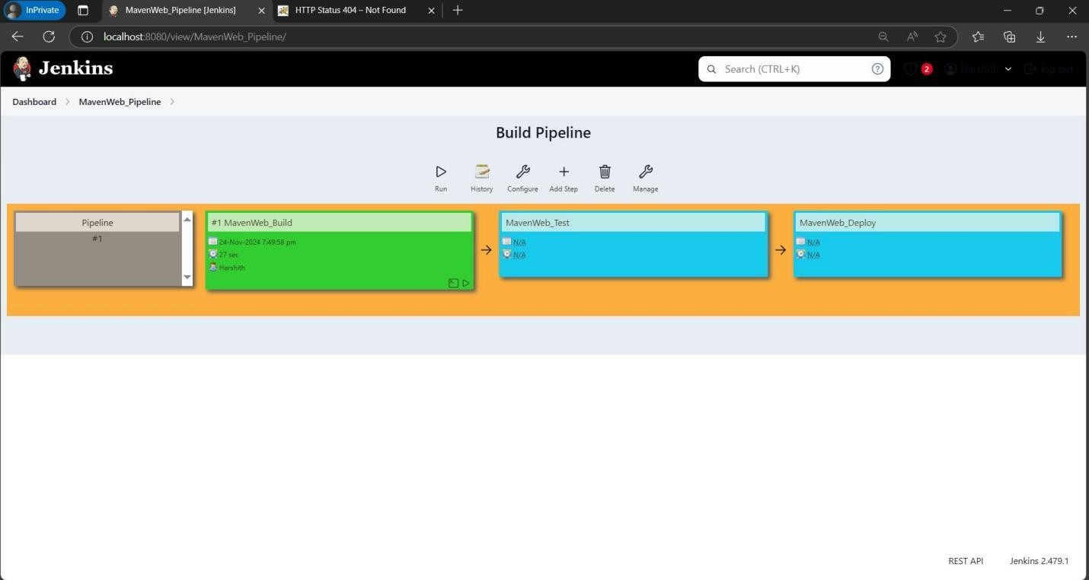

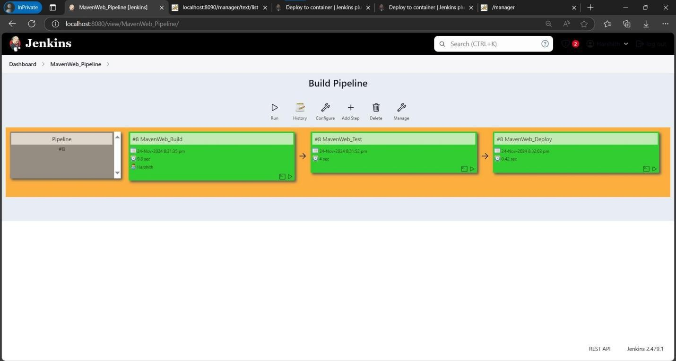

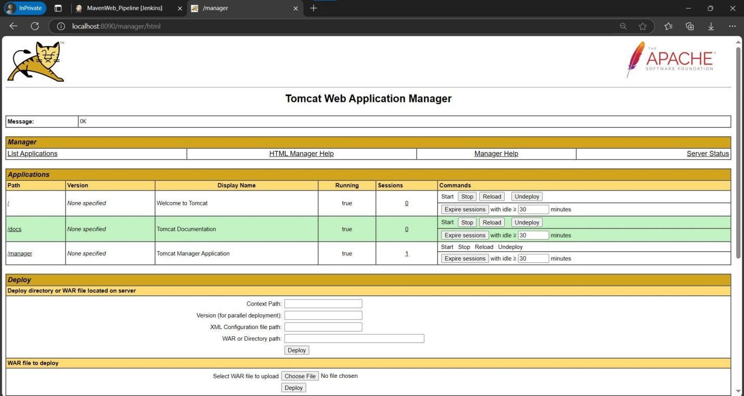

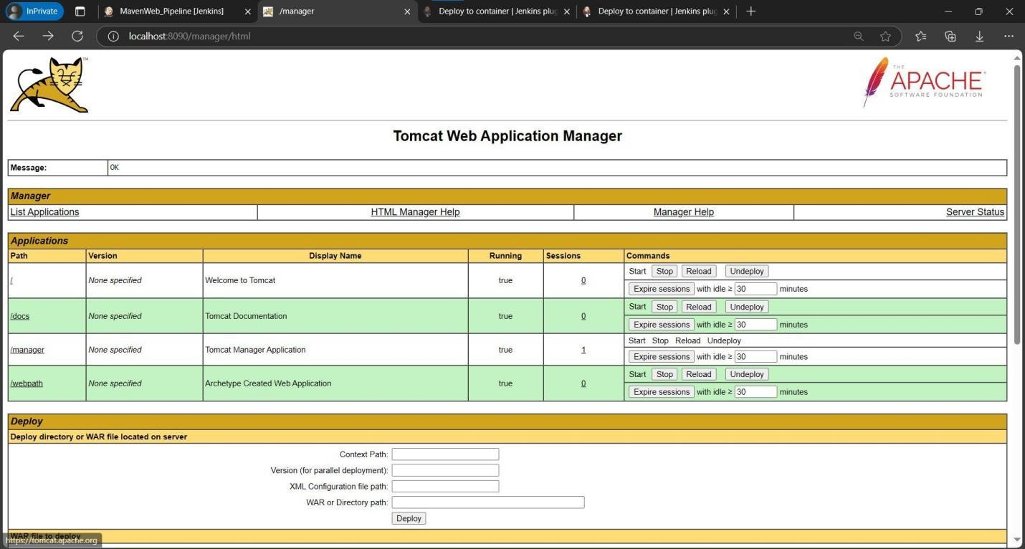

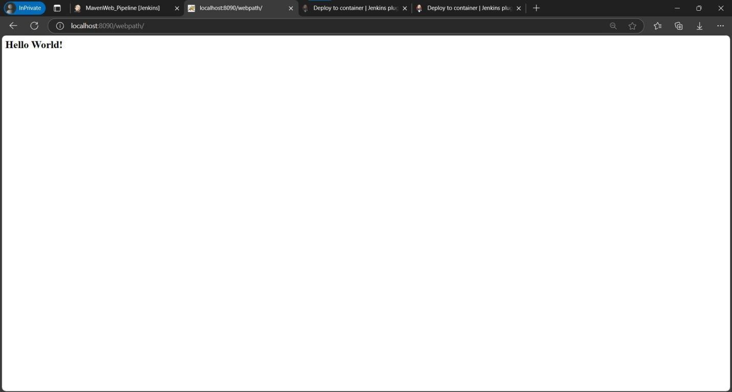

**Pipeline Creation Using Script for Maven Java Project**

Step 1: Log on to Jenkins, and click the New item option on the dashboard

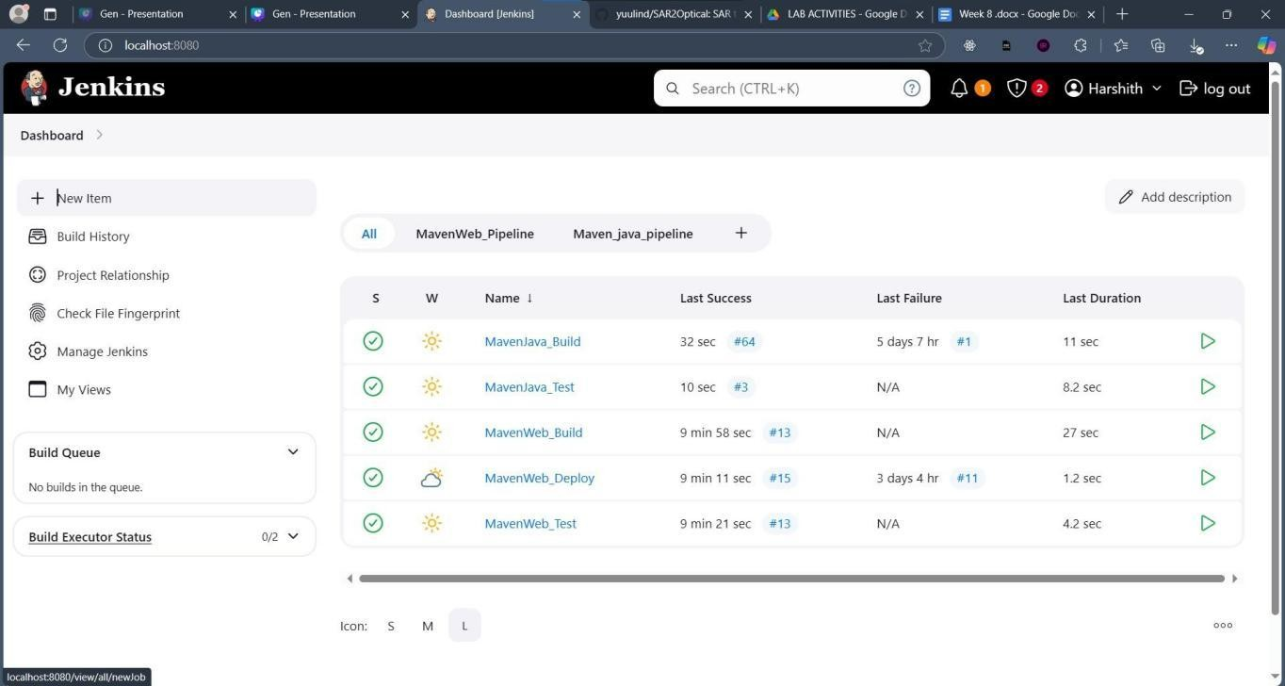

Step 2: Write the Name as ‘pipeline_script’ and select the pipeline option

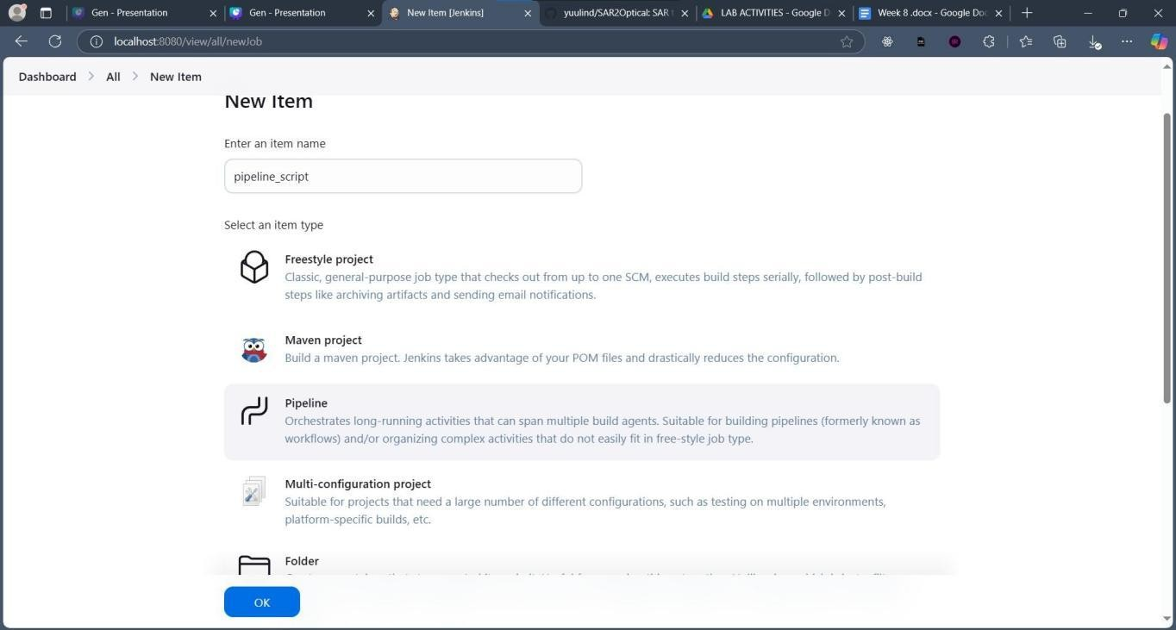

Step 3: Enter pipeline Description

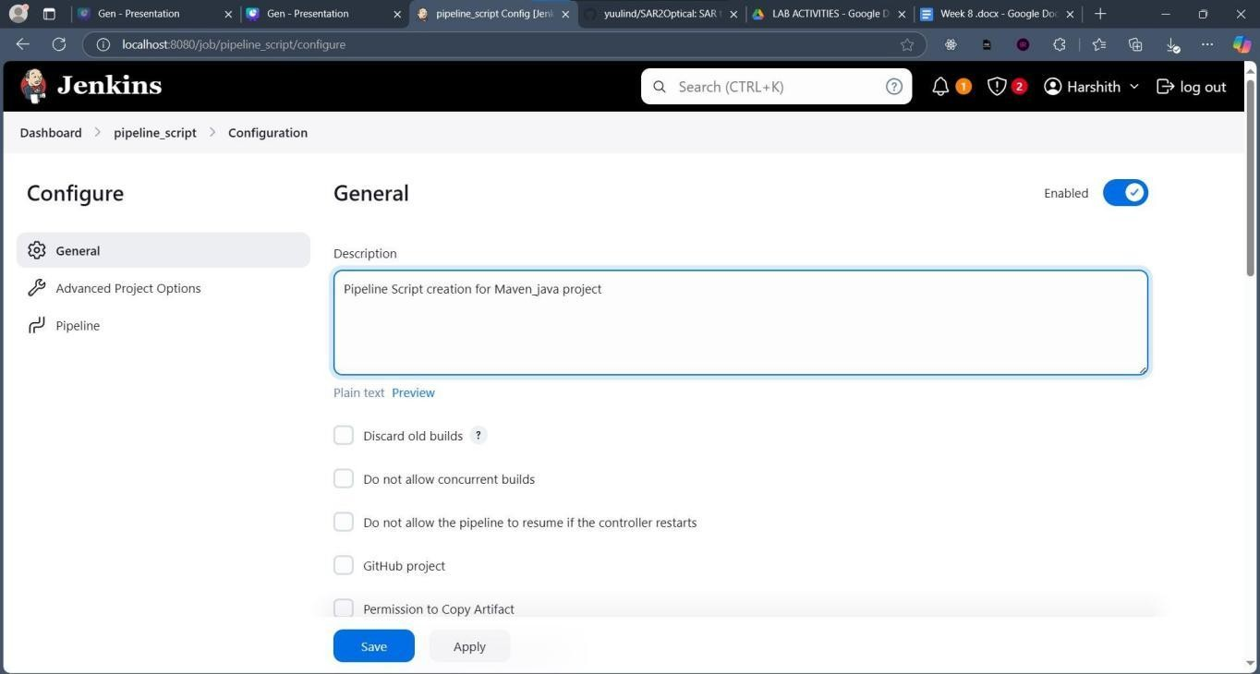

Step 4: Go to Advanced Project Options, select the pipeline script option in the Pipeline Definition drop down menu

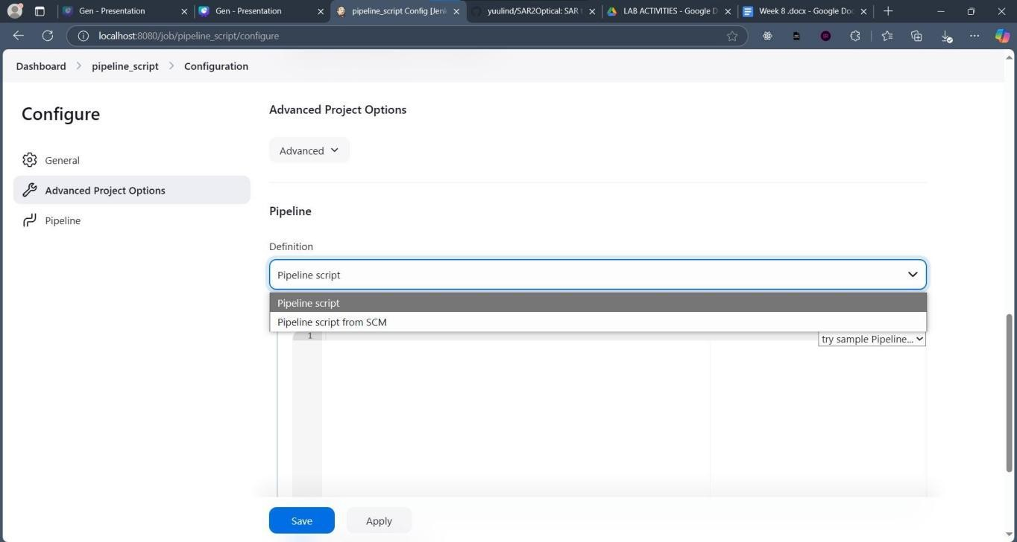

Step 5: Copy the provided pipeline script and paste it. Give the GitHub url at the git clone command of the script. Change the project name in the script to your project Maven_Java project name

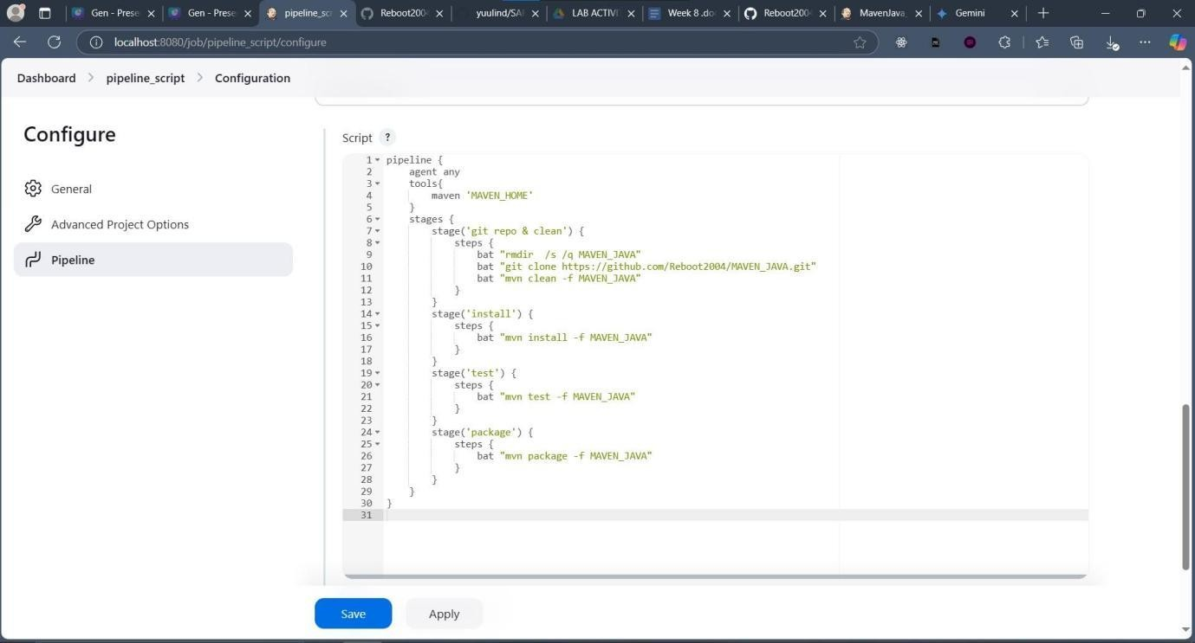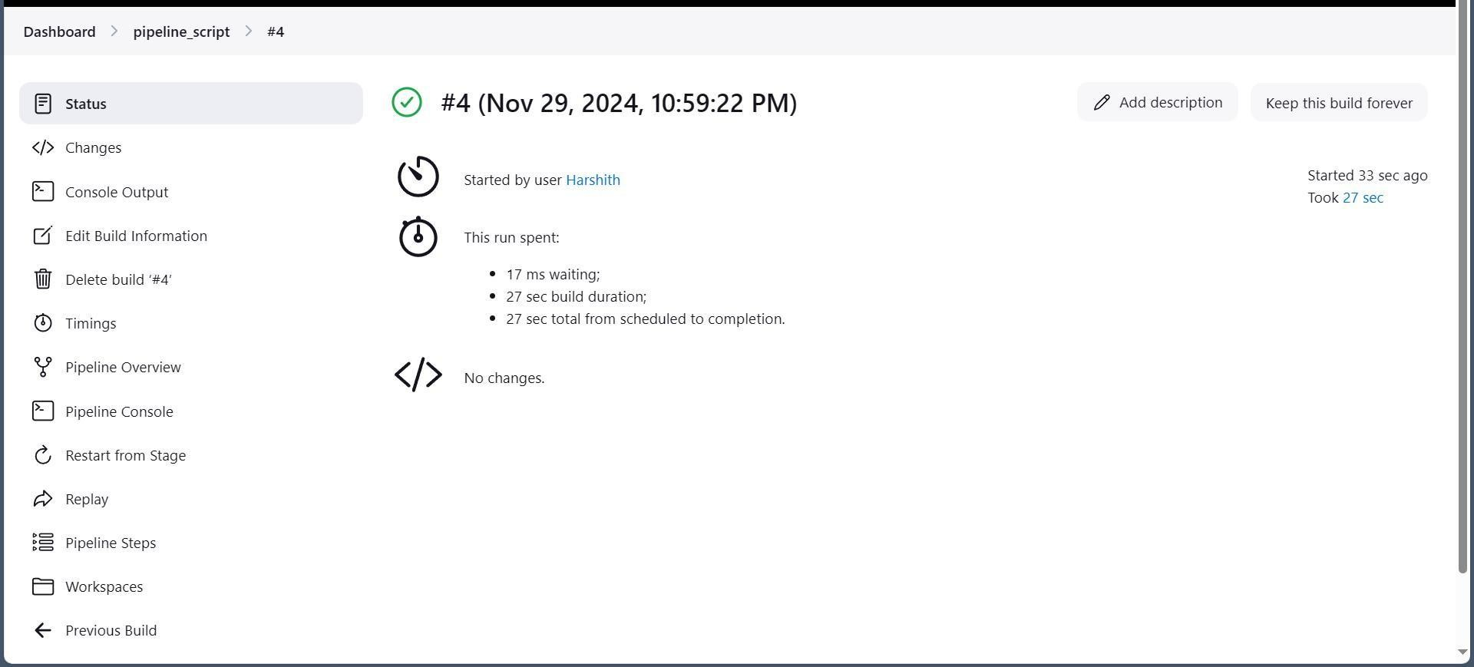

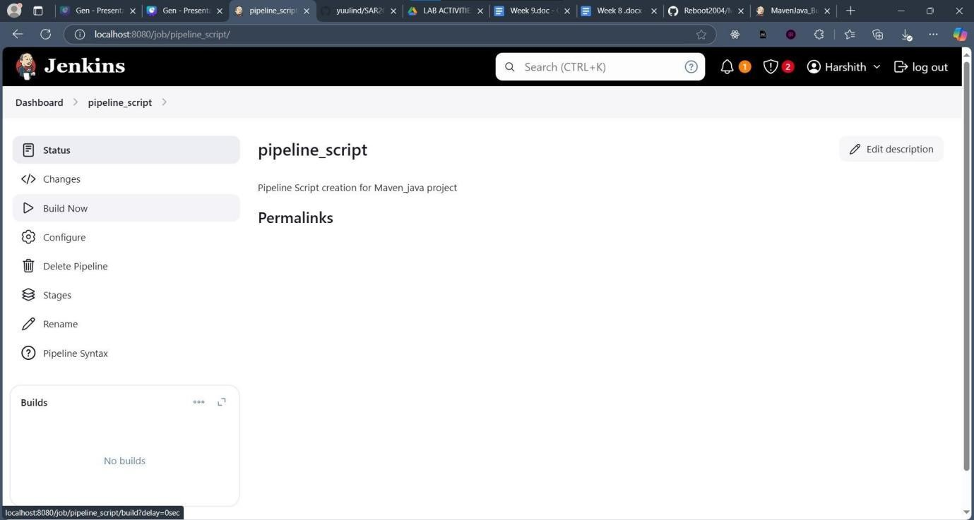Step 6: Click Apply and Save Step 7: Click Build Now

Step 8: The Build Completed Successfully

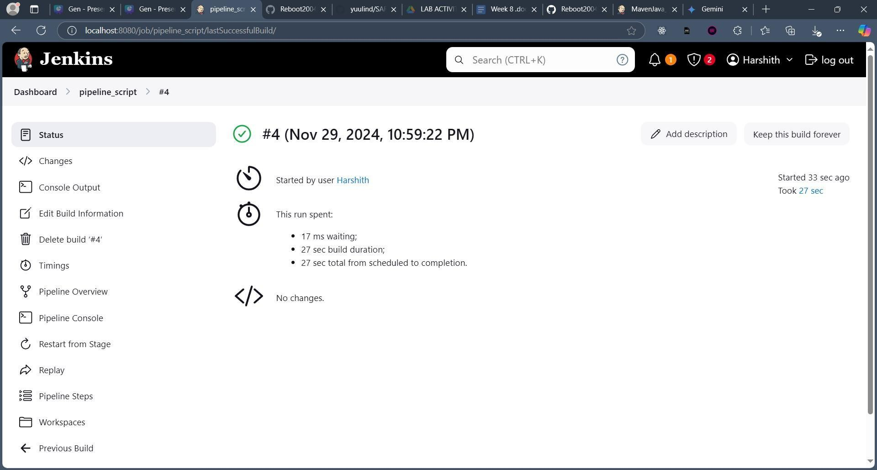

**EXPERIMENT - 7**

Installation of Minikube, Pulling Nginx image from DockerHUb using minikube.

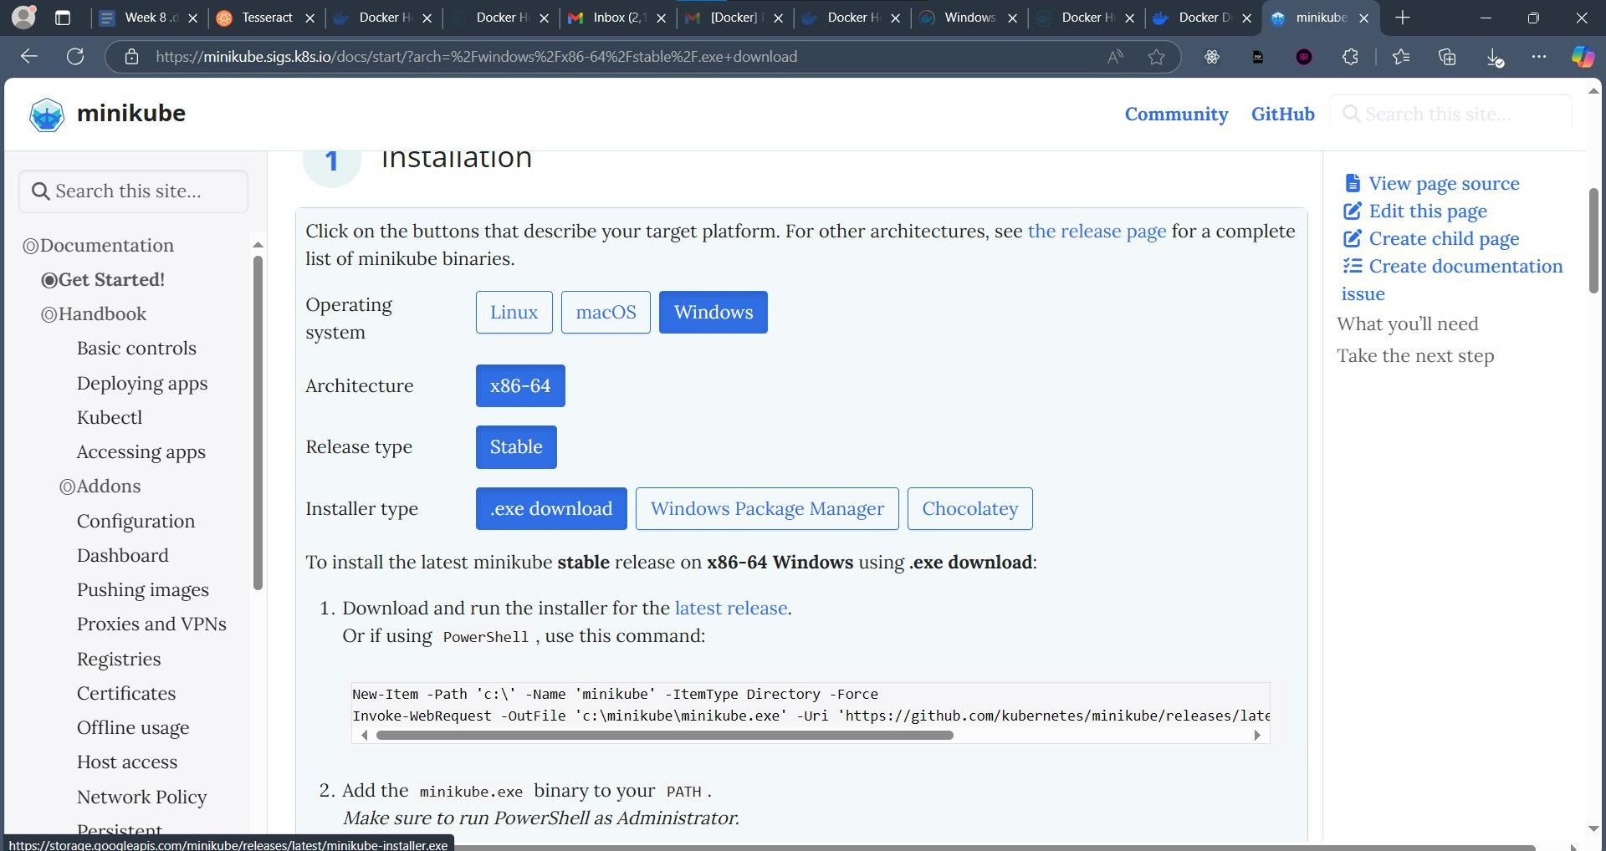

##### Step 2: Click Latest Release

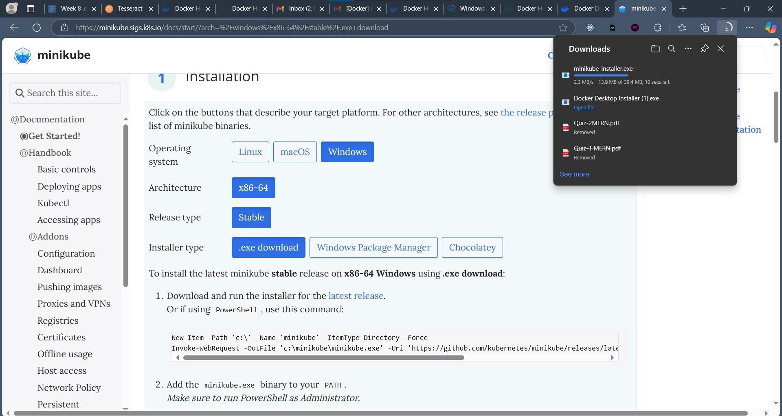

##### Step 3: Open the Installer & Select Installer Language as English

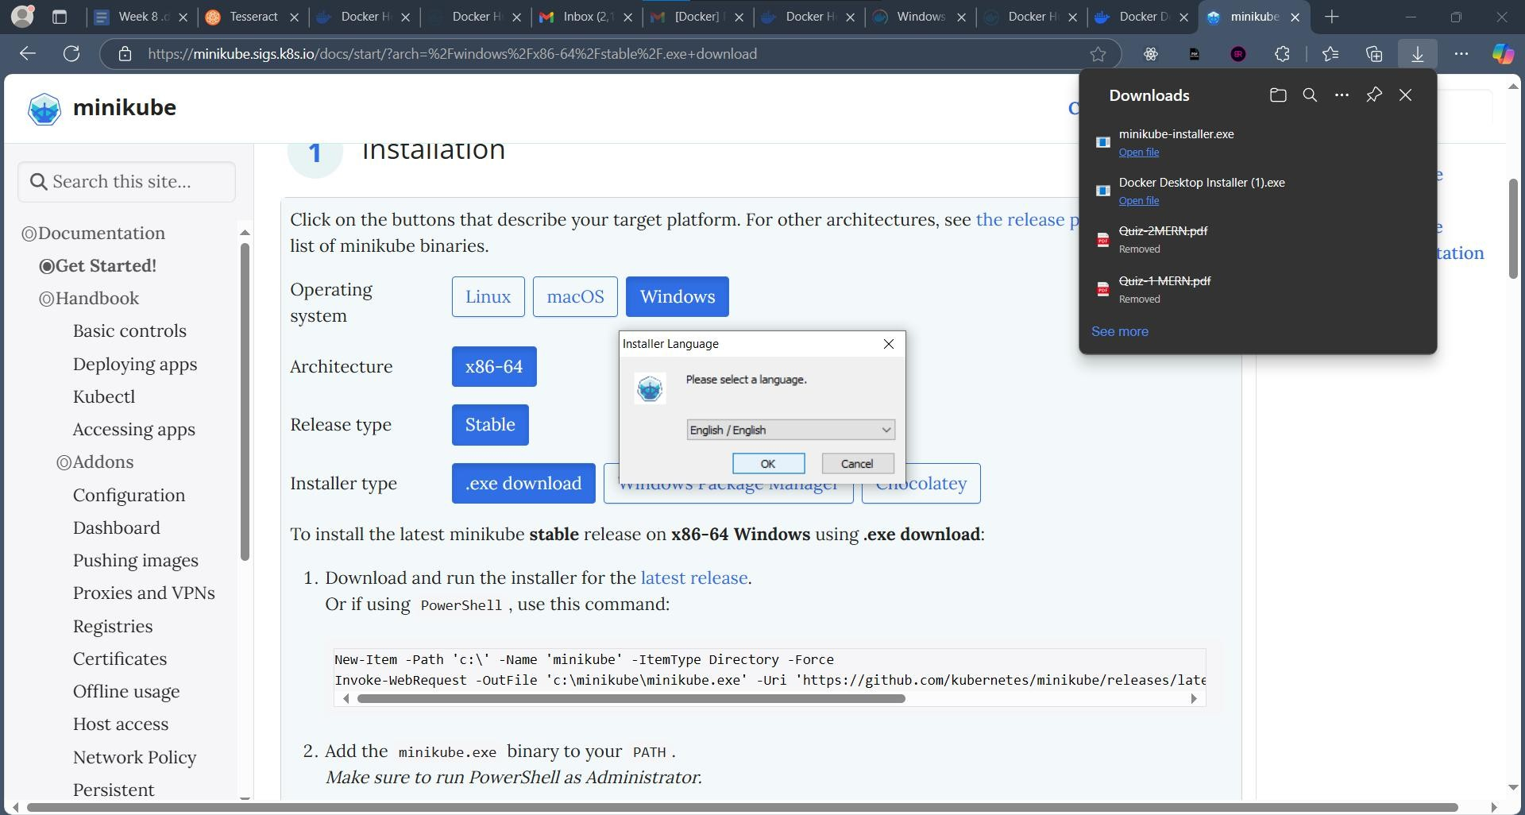

##### Step 4: Click Next and Agree till the installation process completes

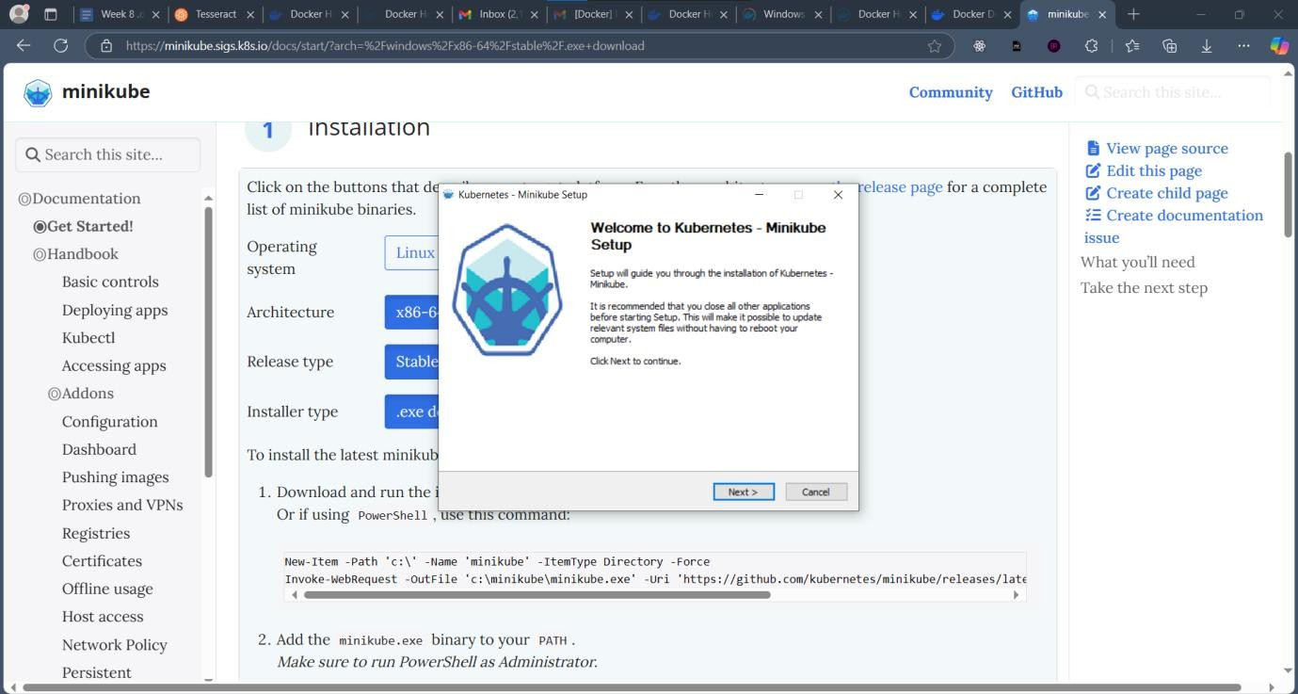

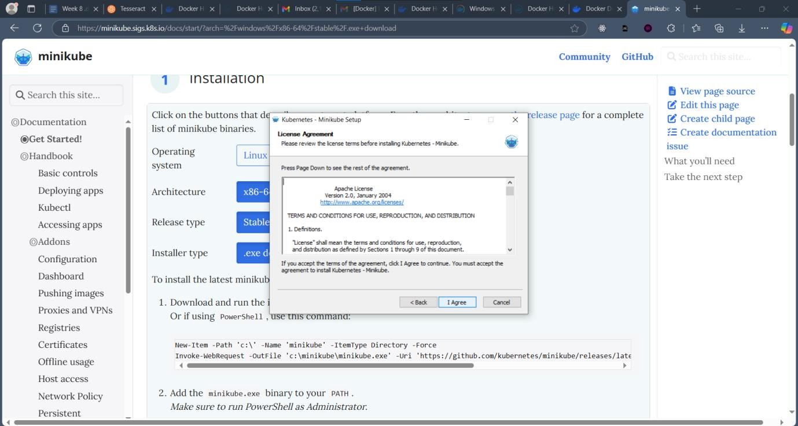

##### Step 5: Set the Installation Location for Minikube and Click Install

##### Step 6: Installation is Complete, Click Next

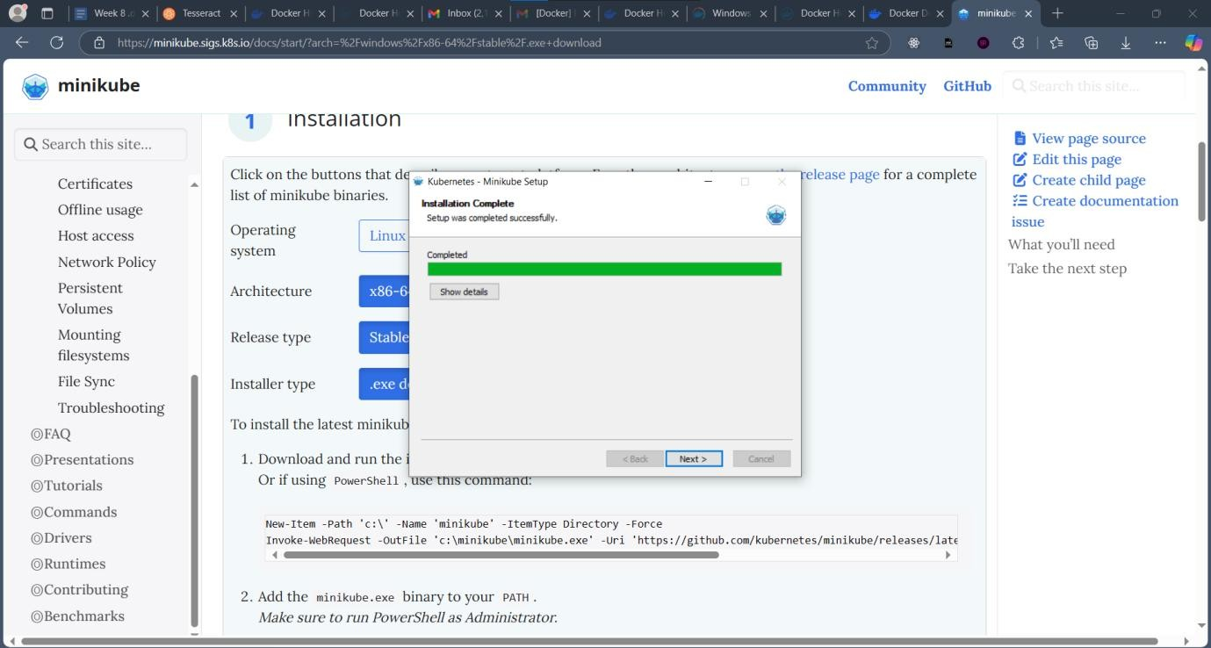

**Docker Hub Account Creation:**

Step 1: Visit hub.docker.com & Click on the Signup Button

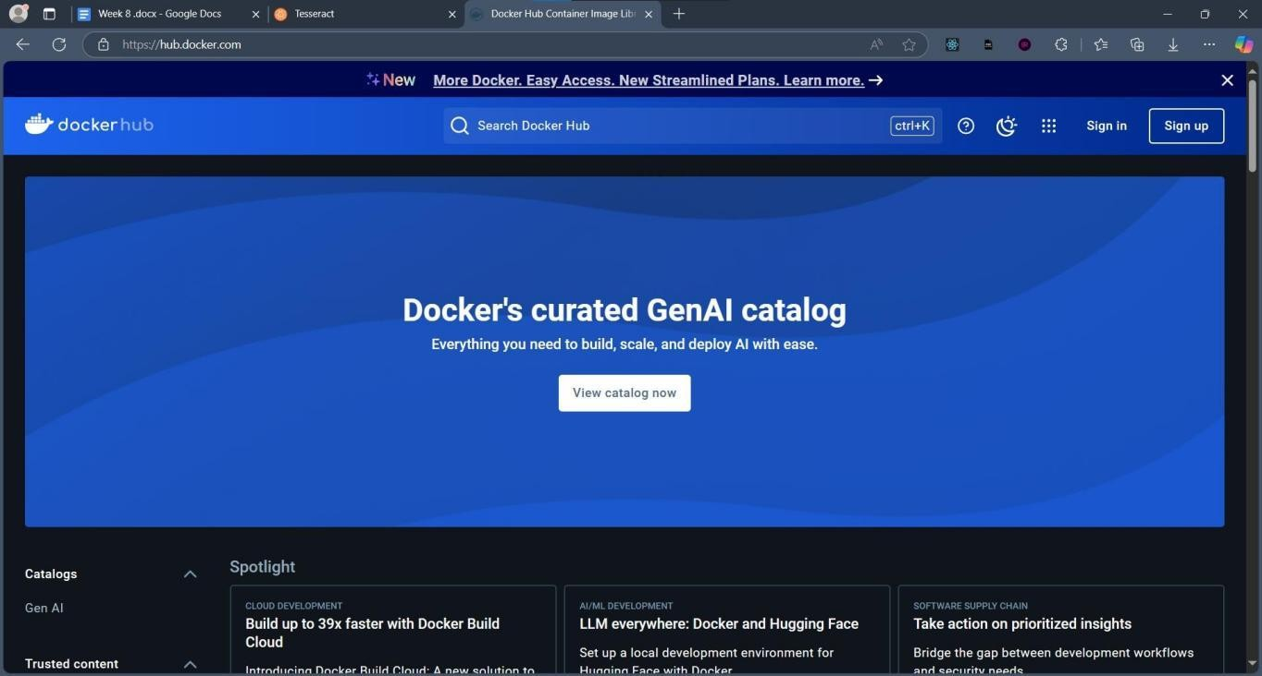

Step 2: Fill the Registration form with Required Information. Click Signup

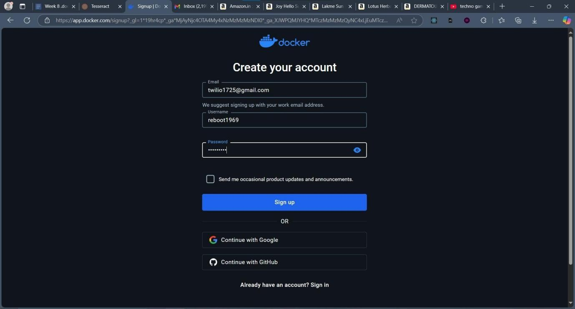

Step 3: Perform the ReCAPTCHA Verification

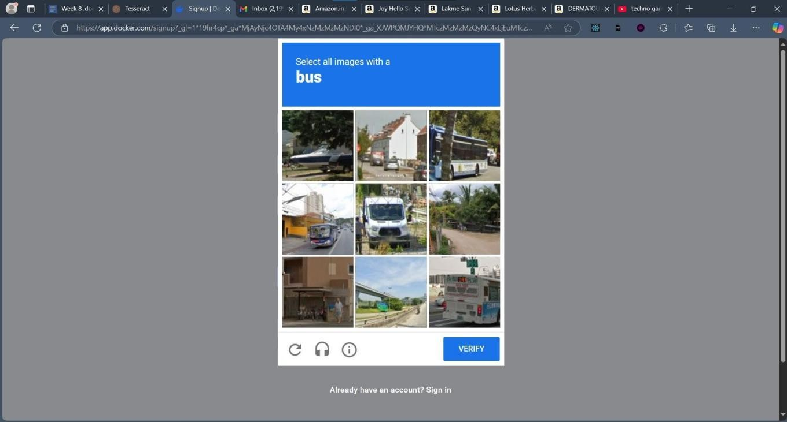

Step 4: Login into your account

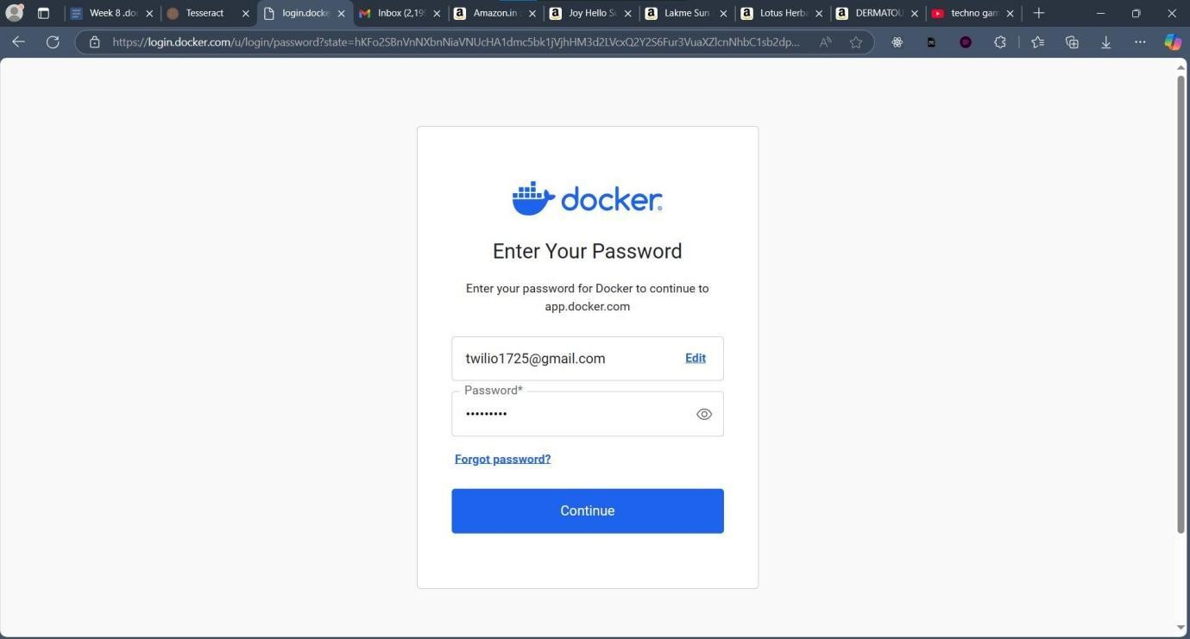

Step 5: Verify the Email Address using the email sent

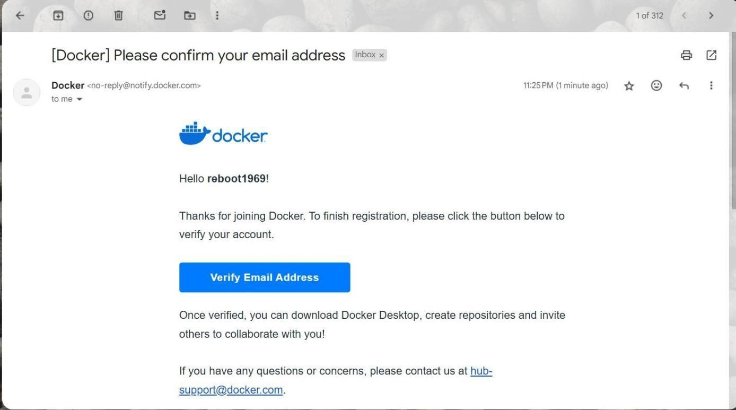

**Pre-requisites:**

Step 1: Check if Virtualization is enabled from the Task Manager. Open Task Manager, go to performance and check

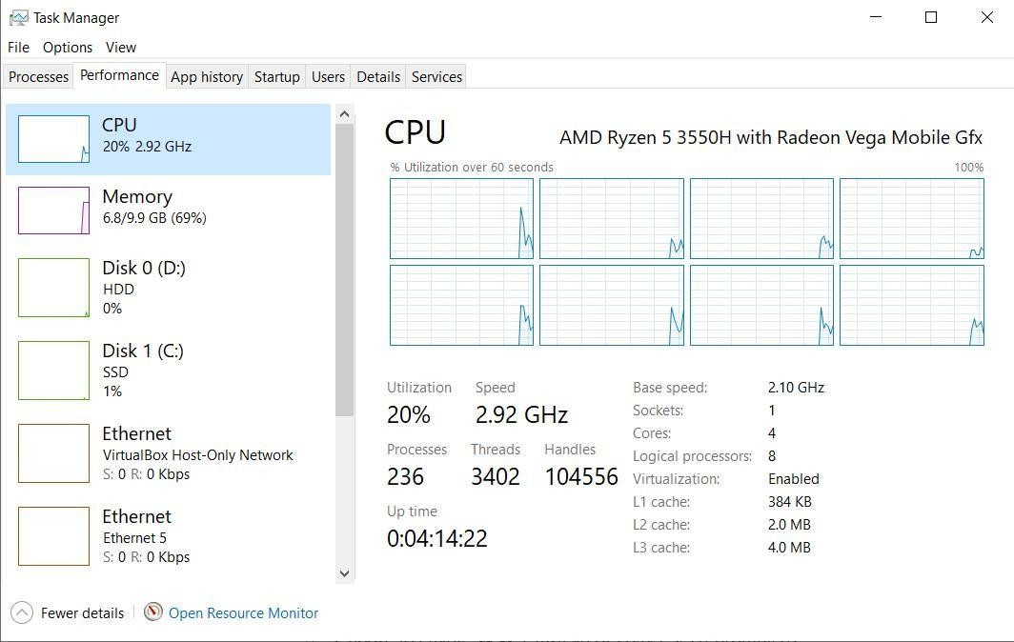

Step 2: Check if WSL 2 is installed. To check, go to Turn on or off Windows features tab in Control Panel and Windows Subsystem for Linux

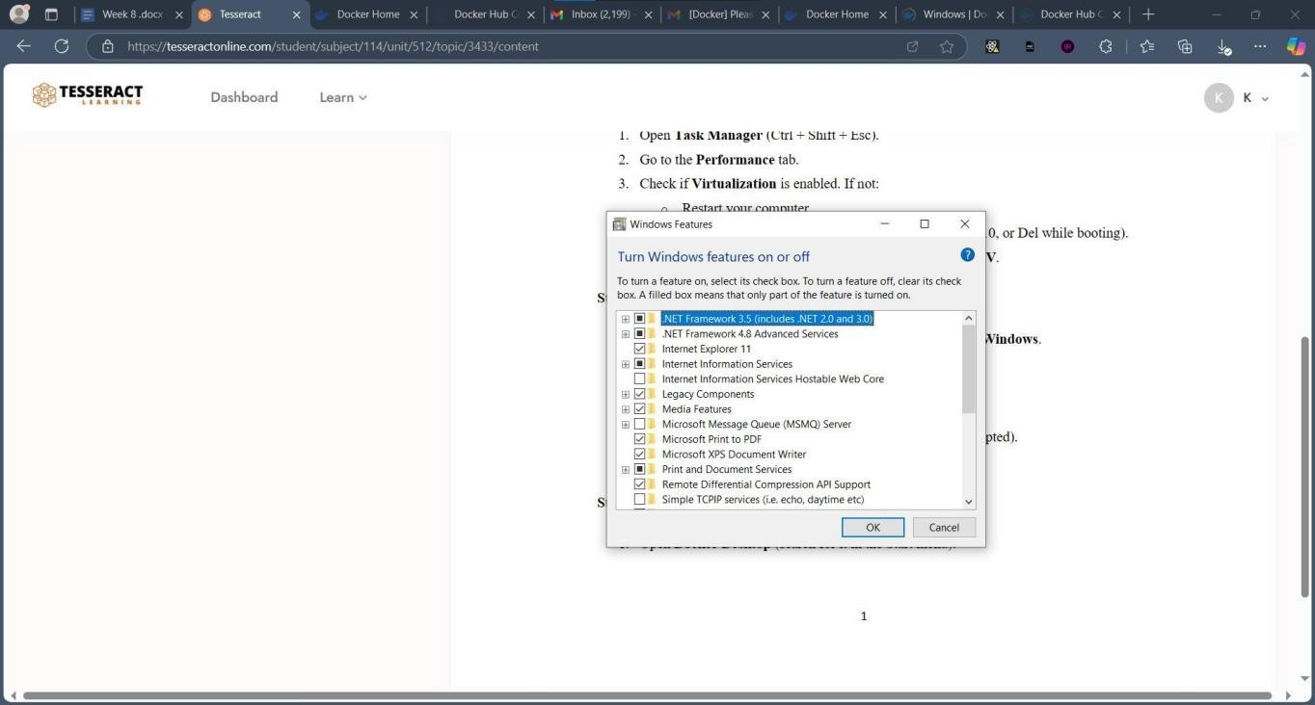

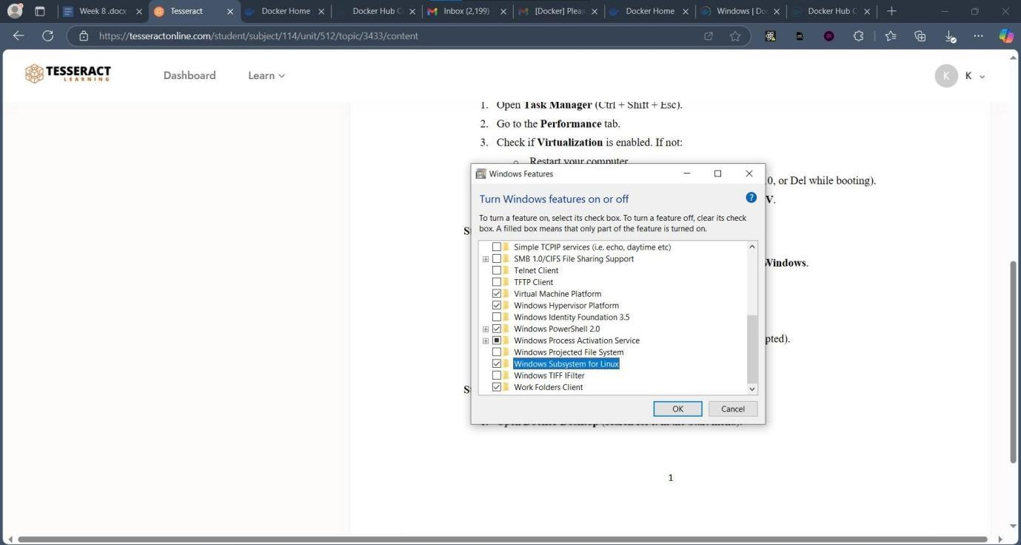

**Docker Desktop Installation:**

Step 1: Visit app.docker.com & Login with your credentials Step 2: In Docker Products, Click Go to Download

Option

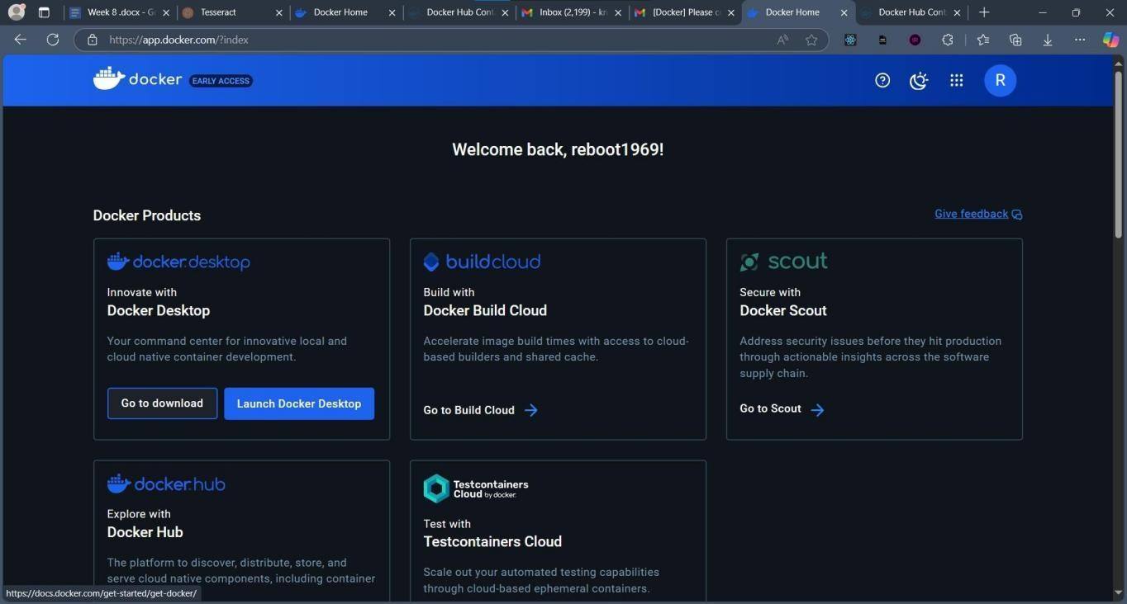

Step 3: Click on Docker Desktop for Windows

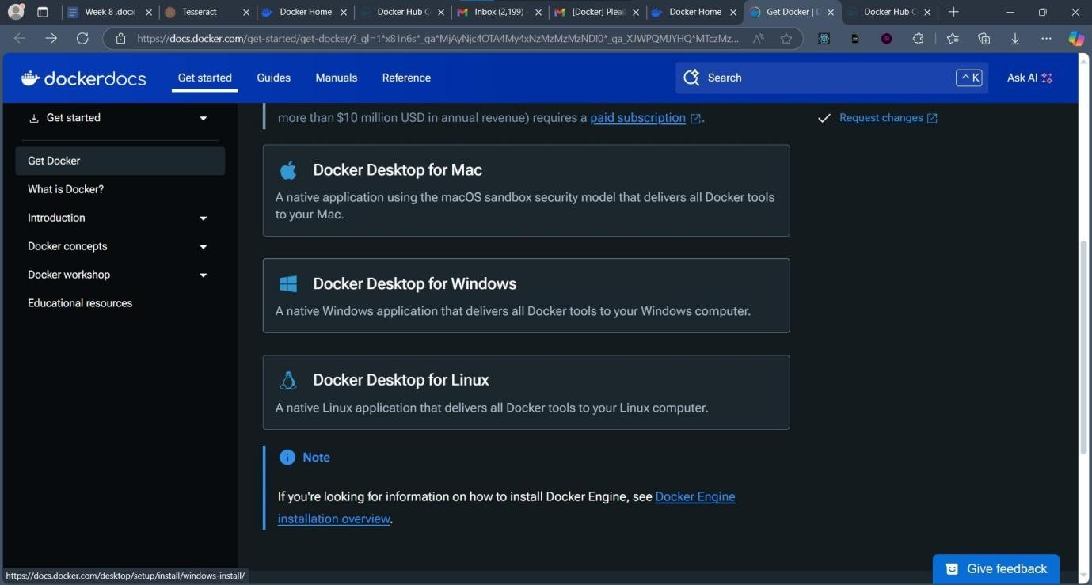

Step 4: Click on Docker Desktop for Windows – x86_64

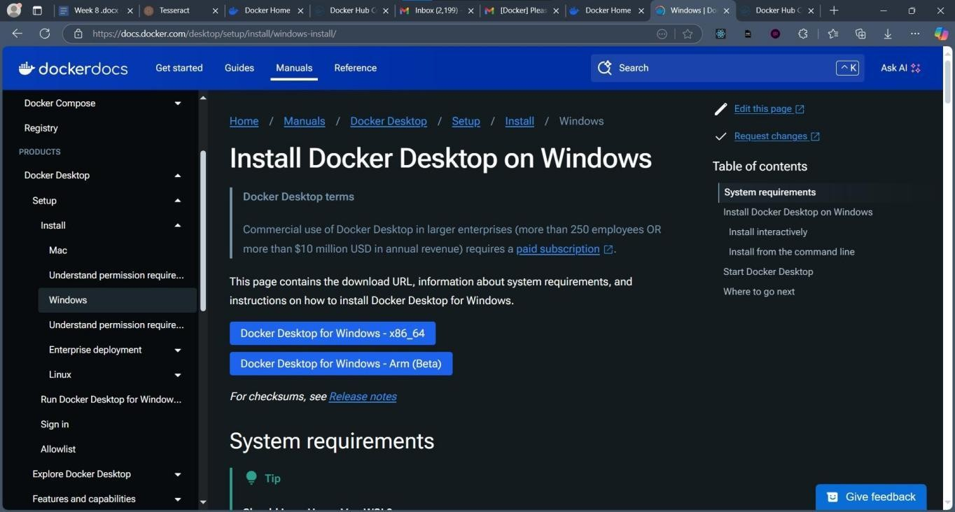

Step 5: The Download Starts

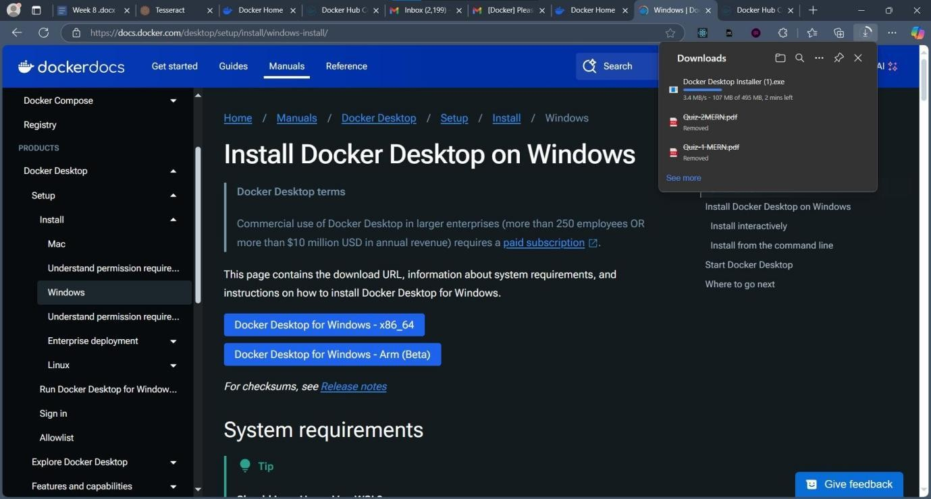

Step 6: Open the Installer

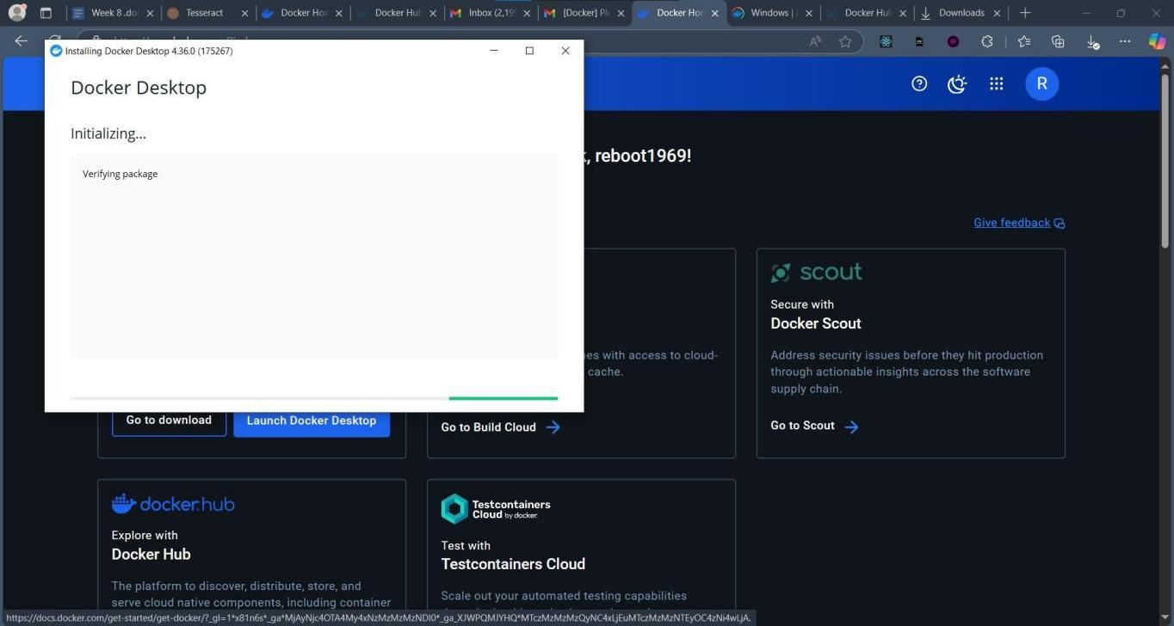

Step 7: Check the Add Shortcut to Desktop Checkbox & Click Ok

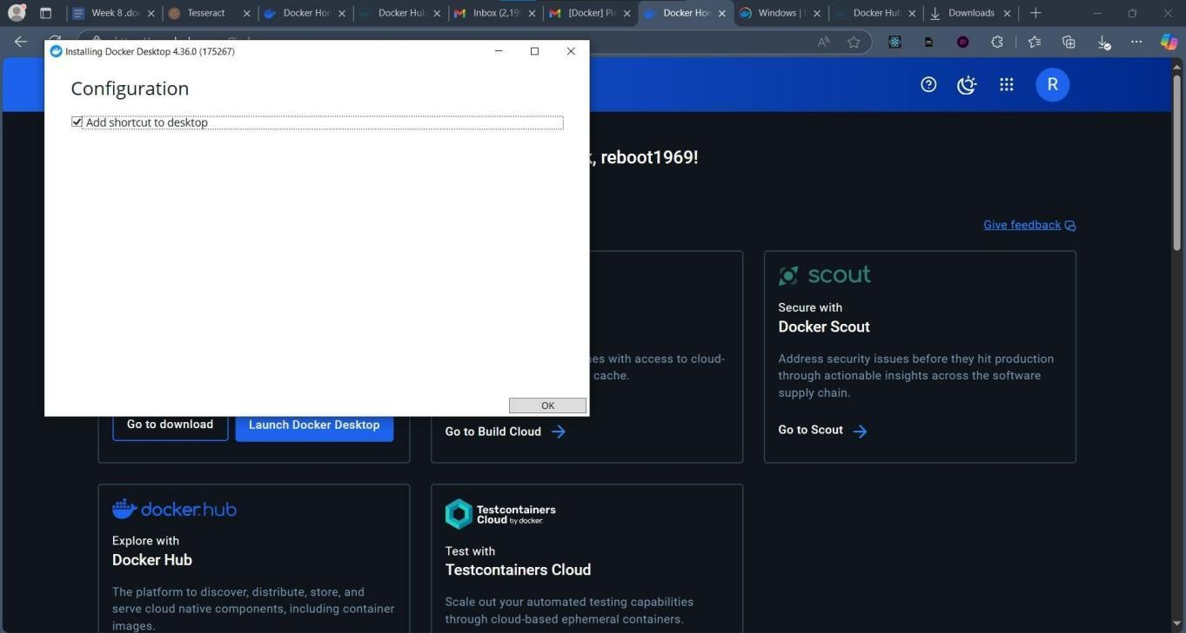

Step 8: The Installation Starts

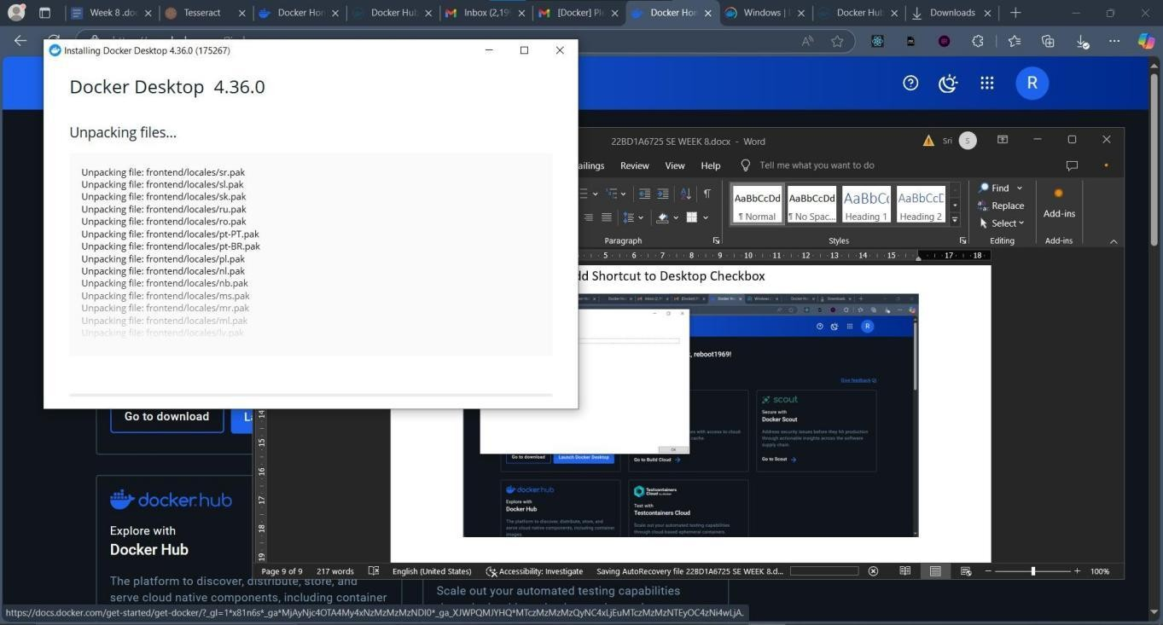

Step 9: Click Close After Installation Completes

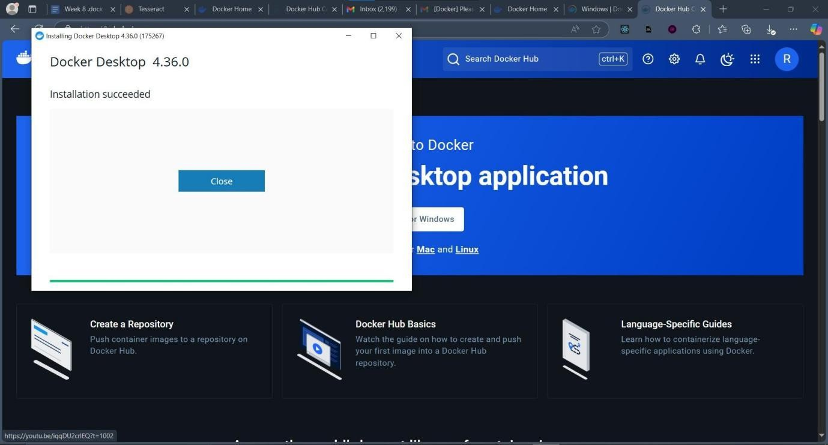

Step 10: Open Docker Desktop App. Accept the Terms and Conditions by clicking Accept

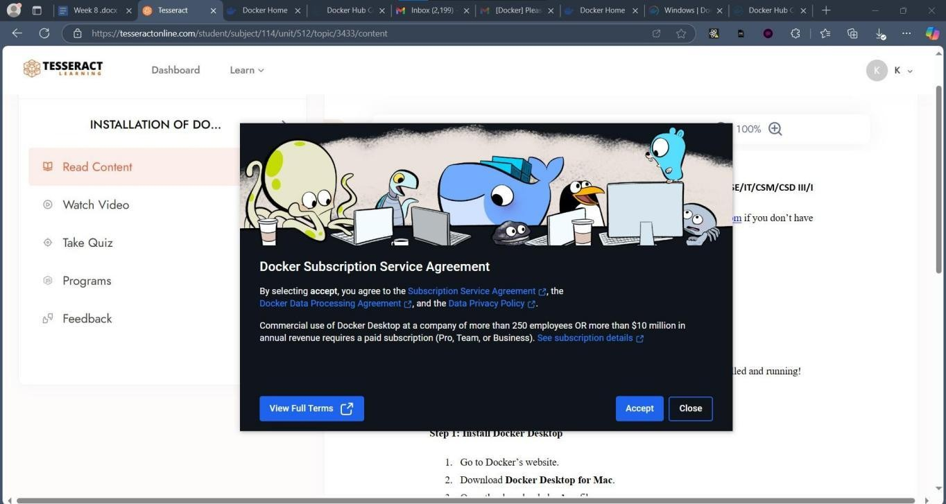

Step 11: Click Use Recommended Settings and Finish

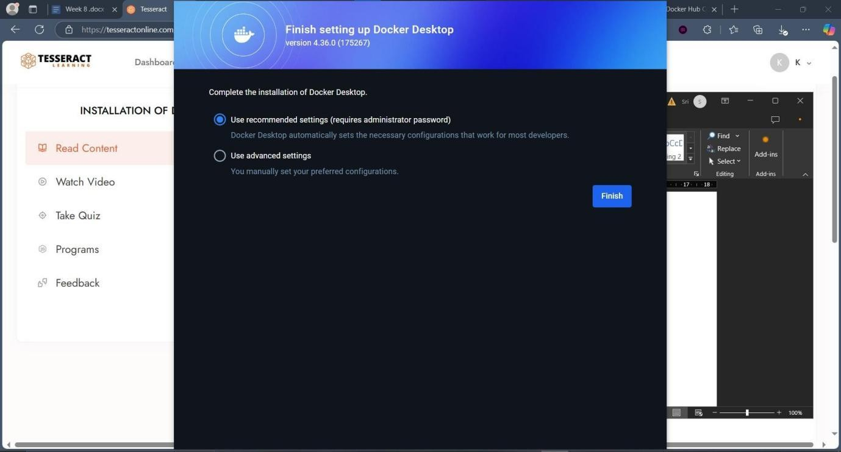

Step 12: Login into Docker Desktop app

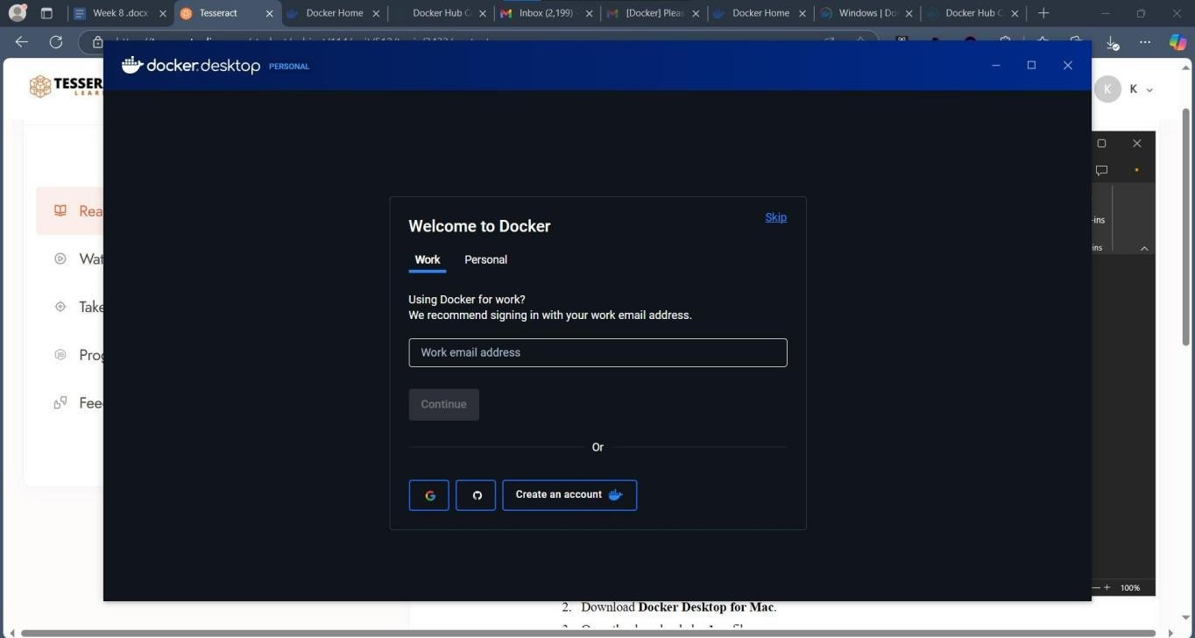

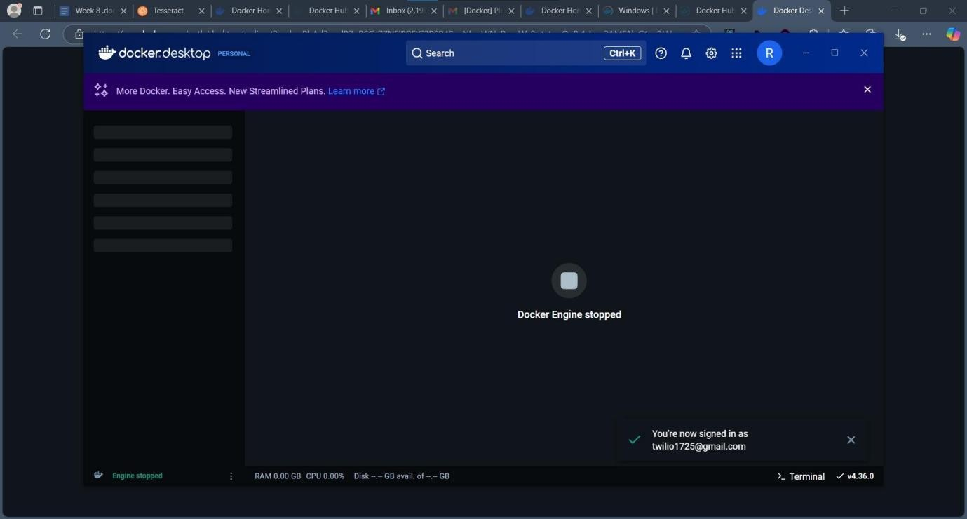

Step 13: Verify Docker has been installed Correctly. Open terminal with administrator rights and run the command docker –version

**Basic docker commands:**

##### Docker version:

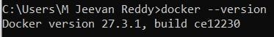

##### Docker pull hello-world:

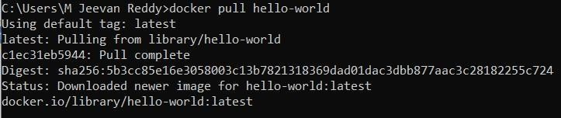

##### Docker images:

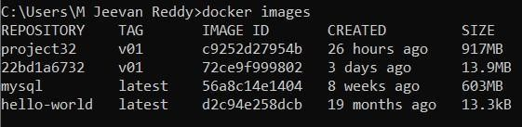

##### Docker run hello-world:

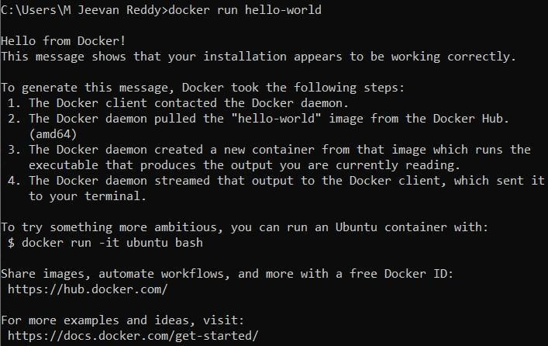

##### Docker ps -a:



##### Docker remove container:

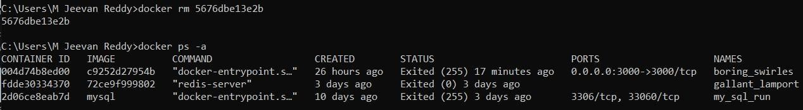

##### Docker remove image:

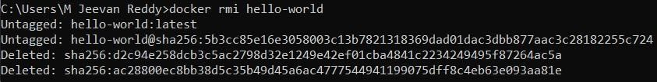

##### Docker pull redis:

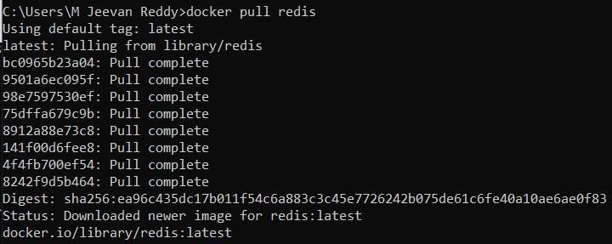

##### Docker run redis:

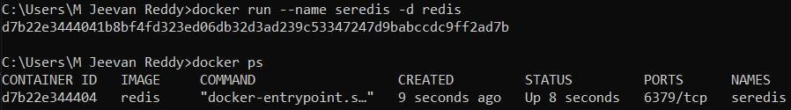

##### Redis exec redis-cli:

##### Redis exit:

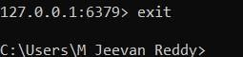

##### Docker stop and delete redis:

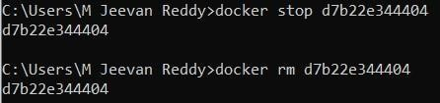

##### Creating a new Docker file:

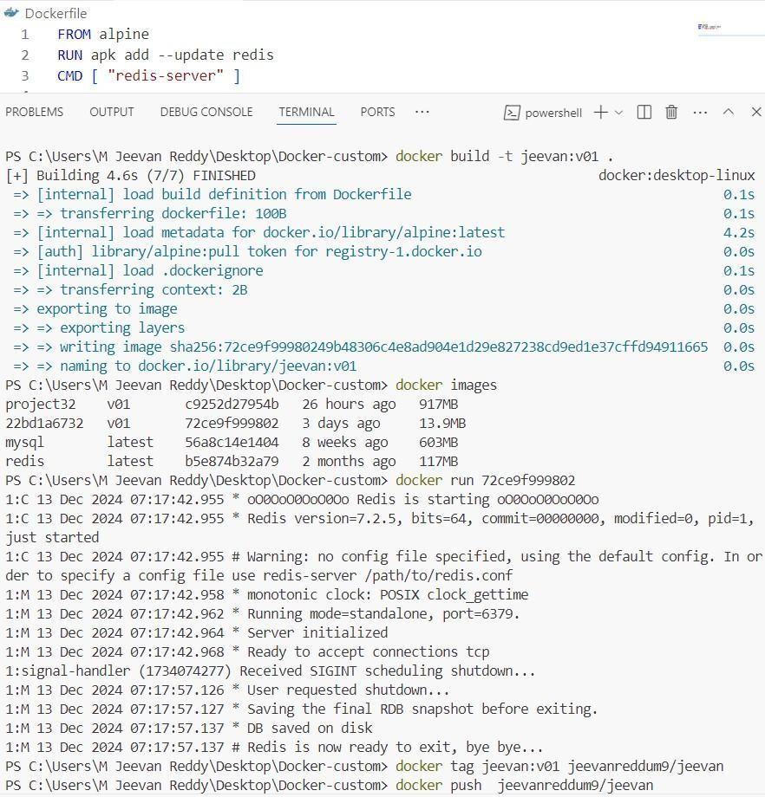

~~102~~

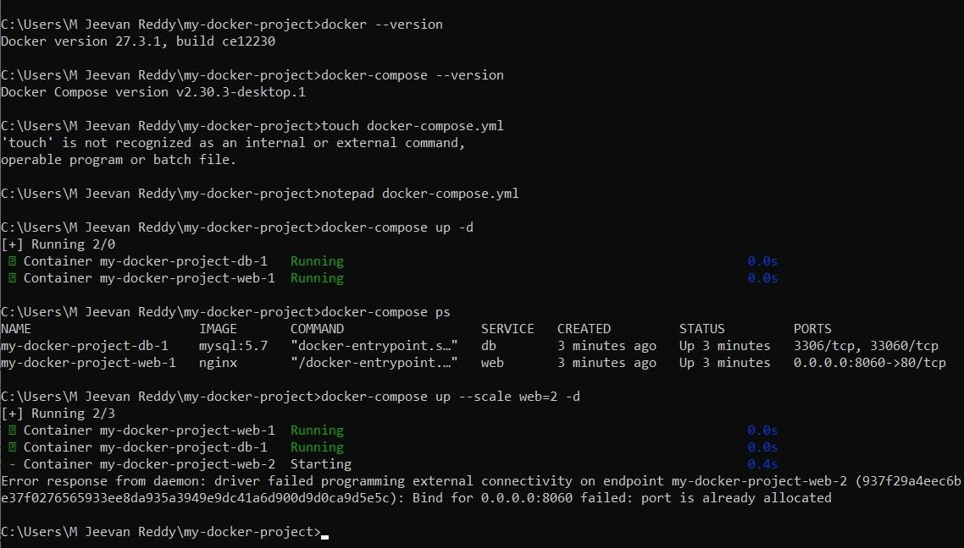

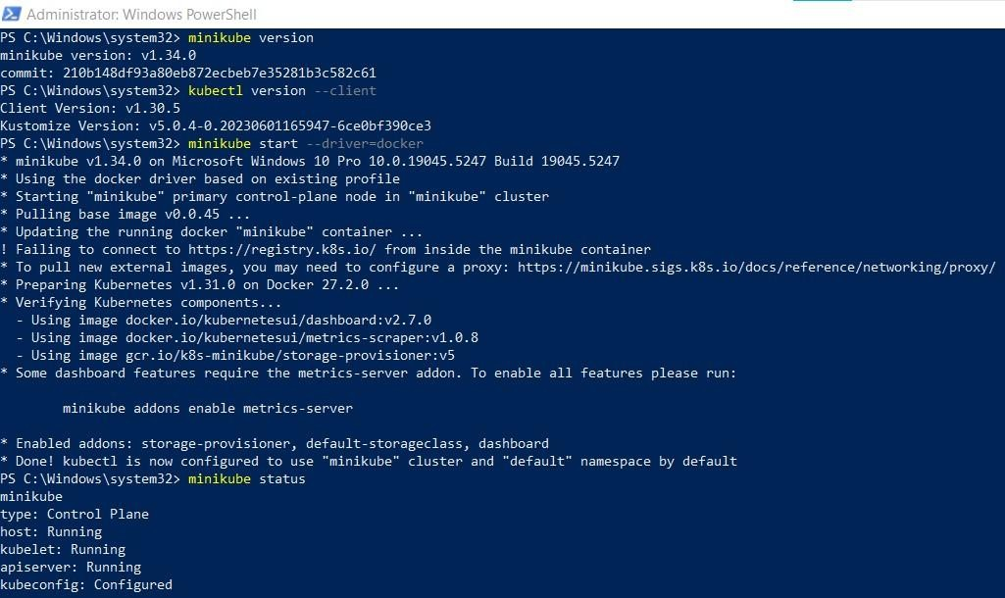

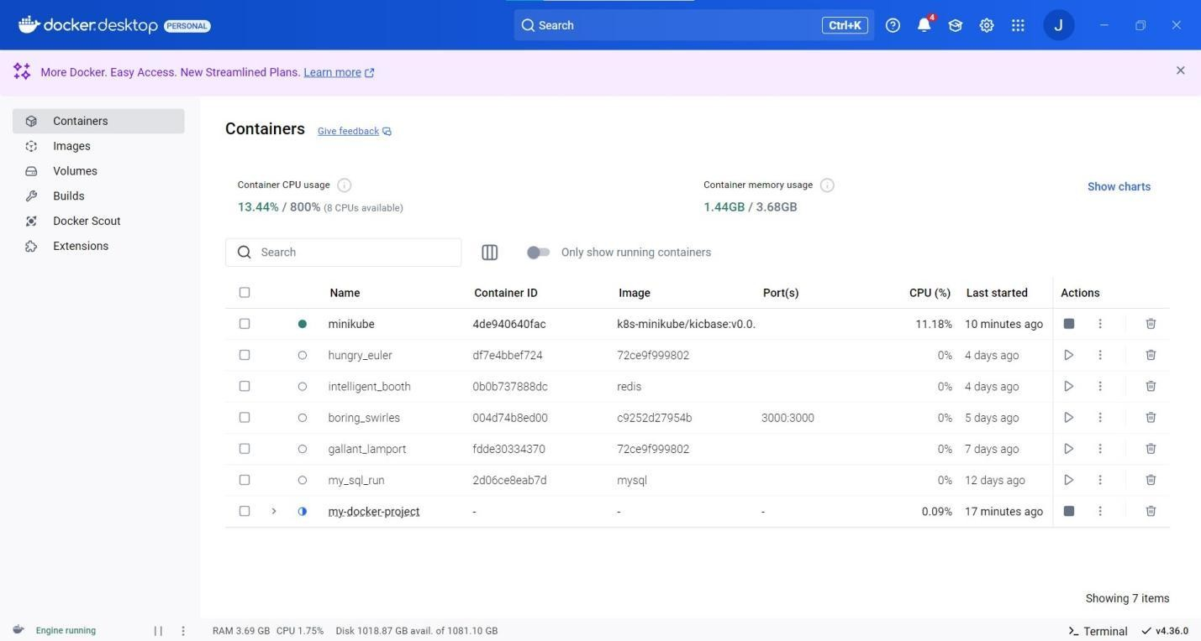

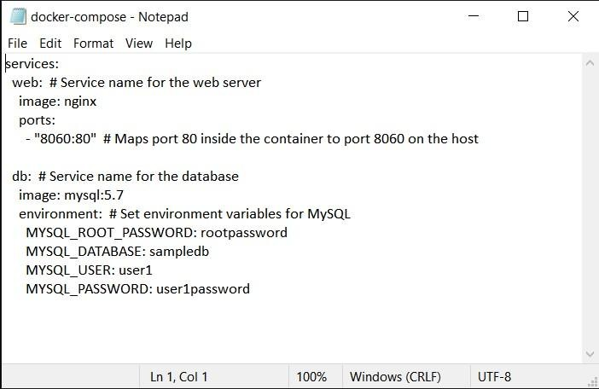

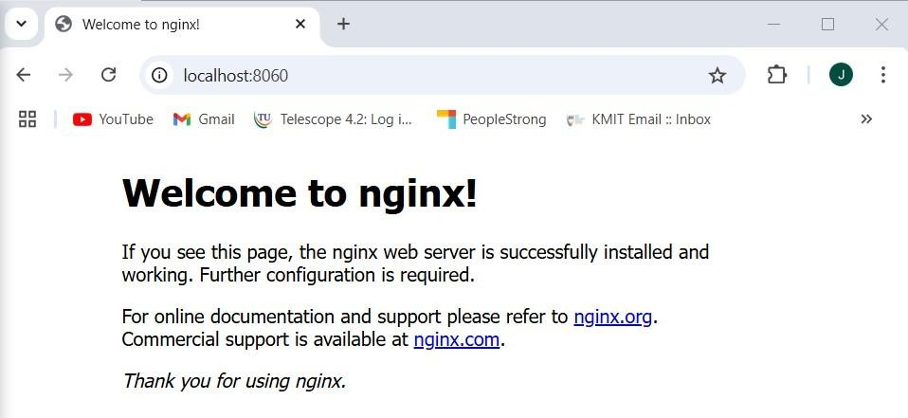

**EXPERIMENT - 8**

**LAB EXERCISE - 8 - A - AWS ACADEMY LEARNING ACCOUNT CREATION**

**STEP 1 :** Open your mail and click on **Get Started**

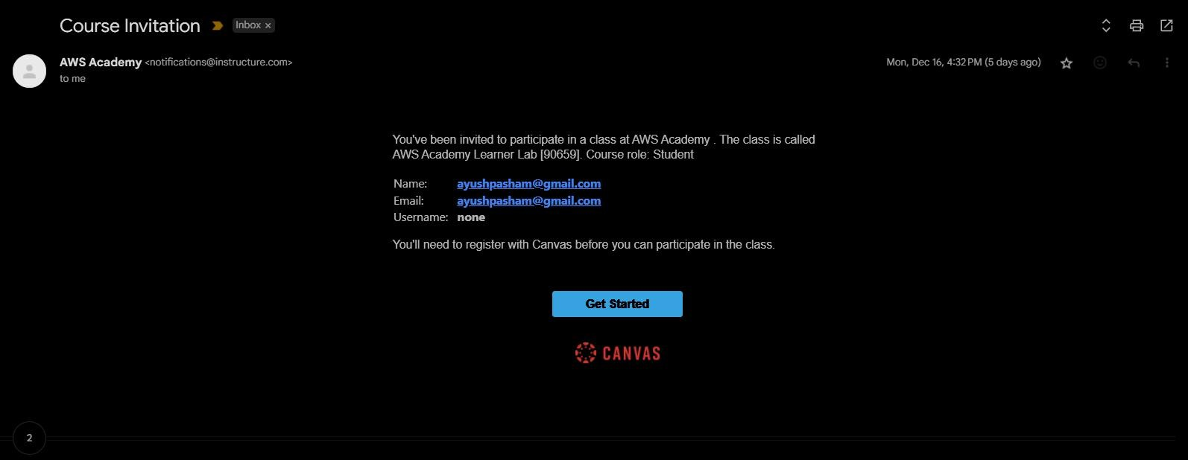

**STEP 2 :** Open Google and type **AWS Academy Login**

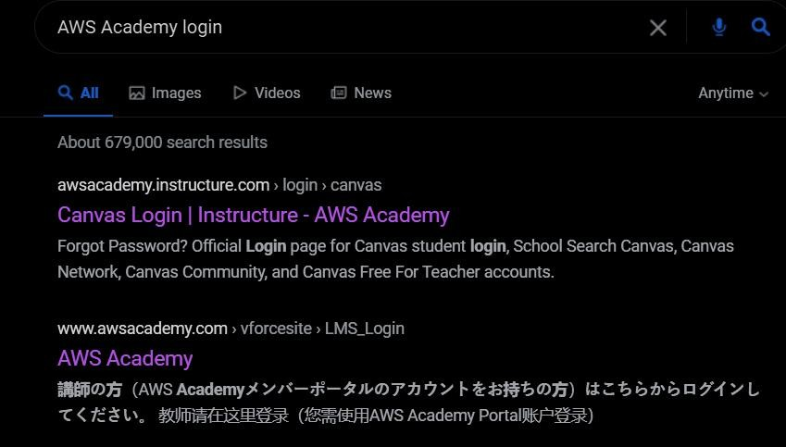

**STEP 3 :** Open this page and click on **Student Loign**

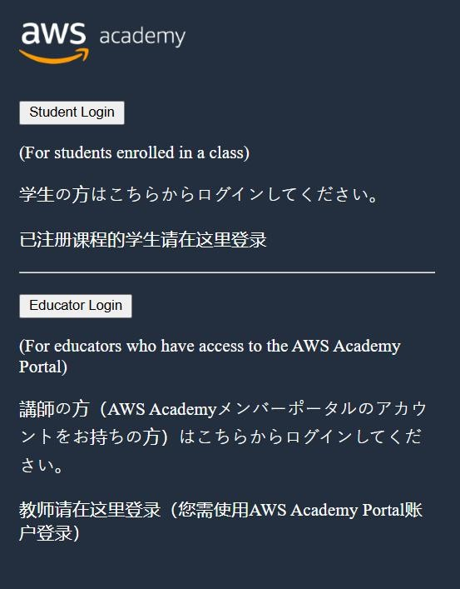

**STEP 4 :** Open Enter your credentials

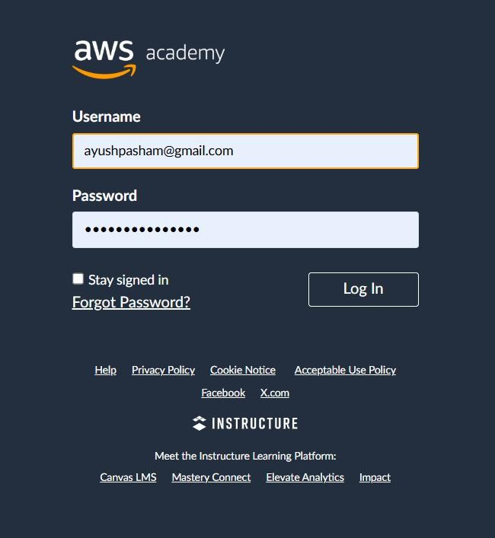

##### **STEP 5 :** Open Click on Modules in this Learner Lab

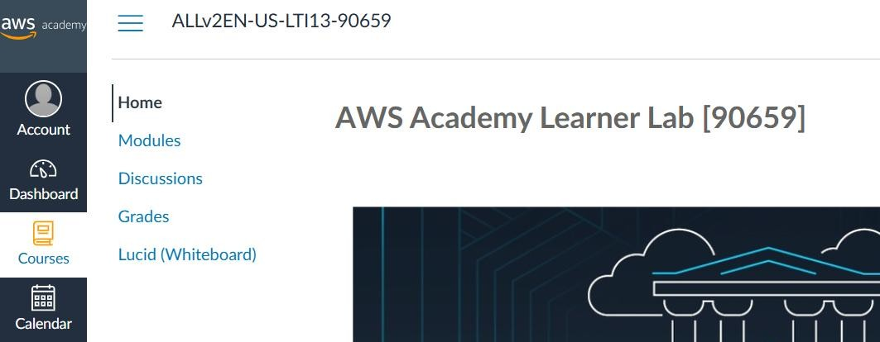

**STEP 6 :** Click on this option **Launch AWS Academy Learner Lab**

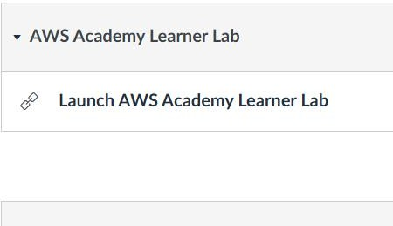

**STEP 7 :** Accept Terms and Conditions

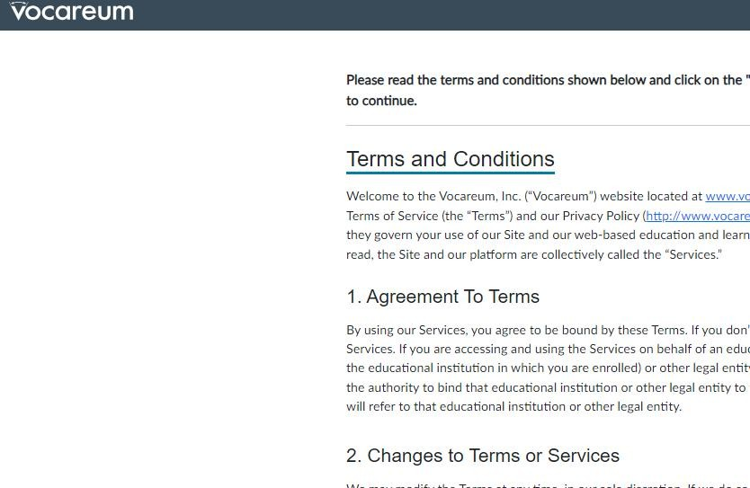

##### **STEP 8 :** Start Lab by clicking on Start Lab button

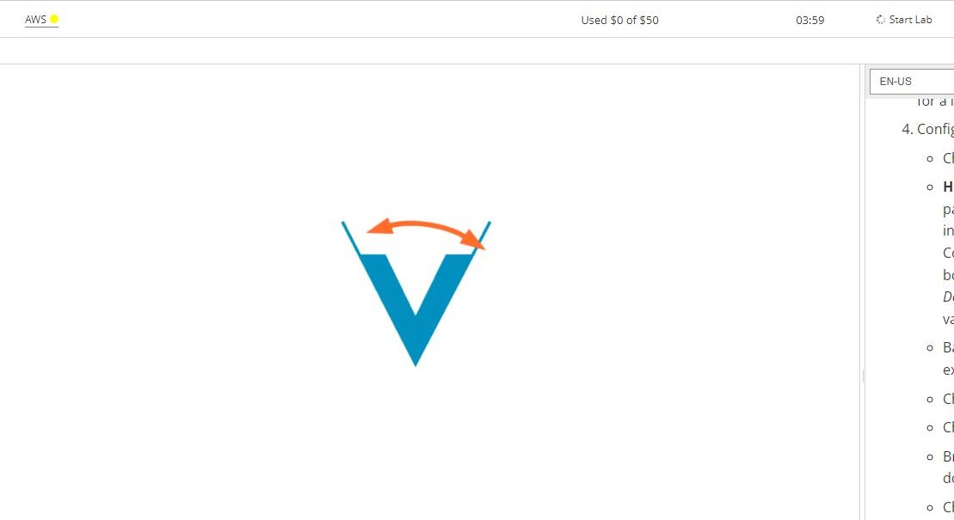

**STEP 9 :** After successfully starting the lab click on **AWS**

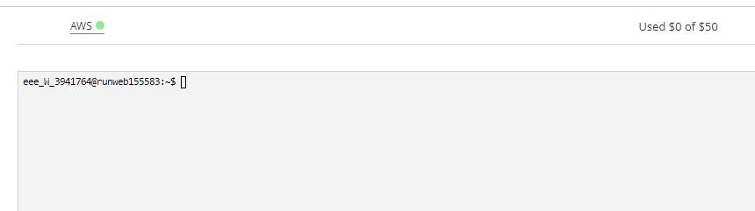

**STEP 10 :** This interface will be opened

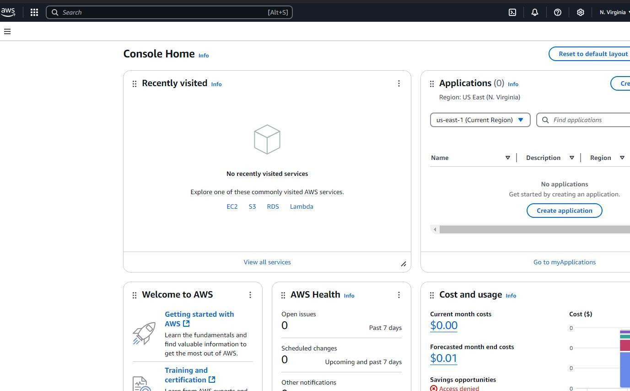

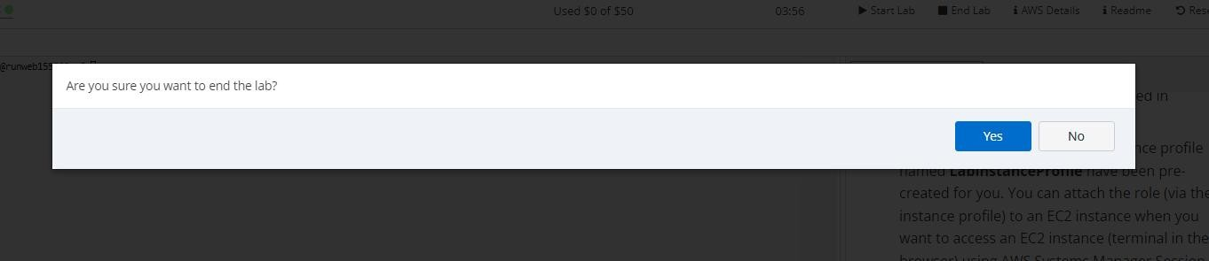**STEP 11 :** Close the lab by clicking on close lab and then **Yes**

##### **STEP 12 :** Verify that the lab is closed by getting the red dot

**LAB EXERCISE - 8 - B - PROJECT DEPLOYMENT IN THE AWS CLOUD USING EC2 INSTANCE**

110

##### **STEP 1 :** Start the lab and wait for the button to turn green

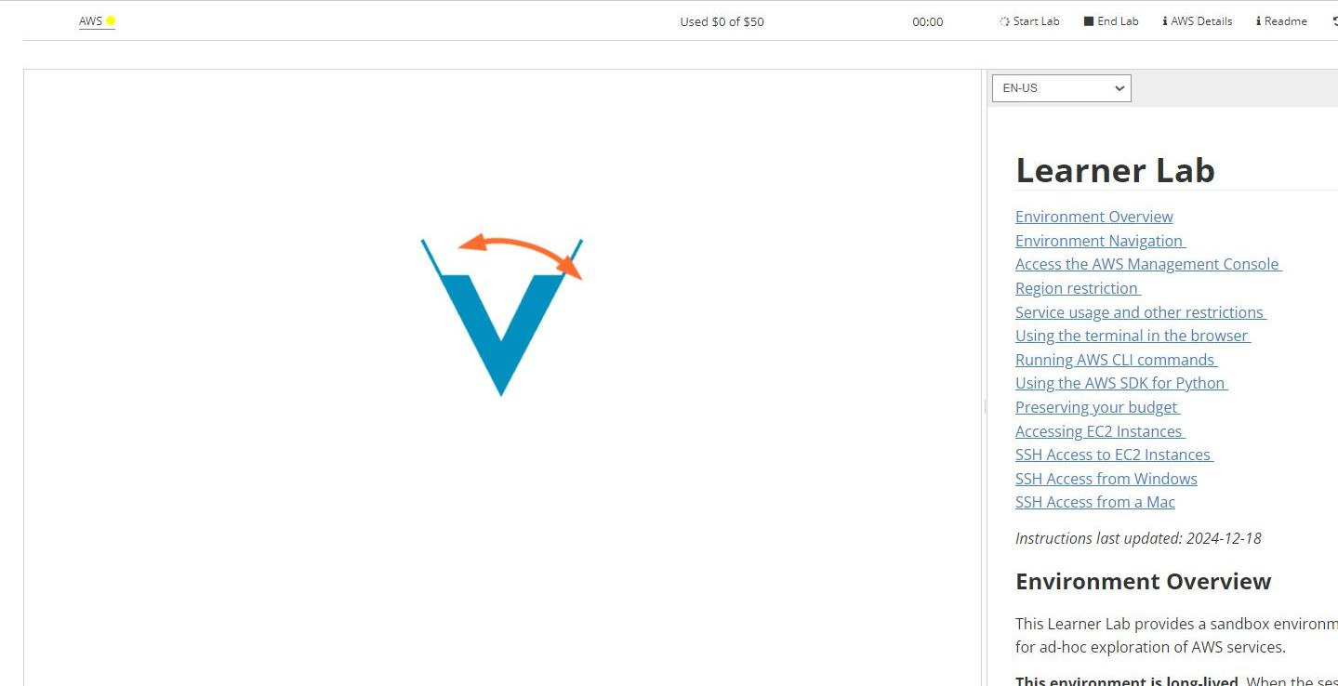

**STEP 2 :** As soon as it turns green click on **AWS**

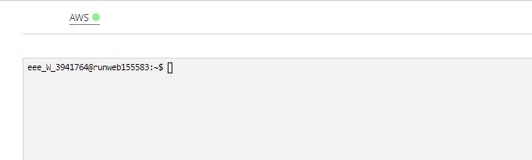

**STEP 3 :** As you enter the lab search for **EC2** instance

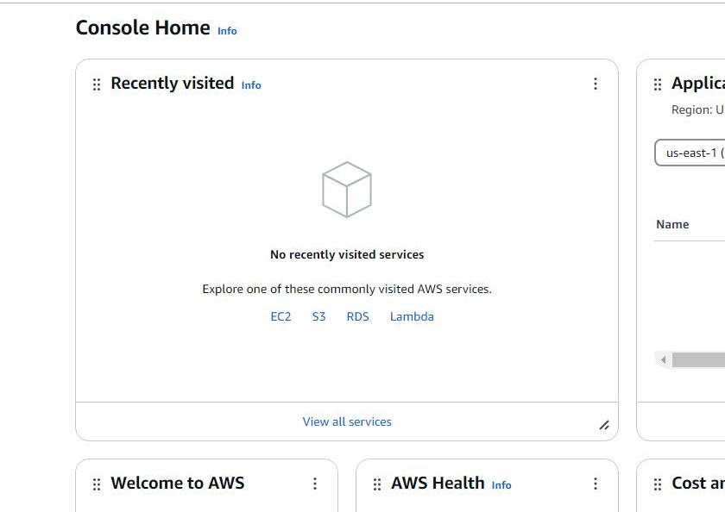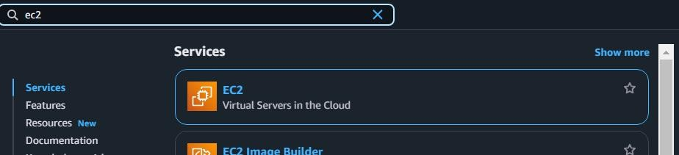

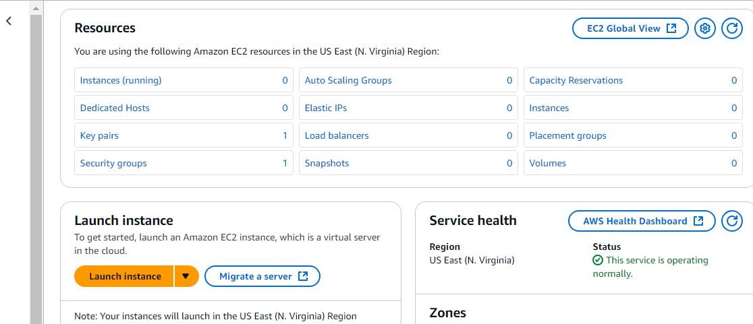

**STEP 5 :** Type an appropriate name

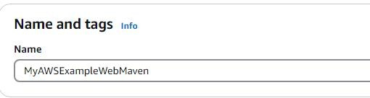

**STEP 6 :** Select Ubuntu Free Tier

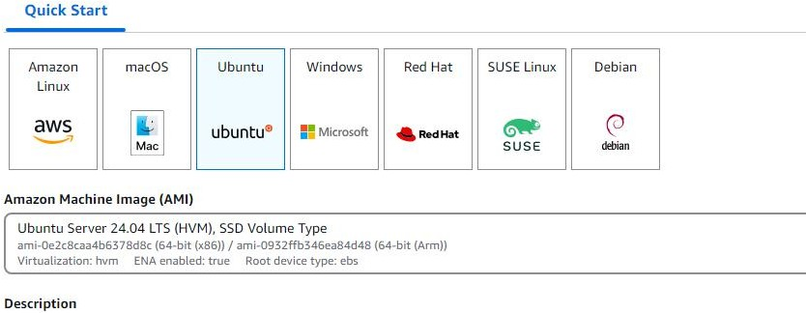

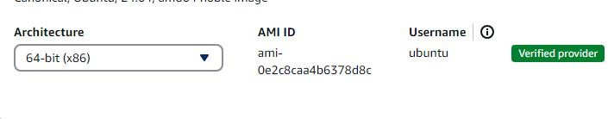

**STEP 8 :** Select t2 free instance type

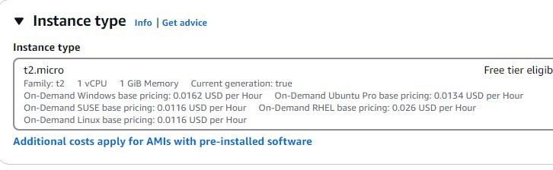

**STEP 9 :** Create your key by clicking **RSA**

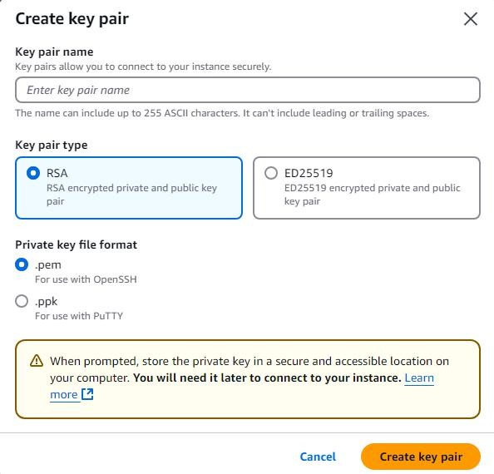

113

**STEP 10 :** In network settings allow both **HTTP – HTTPS** traffic

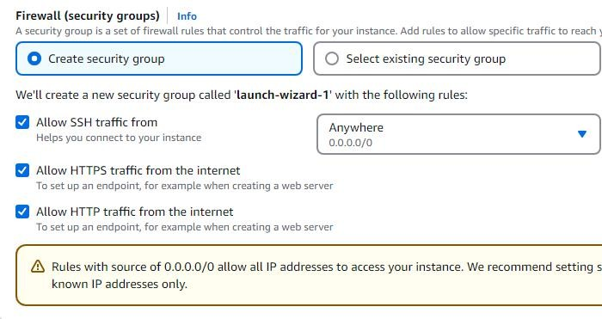

**STEP 11 :** In storage settings select either **8GB | 10GB** which is still free tier

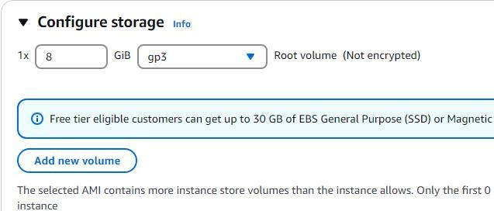

**STEP 12 :** Click on **Launch Instance**

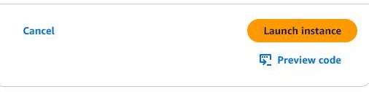

**STEP 13 :** Verify instance has launched

114

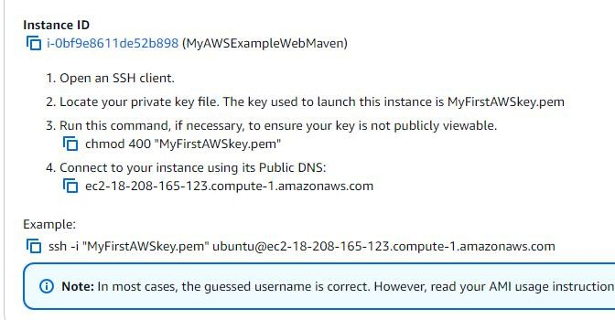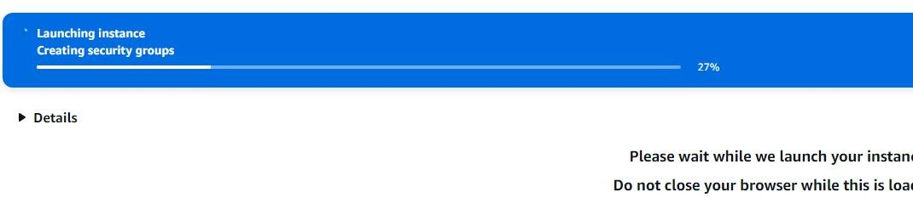

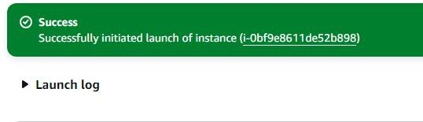

**STEP 14 :** Wait for the instance to load



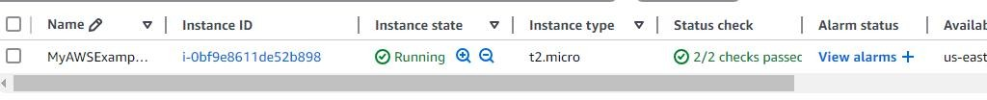

**STEP 15 :** SSH Connect to the instance

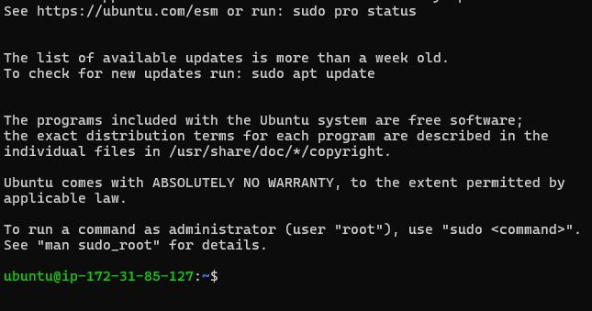

**STEP 17 :** Run the command `**sudo apt update**`

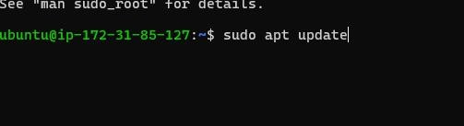

**STEP 18 :** Run the command ` **sudo apt-get install docker.io**`

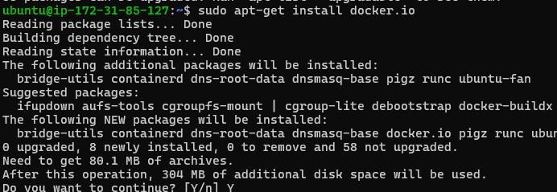

**STEP 19 :** Run the command ` **sudo apt install git**`

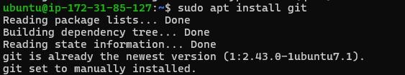

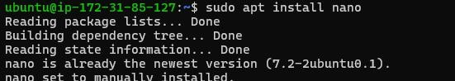

**STEP 21 :** Run the command `**git clone https://github.com/RahZero0/AWSexampleWeb.git**`

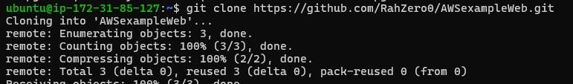

**STEP 22 :** Move to the loaded directory

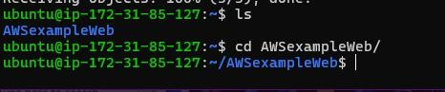

**STEP 23 :** Create the **Dockerfile** and write the below

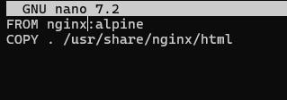

**STEP 24 :** Run the command `**sudo docker build -t mywebapp .**`

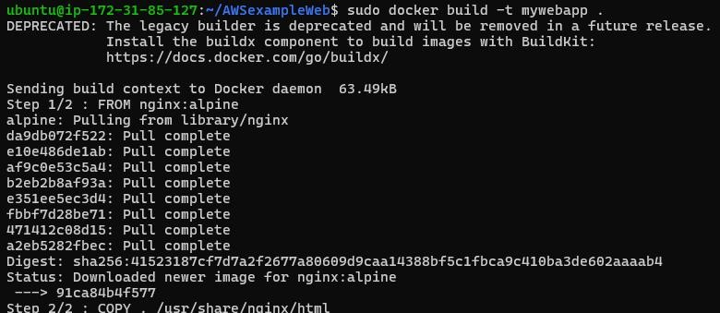

**STEP 25 :** Run the command `**sudo docker run -d -p 80:80 mywebapp**`



**STEP 26 :** Copy the public **IP** address

117

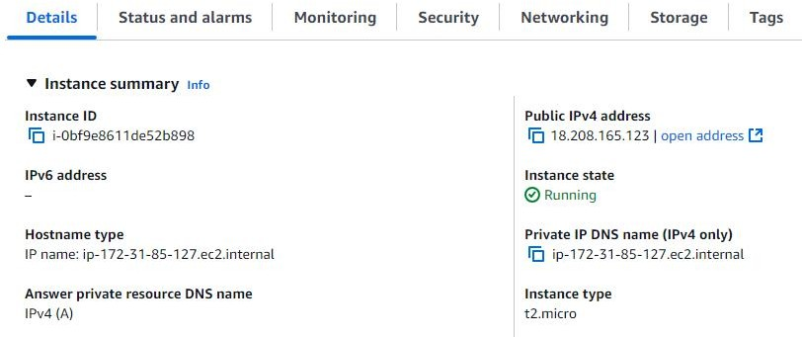

**STEP 27 :** Go to the IP address

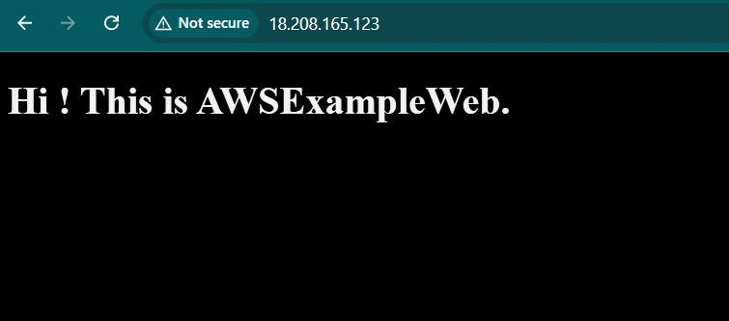

**STEP 28 :** Run the command `sudo docker ps`



##### **STEP 29 :** Run the command `sudo docker stop <container_id>`





**STEP 30 :** Terminate the instance

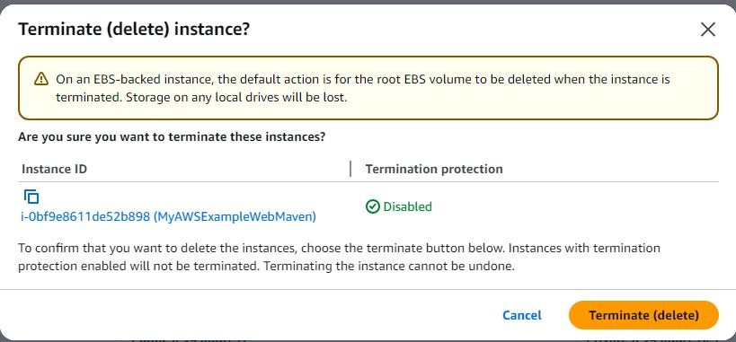

**STEP 31 :** Refresh the page to see if instance is **terminated**



**STEP 32 :** Close the lab

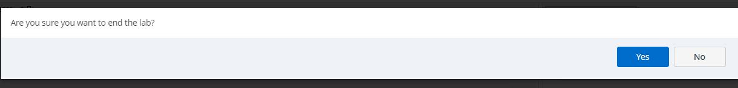

**STEP 33 :** Check for red dot

**LAB EXERCISE - 8 - C - MAVEN WEB PROJECT DEPLOYMENT IN THE AWS CLOUD USING EC2 INSTANCE**

##### **STEP 1 :** Start the lab and wait for the button to turn green



**STEP 2 :** As soon as it turns green click on **AWS**

**STEP 3 :** As you enter the lab search for **EC2** instance



**STEP 4 :** Wait for the screen to load and then click on **Launch Instance**



**STEP 5 :** Type an appropriate name



**STEP 6 :** Select Ubuntu Free Tier



**STEP 7 :** Select 64 bit architecture



**STEP 8 :** Select t2 free instance type



**STEP 9 :** Create your key by clicking **RSA**



122

**STEP 10 :** In network settings allow both **HTTP – HTTPS** traffic



**STEP 11 :** In storage settings select either **8GB | 10GB** which is still free tier



**STEP 12 :** Click on **Launch Instance**



**STEP 13 :** Verify instance has launched

123





**STEP 14 :** Wait for the instance to load





**STEP 15 :** SSH Connect to the instance



##### **STEP 16 :** Copy and paste the ssh line in the terminal



**STEP 17 :** Run the command `**sudo apt update**`



**STEP 18 :** Run the command ` **sudo apt-get install docker.io**`



**STEP 19 :** Run the command ` **sudo apt install git**`



**STEP 20 :** Run the command `**sudo apt install nano**`



**STEP 21 :** Run the command `**git clone** [**https://github.com/RahZero0/Maven-Web-**](https://github.com/RahZero0/Maven-Web-Project.git%60)[**Project.git**`](https://github.com/RahZero0/Maven-Web-Project.git%60)

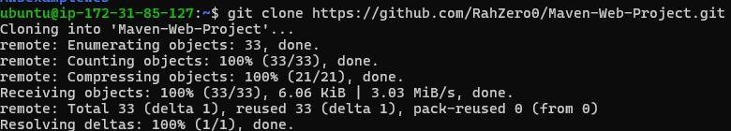

##### **STEP 22 :** Create a Dockerfile and write the contents

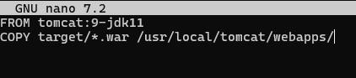

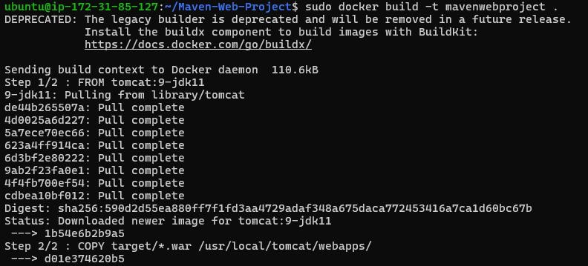**STEP 23 :** Run the command `**sudo docker build -t mavenwebproject .**`

**STEP 24 :** Run the command `**sudo docker run -d -p 9090:8080 mavenwebproject**` **STEP 25 :** Check if 9090 is in the security ports

126

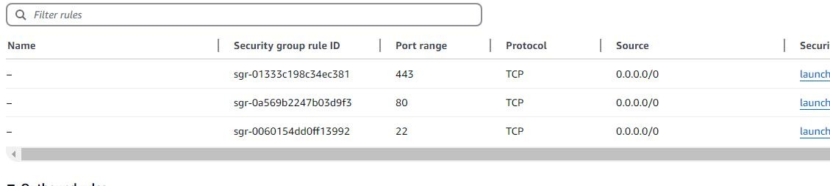

**STEP 26 :** Click on security groups

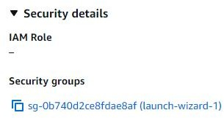

**STEP 27 :** Add 9090 with 0.0.0/0

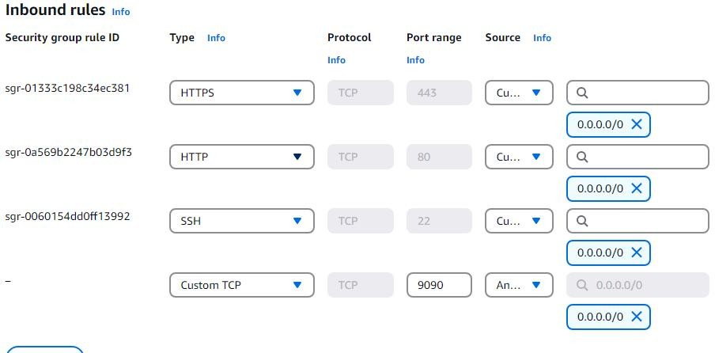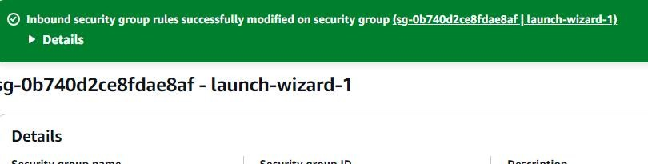

**STEP 28 :** Check the url for the **MavenWebProject**

127

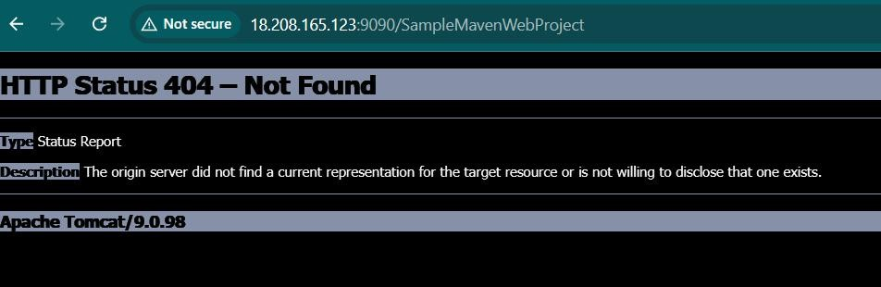

**STEP 29 :** Run the command `**sudo docker ps**`





**STEP 30 :** Open

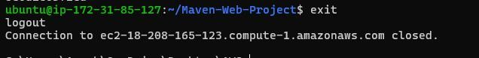

**STEP 31 :** Terminate the instance



**STEP 32 :** Refresh the page to see if instance is 1**t**2**e**8**rminated**



**STEP 33 :** Close the lab



**STEP 34 :** Check for red dot

129